YATTON INFANTS Reading Newsletter March 2023
In Year One, our children have been learning about the life of Mary Anning and have been reading Stone Girl, Bone Girl written by Laurence Anholt and illustrated by Sheila Moxley. This text has provided a great writing stimulus linked to the children’s history topic.
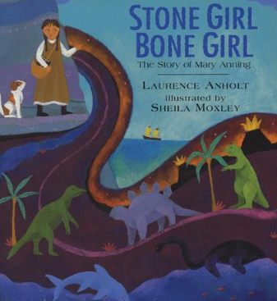
As a baby, Mary was struck by lightning, then as a little girl she found a fossilised sea monster, the most important prehistoric discovery of its time. This is a spectacular tale of a little girl who dared to be different and who followed her dreams.
Look out for these other great books about palaeontology.
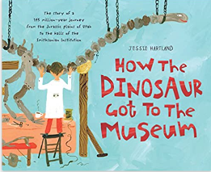 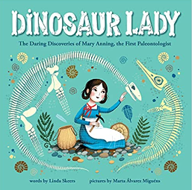
This term in Reception, our children have been learning the story of the Three Little Pigs. They have been using role play, puppets and props to retell the story and have been using the story to inspire some great writing.
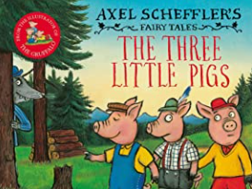

Why not try a mixed up version of this classic story?
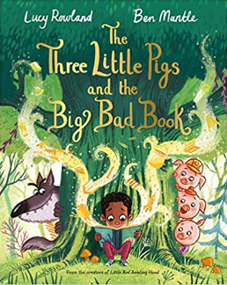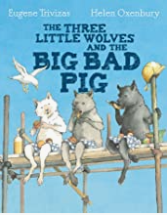
This Term’s Recommended Read
Year 2 have been enjoying the great classic Rohld Dahl book The Twits. It has inspired some great creative writing and some wonderful art work!
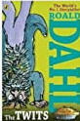
Mr. and Mrs. Twit hate everything -- except playing mean jokes on each other, catching innocent birds to put in their Bird Pies and making their caged monkeys, the Muggle-Wumps, stand on their heads all day. But the Muggle-Wumps have had enough. They don't just want out, they want revenge.

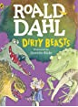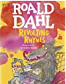
More books by Roald Dahl that will make readers grimace!
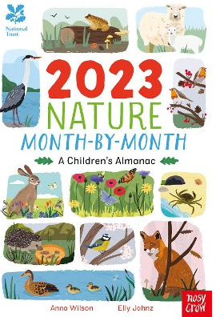
Highly recommended to build children's knowledge of the natural world around them in a fun way.
Discover all the brilliant things that you can see, make and do with this amazing month by month guide to the year. Published in collaboration with the National Trust, 2023 Nature Month-By-Month: A Children's Almanac is packed with nature spotter guides; exciting indoor and outdoor craft and activity ideas; celebrations of festivals and special days; tips for budding gardeners and tasty seasonal recipes.

