Wednesday 16th December
Linked to ‘Twas The Night Before Christmas’ Poem – see copy.
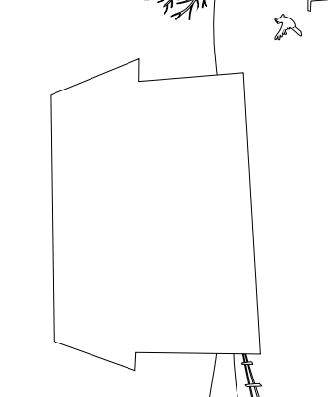
I am thinking about what my house is like on Christmas Eve: Think about using your senses to describe what is happening in your house (just like we did for ‘Coming Home’ )

Extension:
Now think back to the start of the poem and have a go at writing your own version of the first verse:

‘Twas the night before Christmas and all through my house ……
___________________________________________________________________________________________________________________________________________________________________________________________________________________________________________________________________________________________________________________________________________________________________________________________________________________________________________________________________________________________________________________________________________________________

