L.O. to recognise the features of a newspaper report.

Activity 2
Decide which of the sentences are facts and which are opinions.
You can write your answers in two columns, discuss the answers or just think them through in your head.
- The penguins were caught on CCTV escaping their enclosure at 12.05 am.
- Paris is the most romantic city.
- London Bridge crosses the River Thames.
- Earth Day is celebrated on April 22nd.
- The elephants are the best animal to see on a safari.
- The best time to go on holiday is in the summer.

Activity 3
Read the Newsround report about Spanish football. Then answer the five questions below.
- What is the report about?
- Who is involved in the story?
- When did the events take place?
- Where did the events take place?
- Why is this happening?

Activity 4
Using the same Newsround report, find and copy out examples of the newspaper features below.
- The headline (often found at the top of the page)
- Two facts
- A quote showing someone’s opinion (Top tip! Look for inverted commas)
- Three past tense verbs (Top tip! Look for verbs ending in -ed)
- A caption describing what is shown in a picture

Spanish football is back with 'fans' in the stadium... sort of.
12 Jun 202012 June 2020
Last updated at 13:20
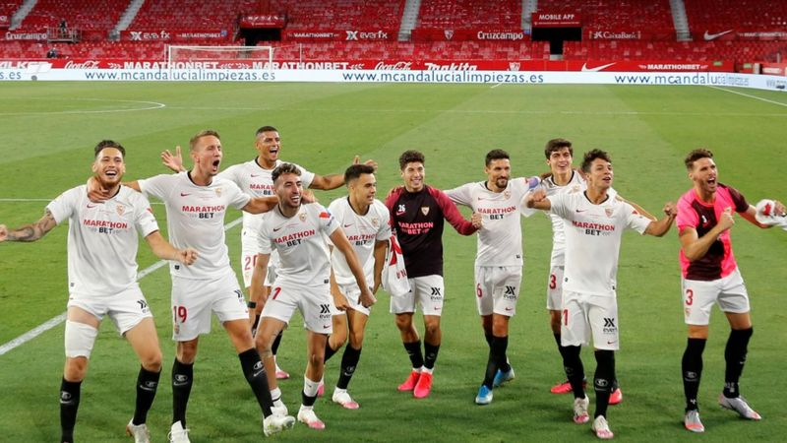REUTERS
Sevilla players celebrated in front of empty stands - there's nothing like a good imagination!
The German Bundesliga has been back since mid-May and the English Premier League is kicking off again next week.
But how did the Spanish top-flight look when it returned on Thursday evening?
Sevilla beat fierce local rivals Real Betis 2-0 in what was the first La Liga match in over three months due to the coronavirus pandemic, but there were a few issues off the pitch.
Some of both team's fans ignored advice and gathered outside the Ramon Sanchez-Pizjuan Stadium in Seville.
However, inside the stadium, the stands were full... sort of!
The television company created virtual fans, putting computer generated people into the empty stands, but the result was slightly blurry people...!
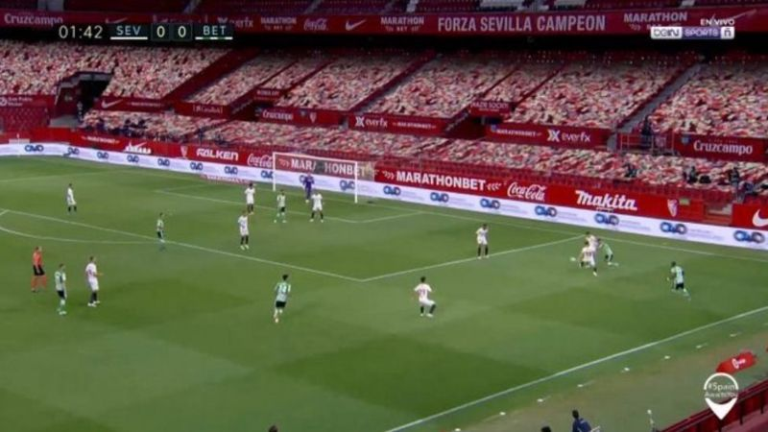BEIN SPORT
They also played crowd noises into the stadium to try and create a more dynamic atmosphere, but there were complaints that it was too quiet and it couldn't be heard on TV.
The La Liga president Javier Tebas has said he hopes to have some fans back in the stadiums by the end of the season.
"Of course it won't be the entire stadium and there will be special precautionary measures," he said.
"If we can have even 10% or 15% by the end of the season, if that happens we will be very happy about that because that's a sign that we are getting back to some form of normality."
GETTY IMAGES
They may want to work on their "social distancing" celebrations!
The players in Germany's Bundesliga, the Premier League and La Liga have all been warned about making sure to keep their distance when celebrating, but it looks like the Sevilla players missed that memo!
In the Premier League, players will be encouraged not to spit or clear their noses and there will be no ball boys or girls - a system of sterilised replacement balls will be used.

