Challenge 1, 2 & 3
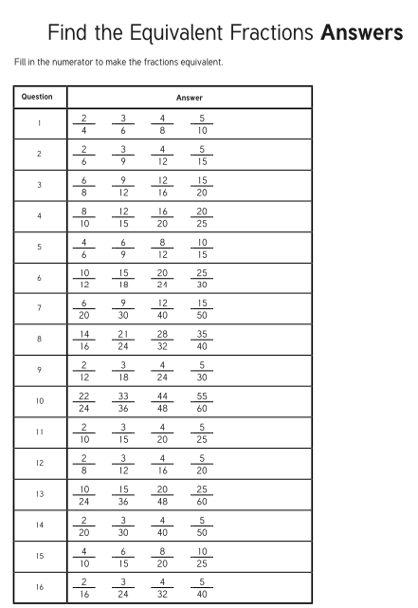
Possible answers

