Monday 08.02.21 L.O. Tenths

Question 1
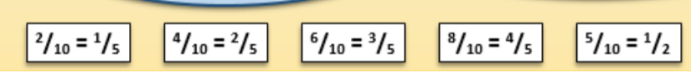

Question 2
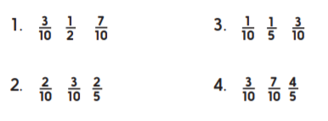

Question 3
2/5 3/5 4/5
1/10 3/10 4/10 5/10 6/10 7/10 8/10 9/10
½

Question 4

