Tuesday 09.02.21
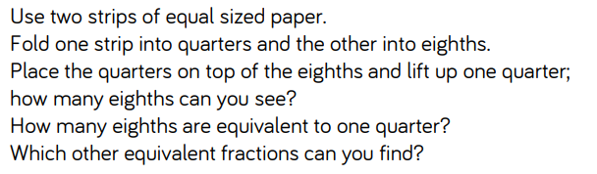
Activity 1

Activity 2
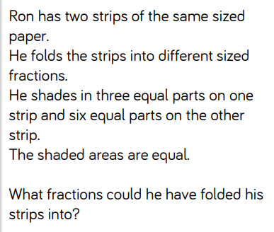

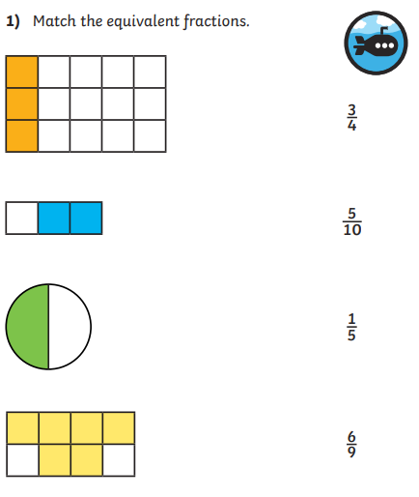
Activity 3
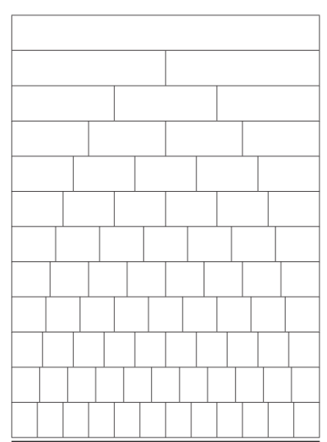
Complete the fractions wall, the top shows one whole.
Colour each strip to show the different fractions.
Find different equivalent fractions using your fractions wall and use it to help you answer the question to the right.

