How to make your own one cut book
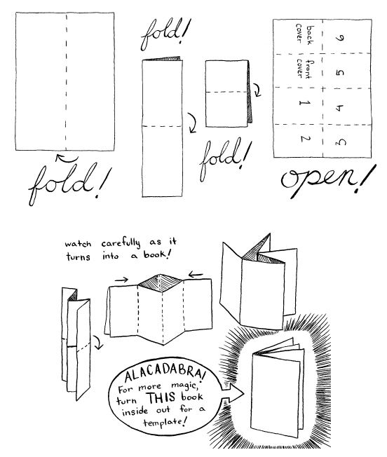
A4 will work, A3 is best. Old paper looks amazing.
Cut carefully down the middle fold

