Monday 08.02.21 L.O. Tenths

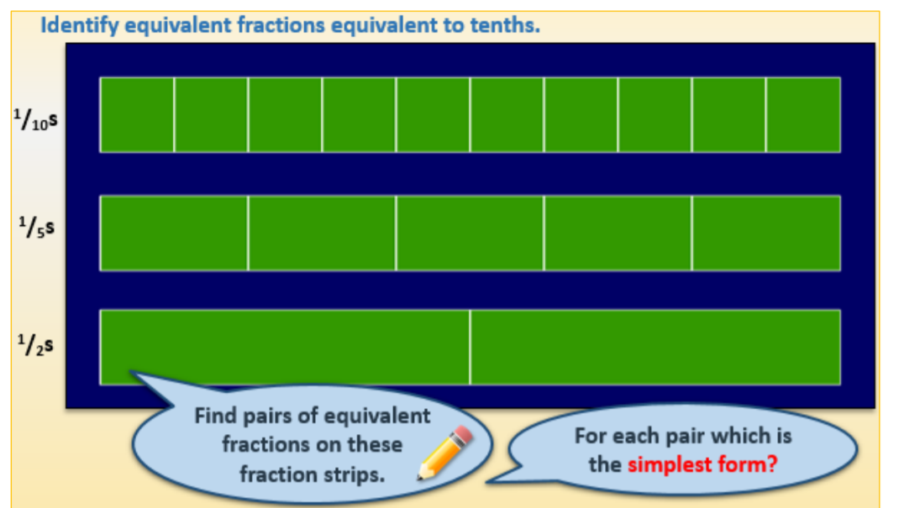
Question 1

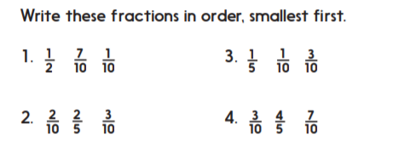
Question 2

Question 3
Mark these fractions below the number line: 1/10 2/10 3/10 4/10 5/10 6/10 7/10 8/10 9/10

Write each in its simplest form, where you can, above the line. One pair has been completed to get you started.

Question 4

