Tuesday 09.02.21
Activity 1 Activity 2
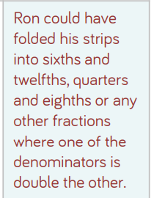
You should see 2/8
2/8 are equivalent to ¼
Other equivalent fractions would be:
4/8 = 2/4 = 1/2
¾ = 6/8

Activity 3
