**Thursday 11.02.21 Fractions greater than 1**

**Challenge 1**

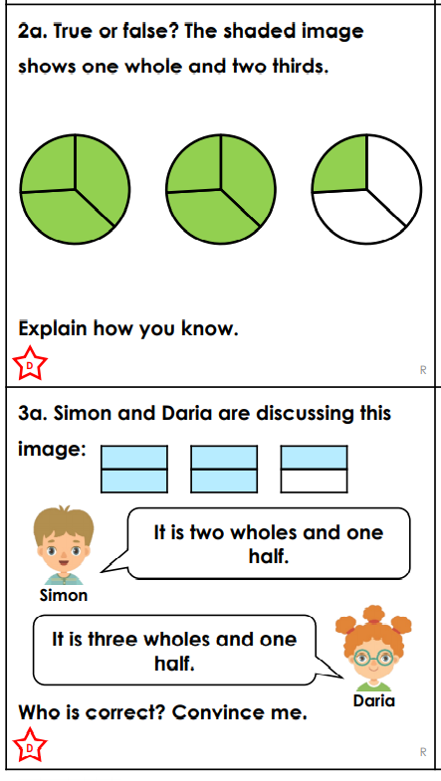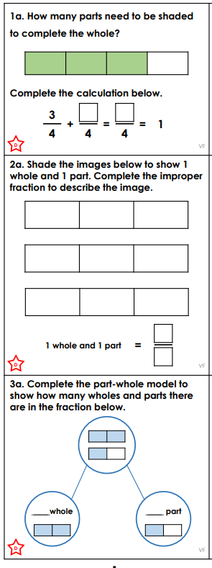

**Thursday 11.02.21 Fractions greater than 1**

**Challenge 2**

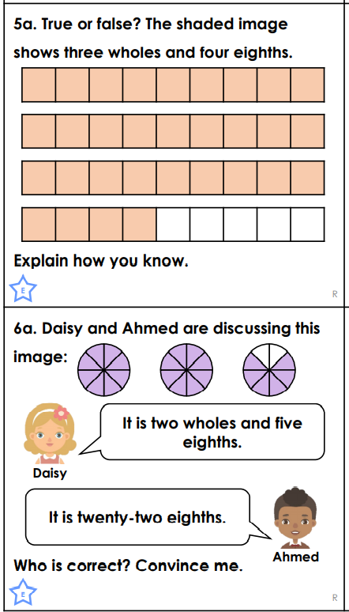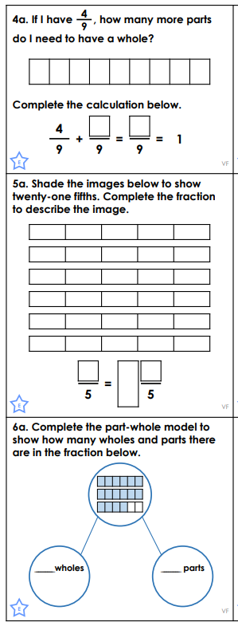

**Thursday 11.02.21 Fractions greater than 1**

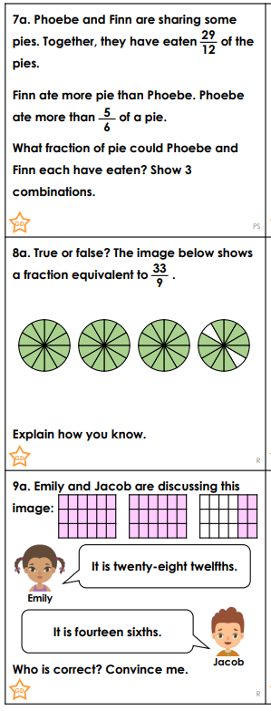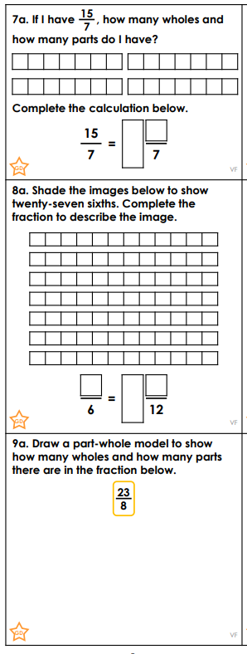**Challenge 3**