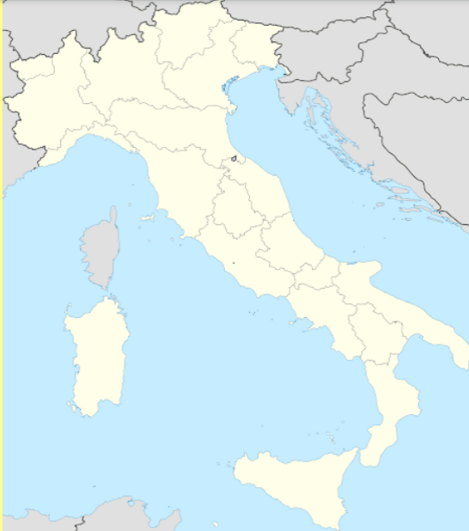

**Super Challenge**

Using the information, you researched in challenge 1 – 3, plot the various places, seas, volcanoes, rivers, lakes and mountains that you learned about on the map, precisely where they should appear.