Wednesday 10.02.21
Challenge 1
Write 1 equivalent fractions for each of these fractions, use the burger method.
Challenge 2
Write 2 equivalent fractions for each of these fractions, use the burger method.
Challenge 3
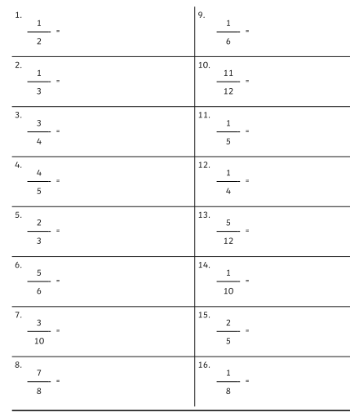
Write 3 equivalent fractions for each of these fractions, use the burger method.

