Year 6 maths – Friday 12th February
Metric measures – practical activity
For today’s non-screen activity, we want you to get to grips with metric measures!

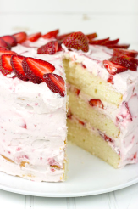
There is plenty of scope for using metric measurements in a practical context at home. It doesn’t matter what you do, or how good it is; the most important thing is that you get used to do some measuring using metric units. Here are some things you could do:

- Calling all Junior Bakers! Bake something mouth-watering: accurately measure the weight or volume of ingredients. Find a recipe that uses metric measures (g/kg/ ml/l) rather than cups. Alternatively, you could cook a delicious dinner.
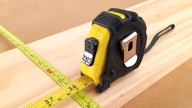
- Maybe you enjoy making things. Using mm/cm/m, measure wood, card or paper (for example) in a construction project. Measure accurately for perfect results.
- Make some paper aeroplanes. Try out some different designs and measure how far they fly. Which plane flew the furthest? Is it best to measure in mm, cm or m?

- Cupboard clear out! Need to sort out your cupboards? Read the labels and sort items based on their mass or volume. Which units do the items use? Can you display all the different masses and volumes in order?
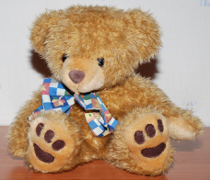
- Weighing your teddies. Measure in grams. Which is the heaviest? Which is the lightest?

- These are just a few suggestions. Can you surprise us with any other exciting ideas to get practical with metric measurements?

Share what you did with your teacher, explaining how you used metric units of measurement. Take photos, videos or write a report on what you did.
Good luck!

