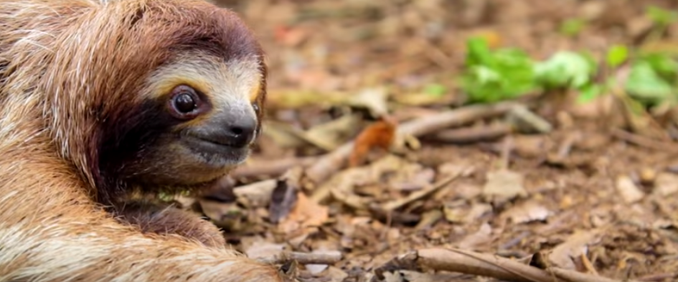
KS2 Comprehension
The Extreme Life of a Sloth
https://www.youtube.com/watch?v=DpV4k3Edr-I

- How often do sloths poo?
- What is a sloth’s top speed?
- How many years ago did sloths lose the ability to see?
- In the video, sloths are described as “sluggish.”
List three other words that have a similar meaning.
- Give an antonym of the word “sluggish.”
- What kinds of benefits come with being sluggish?
- What enables the three-fingered sloth to turn its head 270 degrees?
- What three adaptations have allowed sloths to hang upside down on branches?
- Explain why the sloth’s weekly mission to poop is so risky.
- What additional benefit does pooing on the ground give sloths?
- Pause at 3:30. List as many adjectives as you can to describe the sloth’s fur.
- What provides sloths with green camouflage?
- Do you think sloths are boring? Explain your answer.
- What is your favourite thing about a sloth that you have learned today? Why?
- Why do you think the author has repeatedly emphasised the fact that sloths are not boring?
- At the end of the video, the sloth is described as a “daredevil.” Do you agree with this assessment? Explain your answer.
- Sequence the following events in chronological order.
The sloth comes down from the tree to poo. _____
Algae calls a sloth’s fur ‘home.’ _____
We learn about the sloth’s hook-like fingernails. _____
We learn that sloths take predator avoidance to the next level. _____

