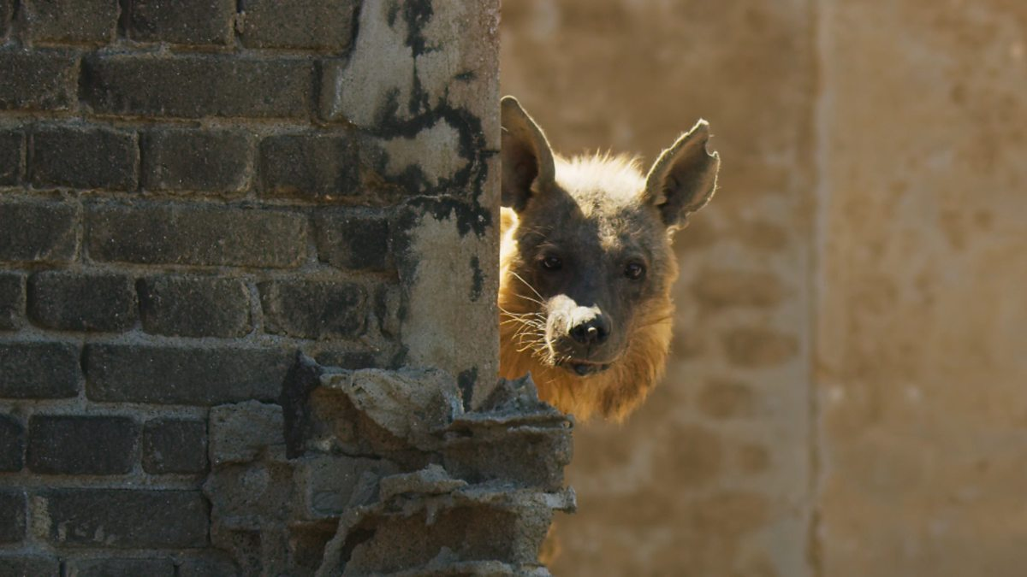
This Ghost Town is Home to Africa’s Rarest Predator.
Answers:
- The animal in this clip is described as a desert specialist. What do you think the word specialist means? Adapted uniquely to their environment and the resources available.
- What is the name of this rare predator? Brown Hyena.
- Pause at 48 seconds – Why might the brown hyena have chosen to make her home in this ghost town? Various Answers – link to lack of predators, protection from elements, safety, etc…
- What do you think is meant by the phrase ‘ghost town’? A deserted town with few/no remaining inhabitants.
- What do the ruins give the brown hyena? Valuable protection from the elements.
- Pause at 1.03 – Why do you think this image was included? What is interesting about what you are looking at? Various answers – link to contrast between human habitat and wild animal…
- How long has the brown hyena spent living in the ghost town? 15 years.
- Sir David Attenborough says the brown hyena ‘has already reared nine generations of cubs.’ Can you think of synonyms for the words ‘reared’ and ‘cubs’
- Synonym for reared – bring up, look after, nurture, parent, raise, etc…
- Synonym for cubs – baby, young, offspring, etc…
- How old are the two youngsters? 4 months.
- What do the two young cubs now need? Regular solid food.
- Why does the brown hyena sometimes have to leave her cubs for several days on end? Searching for food.
- Pause at 2.29 – What is the point of this few seconds of imagery focusing on a bright sun in a clear sky? Various answers – link to heat, dangers of this, hostile environment, etc…
- How far can a brown hyena walk in a day when searching for food? 20 miles.
- Sir David Attenborough describes the territory featured in this clip as ‘some of the most hostile country on the planet.’ Why might this area be ‘hostile’? Various answers – lack of food, exposed, no water, heat, etc…
- Pause at 3.02 – Choose one word to describe the image. Explain your choice. Many potential answers to discuss.
- Do you think the brown hyena will be successful in her search for food? Explain your answer referencing what you have seen and heard in this clip. Yes – raised cubs successfully, lived there for 15 years, etc… No – hostile environment, looks abandoned, etc... Maybe – combination of both…
- Summarise this clip in 20 words or less. Various possible answers to share and discuss.

