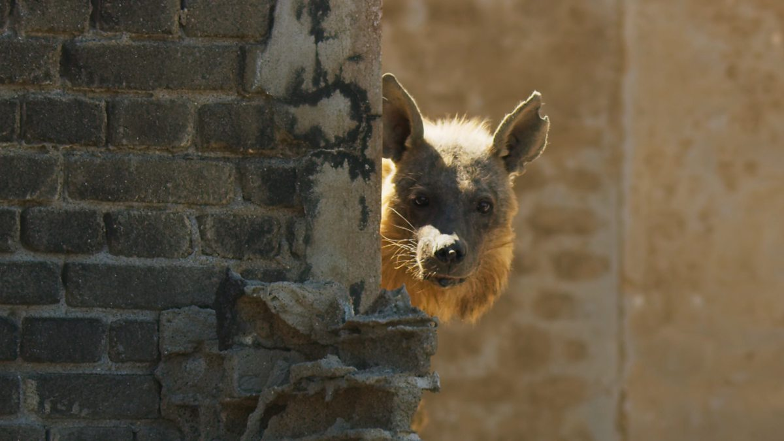
This Ghost Town is Home to Africa’s Rarest Predator.
https://www.youtube.com/watch?v=jrc4aOfu7aQ&t=35s
- The animal in this clip is described as a desert specialist. What do you think the word specialist means?
- What is the name of this rare predator?
- Pause at 48 seconds – Why might the brown hyena have chosen to make her home in this ghost town?
- What do you think is meant by the phrase ‘ghost town’?
- What do the ruins give the brown hyena?
- Pause at 1.03 – Why do you think this image was included? What is interesting about what you are looking at?
- How long has the brown hyena spent living in the ghost town?
- Sir David Attenborough says the brown hyena ‘has already reared nine generations of cubs.’ Can you think of synonyms for the words ‘reared’ and ‘cubs’
- Synonym for reared –
- Synonym for cubs –
- How old are the two youngsters?
- What do the two young cubs now need?
- Why does the brown hyena sometimes have to leave her cubs for several days on end?
- Pause at 2.29 – What is the point of this few seconds of imagery focusing on a bright sun in a clear sky?
- How far can a brown hyena walk in a day when searching for food?
- Sir David Attenborough describes the territory featured in this clip as ‘some of the most hostile country on the planet.’ Why might this area be ‘hostile’?
- Pause at 3.02 – Choose one word to describe the image. Explain your choice.
- Do you think the brown hyena will be successful in her search for food? Explain your answer referencing what you have seen and heard in this clip.
- Summarise this clip in 20 words or less.

Script:
A desert specialist. And one of Africa’s rarest predators – the brown hyena. This ghost town is her home. Its ruins give her valuable protection from the elements. She has been here for 15 years. She’s already reared nine generations of cubs. These two youngsters have reached a critical stage in their lives. They’re four months old and now they need regular solid food but there is nothing edible in these ruins so their mother has to look elsewhere and may leave them for several days on end. Brown hyenas may walk over 20 miles a day in search of food. This is some of the most hostile country on the planet.

Answers:
- The animal in this clip is described as a desert specialist. What do you think the word specialist means? Adapted uniquely to their environment and the resources available.
- What is the name of this rare predator? Brown Hyena.
- Pause at 48 seconds – Why might the brown hyena have chosen to make her home in this ghost town? Various Answers – link to lack of predators, protection from elements, safety, etc…
- What do you think is meant by the phrase ‘ghost town’? A deserted town with few/no remaining inhabitants.
- What do the ruins give the brown hyena? Valuable protection from the elements.
- Pause at 1.03 – Why do you think this image was included? What is interesting about what you are looking at? Various answers – link to contrast between human habitat and wild animal…
- How long has the brown hyena spent living in the ghost town? 15 years.
- Sir David Attenborough says the brown hyena ‘has already reared nine generations of cubs.’ Can you think of synonyms for the words ‘reared’ and ‘cubs’
- Synonym for reared – bring up, look after, nurture, parent, raise, etc…
- Synonym for cubs – baby, young, offspring, etc…
- How old are the two youngsters? 4 months.
- What do the two young cubs now need? Regular solid food.
- Why does the brown hyena sometimes have to leave her cubs for several days on end? Searching for food.
- Pause at 2.29 – What is the point of this few seconds of imagery focusing on a bright sun in a clear sky? Various answers – link to heat, dangers of this, hostile environment, etc…
- How far can a brown hyena walk in a day when searching for food? 20 miles.
- Sir David Attenborough describes the territory featured in this clip as ‘some of the most hostile country on the planet.’ Why might this area be ‘hostile’? Various answers – lack of food, exposed, no water, heat, etc…
- Pause at 3.02 – Choose one word to describe the image. Explain your choice. Many potential answers to discuss.
- Do you think the brown hyena will be successful in her search for food? Explain your answer referencing what you have seen and heard in this clip. Yes – raised cubs successfully, lived there for 15 years, etc… No – hostile environment, looks abandoned, etc... Maybe – combination of both…
- Summarise this clip in 20 words or less. Various possible answers to share and discuss.

