
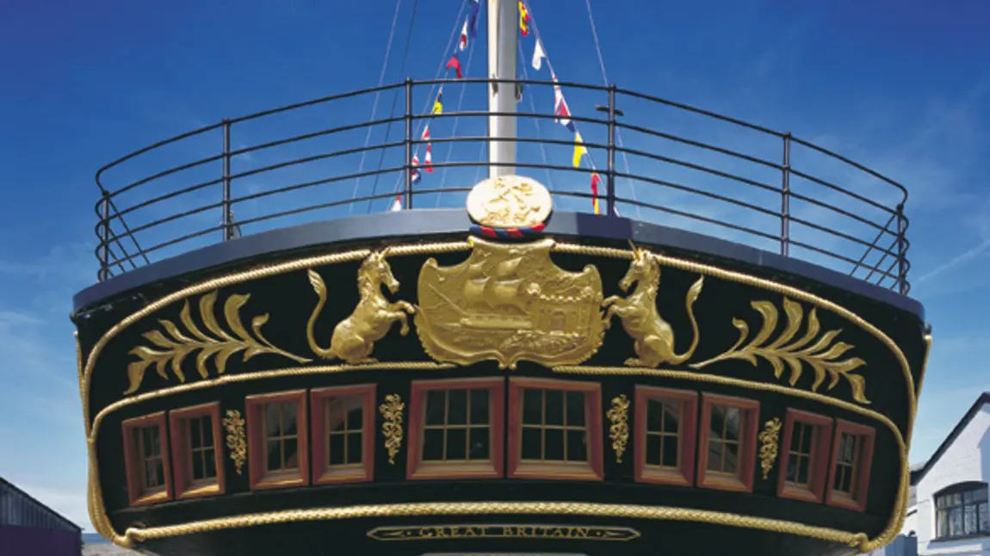

The History Curriculum at Lighthouse Schools Partnership

History at Lighthouse Schools Partnership


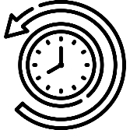
We believe that a high-quality history education can bring pupils into a rich dialogue with the past and with the traditions of historical enquiry.

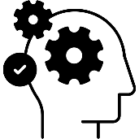

Through our history curriculum, we aim for our pupils to develop a rich understand of their place in the world, and in the long story of human development. We know that history helps pupils to understand the complexity of people’s lives, the process of change, the diversity of societies and relationships between different groups, as well as their own identity and the challenges of their time. With this in mind, pupils learn how the past, and changing accounts of the past, have shaped the identities of diverse people, groups and nations.

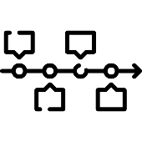

Our history curriculum allows pupil to understand methods of historical enquiry and is designed to inspire pupils’ curiosity to know more about the past. As pupils progress through the curriculum, they learn how historians and others construct accounts about the past, building on and challenging or refining the work of others. Pupils learn how argument and debate can be underpinned by shared principles of enquiry, and how this can drive and test new knowledge and insight about shared pasts. Teaching will equip pupils to ask perceptive questions, think critically, weigh evidence, sift arguments, and develop perspective and judgement.

Our history curriculum aims to ensure that all pupils:

- know and understand the history of our local area and the UK islands as a coherent, chronological narrative, from the earliest times to the present day: how people’s lives have shaped this nation as well as how Britain has influenced and been influenced by the wider world.
- know and understand significant aspects of the history of the wider world: the nature of ancient civilisations; the expansion and dissolution of empires; characteristic features of past non-European societies; achievements and follies of mankind gain and deploy a historically grounded understanding of abstract terms.
- understand historical concepts such as continuity and change, cause and consequence, similarity, difference and significance, and use them to make connections, draw contrasts, analyse trends, frame historically valid questions and create their own structured accounts, including written narratives and analyses.
- understand the methods of historical enquiry, including how evidence is used rigorously to make historical claims, and discern how and why contrasting arguments and interpretations of the past have been constructed.
- gain historical perspective by placing their growing knowledge into different contexts, understanding the connections between local, regional, national and international history; between cultural, economic, military, political, religious and social history; and between short- and long-term timescales.


Progression in history through the curriculum
An overview of progression through our vertical concepts

  Trade and Settlements | 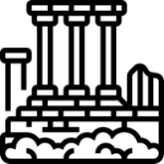  Empires and Civilisation | 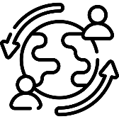  Invasion, migration and peace |   Technology and Innovation
EYFS: Who am I?  Pupils will talk about themselves. They will explore what a family is, who is in their family and how this is similar and different to other families. | LKS2: What were the beliefs of the Ancient Egyptians and how are these different to what different religions believe today?  Pupils will learn that Ancient Egypt was a civilisation in Northeast Africa situated in the Nile Valley. They focus on the beliefs of the Ancient Egyptians, the significance of these beliefs on the lives of people living in the civilisation before comparing them to the beliefs of people living in Britain today. | LKS2: What changed after the Romans left?  Pupils will learn about changes in life for people in the Anglo-Saxon civilisation including the changes to the English language, regional government and the establishment of Christianity following the time of the Romans in Britain. Pupils will compare life in Anglo-Saxon times with life during the Roman era and life in modern Britain. | KS1: How has technology impacted how people stay in contact with each other?  Pupils will learn about changes in how people communicate with each other as a result of technological advancements. They will explore similarities and difference in written and verbal forms of communication, in particular in the last 100 years.
EYFS: Who are the people who help us in our community?  Pupils will explore the different occupations of people who work in the local community. They will think about why you may visit these people including looking at pictures and stories from the past and present. | LKS2: What was the Roman Empire and what was its impact on Britain?  Pupils will learn about the reasons why the Roman Empire grew so successfully focussing on the invasion of Britain. Then, they will look at the positive impact of the Romans on Britain including their legacy today. | LKS2: Why did the Vikings come to the British Isles and what was the impact?  Pupils will learn about the Viking raids of the British Isles. They will learn about how and why they came to Britain. Pupils will explore why there was a struggle for the Kingdom of England and what the consequences of this were. | KS1: What is similar and different between holidays now and in the past?  Pupils will compare and contrast seaside holidays during the Victorian era with holidays today. They will look at similarities and differences in how people travel to holiday destinations, how they are entertained as well as what they wear and why.
KS1: What were the causes of the Great Fire of London and why did it spread so quickly?  Pupils will learn about the events of the Great Fire of London including the initial cause. They will compare the settlement of London at the time of the fire with London today to understand some of the reasons why the fire spread so quickly. They will also learn about the impact of the fire on how London was rebuilt as well as on how fires are now fought. | UKS2: Why have people argued about the Benin Bronzes?  Pupils will learn about life in the Kingdom of Benin and the factors that led to its destruction. They will explore the Oba of Benin and the links of Benin to Europe. Pupils will learn about why arguments have broken out about the Benin Bronzes and form an opinion on it. | UKS2: How did people’s experiences differ during World War 2?  Pupils will learn about the outbreak of the Second World War and who the axis and allies were. They will focus on the experiences of women, civilians, nurses and the military on the Home Front. | KS1: What impact did Mary Seacole and Florence Nightingale have on nursing?  Pupils will learn about what nursing was like during the 1800s including what was similar and different about these 2 significant individuals. They will think about what caused the changes in medical care, forming an opinion on whether the changes were for the better.
LKS2: What changed in Britain during the Stone Age?  Pupils will learn about what life was like for individuals during the Stone Age through looking at their settlements, what jobs they had and what they traded. They will understand how we know what life was like during the Stone Age and will explore the evidence that we have. | UKS2: How did Ancient Greece influence modern day democracy?  Pupils will learn about the Ancient Greek civilisation – the first civilisation to create a democracy. They will look at the similarities and differences of Athenian democracy and democracy in modern Britain. | UKS2: How did Baghdad become the ‘City of Peace’?  Pupils will learn about the rise of Islam, how it spread and the early caliphates. They will understand the geography of the Umayyad Caliphate. Finally pupils will explore Baghdad and what events led up to it being known as the ‘City of Peace’. | KS1: What was Brunel’s legacy in Bristol?  Pupils will learn about Brunel’s designs, architecture and engineering firsts in the South West region. They will understand the significant impact Brunel had on Bristol through the focussing on Clifton Suspension Bridge and the GWR.
LKS2: How did life change in Britain during the Bronze and Iron Age?  Pupils will learn about the first use of bronze and how this changed life in Britain during this time through a focus on agriculture, settlements and trade. |  | UKS2: Who are the Windrush Generation and what is their legacy?  Pupils will learn about the reasons for migration to the United Kingdom following World War 2, the experiences of these people and the significance of this on the cultural diversity in the city of Bristol over time. | KS1: How has seafaring changed over time and why?  Pupils will compare and contrast The Matthew (used by John Cabot to cross the Atlantic) with the SS Great Britain (designed by Isambard Kingdom Brunel). They will learn about the ways in which these ships were used during their lifetime will look at similarities and differences between passenger experiences.
UKS2: Why is trade significant to the city of Bristol?
Pupils will explore the significance of trade in Bristol, particularly since Tudor times. They will explore the history of trade in the city and the surrounding areas. Pupils will learn about Bristol’s links to the slave trade and will unpick why the legacy of Edward Colston is now considered controversial.

Year group and term | National Curriculum Mapping | Substantive Knowledge | Disciplinary Knowledge | Enquiry Question | Vertical Concepts
EYFS Understanding the World: Past and Present
Nursery/ Reception  Autumn Term 1 | Talk about the lives of the people around them and their roles in society  Know some similarities and differences between things in the past and now, drawing on their experiences and what has been read in class  Understand the past through settings, characters and events encountered in books read in class and storytelling | Myself, my family, my friends | Similarity and Difference | Who am I? | Trade and Settlements
Nursery/ Reception  Autumn Term 2 |  | People in the community  Me and my family | Significance | Who are the people who help us in our community? | Technology and Innovation  Trade and Settlements
KS1 History Curriculum
Year 1 Autumn  Term 1/2 | Changes within living memory | History of communication | Similarity and Difference | How has technology impacted how people stay in contact with each other? | Technology and Innovation
Year 1 Spring  Term 3/4 | Events beyond living memory that are significant nationally  Significant historical events | The Great Fire of London | Cause and Consequence  Significant Event | What were the causes of the Great Fire of London and what was the impact of this event? | Technology and Innovation  Trade and Settlements
Year 1 Summer  Term 5/6 | Changes within living memory | Seaside holidays in the past | Similarity and Difference | What is similar and different between holidays in the past and holidays today? | Technology and Innovation  Trade and Settlements
Year 2 Autumn  Term 1/2 | The lives of significant individuals in the past who have contributed to national and international achievements | Impact of significant individuals | Significant Individuals | What impact did Mary Seacole and Florence Nightingale have on nursing? | Technology and Innovation  Invasion, migration and peace
Year 2 Spring  Term 3/4 | Significant historical events, people and places in their own locality | Impact of significant individuals | Significant individuals | What was Brunel’s legacy in Bristol? | Technology and Innovation
Year 2 Summer  Term 5/6 | Significant historical people and places in their own locality | How has seafaring changed? | Significant individuals | How has seafaring changed over time and why? | Technology and Innovation  Invasion, migration and peace
LKS2 History Curriculum
Year 3 Autumn  Term 1/2 | Changes in Britain from the Stone Age to the Iron Age | The Stone Age | Continuity and change | What changed in Britain during the Stone Age? | Trade and Settlements  Technology and Innovation
Year 3 Spring  Term 3/4 | Changes in Britain from the Stone Age to the Iron Age | The Iron Age | Continuity and change | How did life change in Britain during the Bronze and Iron Age? | Invasion, migration and peace  Trade and Settlements
Year 3 Summer  Term 5/5 | The achievements of the earliest civilisations | Ancient Egyptian Beliefs | Similarity and difference | What were the beliefs of the Ancient Egyptians and how are these different to what different religions believe today? | Empires and civilisations
Year 4 Autumn  Term 1/2 | The Roman Empire and its impact on Britain | Roman Empire in Britain | Cause and consequence | What was the Roman Empire and what was its impact on Britain? | Empires and civilisation
Year 4 Spring  Term 3/4 | Britain’s settlement by Anglo-Saxons and Scots | Settlement by Anglo-Saxons and Scots | Similarity and difference | What changed after the Romans left? | Invasion, migration and peace
Year 4 Summer  Term 5/6 | The Viking and Anglo-Saxon struggle for the Kingdom of England to the time of Edward the Confessor | Vikings | Cause and consequence | Why did the Vikings come to the British Isles and what was the impact? | Invasion, migration and peace  Trade and Settlements
UKS2 History Curriculum
Year 5 Autumn  Term 1/2 | A local history study | Trade and Bristol | Significance | Why is trade significant to the city of Bristol? | Trade and Settlements
Year 5 Spring  Term 3/4 | A non-European society that provides contrasts with British history.  A local history study | Benin | Significance  Cause and consequence | Why have people argued about the Benin Bronzes? | Invasion, migration and peace  Empires and Civilisation
Year 5 Summer  Term 5/5 | A study of Greek life and achievements and their influence on the western world  The legacy of Greek culture | Ancient Greece | Significance  Similarity and difference | How did Ancient Greece influence modern day democracy? | Empires and Civilisation
Year 6 Autumn  Term 1/2 | A local history study  A significant turning point in British history. | World War 2 | Similarity and difference  Significance | How did people’s experiences differ during World War 2? | Invasion, migration and peace
Year 6  Spring  Term 3/4 | A local history study  A study of an aspect of theme in British history that extends pupils chronological knowledge beyond 1066 | The Windrush Generation in Bristol | Significance | Who are the Windrush Generation and what is their legacy? | Invasion, migration and peace
Year 6 Summer  Term 5/6 | A non-European society that provides contrasts with British history | Early Islamic Civilisation | Continuity and Change  Cause and consequence | How did Baghdad become the ‘City of Peace’? | Invasion, migration and peace  Trade and Settlements

Progression of skills within the History Curriculum
Medium term plans define the substantive knowledge which should be learnt during the course of each unit. In addition, disciplinary skills are also defined; these are used, deliberately practiced and developed in order for pupils to understand how historians work and how we learn about, and from, the past. These skills are broken down by phase and are integral to rich learning in history. As these skills are used in each unit, pupils will become more and more skilled and confident in their use of them as they will have 6 opportunities across their time in each phase to develop competency before moving into the next stage of learning.
Chronology

Interpretation

Past and Present

Communication

Using sources

Enquiry

Past and Present
Nursery (3 and 4) | Reception | ELG
- Begin to make sense of their own life-story and family’s history  - Show interest in different occupations | - Talk about members of their immediate family and community  - Name and describe people who are familiar to them  - Comment on images of familiar situations in the past  - Compare and contrast characters from stories, including figures from the past | Children at the expected level of development will:  - Talk about the lives of the people around them and their roles in society  - Know some similarities and differences between things in the past and now, drawing on their experiences and what has been read in class  - Understand the past through settings, characters and events encountered in books read in class and storytelling

Communication – listening and attention
Nursery (3 and 4) | Reception | ELG
- Enjoy listening to longer stories and can remember much of what happens  - Understand ‘why’ questions, like: “Why do you think the caterpillar got so fat?” | - Understand how to listen carefully and why listening is important  - Learn new vocabulary  - Listen to and talk about stories to build familiarity and understanding  - Listen to and talk about selected non-fiction to develop a deep familiarity with new knowledge and vocabulary | Children at the expected level of development will:  - Listen attentively and respond to what they hear with relevant questions, comments and actions when being read to and during whole class discussions and small group interactions  - Make comments about what they have heard and ask questions to clarify their understanding  - Hold conversation when engaged in back-and-forth exchanges with their teacher and peers
Communication – speaking
Nursery (3 and 4) | Reception | ELG
- Use a wider range of vocabulary  - Use longer sentences of four to six words.  - Develop their communication but may continue to have problems with irregular tenses and plurals, such as ‘runned’ for ‘ran’, ‘swimmed’ for ‘swam’  - Be able to express a point of view and to debate when they disagree with an adult or a friend, using words as well as actions  - Start a conversation with an adult or a friend and continue it for many turns  - Use talk to organise themselves and their  play: “Let’s go on a bus... you sit there... I’ll be the driver.” | - Use new vocabulary through the day  - Ask questions to find out more and to check they understand what has been said to them  - Articulate their ideas and thoughts in well-formed sentences  - Connect one idea or action to another using a range of connectives  - Describe events in some detail  - Use talk to help work out problems and organise thinking and activities, and to explain how things work and why they might happen.  - Engage in non-fiction books | Children at the expected level of development will:  - Participate in small group, class and one-to-one discussions, offering their own ideas, using recently introduced vocabulary  - Offer explanations for why things might happen, making use of recently introduced vocabulary from stories, non-fiction, rhymes and poems when appropriate  - Express their ideas and feelings about their experiences using full sentences, including use of past, present, and future tenses and making use of conjunctions, with modelling and support from their teacher.

Enquiry, Interpretation and Using Sources
Year 1 and 2 | Year 3 and 4 | Year 5 and 6
- Make simple observations about different people, events, beliefs and communities  - Ask and answer questions about the past through observing, handling and using a range of sources such as objects, pictures, stories, plays, songs, film clips, buildings, museum displays and people talking about their past  - Consider why things may change over time  - Recognise some of the reasons why people in the past acted as they did. Ask questions e.g. what was different..?’  - Identify some of the basic ways the past can be represented e.g. through pictures  - Choose parts of stories and other sources to show what they know about significant people and events | - Use sources to address historically valid questions and hypotheses about change, cause, similarity and difference, and significance. Ask questions e.g. ‘How did..?’ ‘Why were..?’ ‘What was important..?’  - Recognise that our knowledge of the past is constructed from primary and secondary sources of evidence  - Recognise how sources of evidence are used to make historical claims. Ask questions such as, ‘What might this tell us about..?’  - Recognise that different versions of past events may exist  - Recognise why some events happened and what happened as a result. Ask questions such as, ‘Why did..?’ ‘What were the effects..?’  - Describe some of the different ways the past can be represented e.g., through artists’ pictures, museum displays, films and written sources  - Identify historically significant people and events in different situations | - Use a wide range of sources as a basis for research to answer questions and to test hypotheses  - Regularly address and sometimes devise historically valid questions about change and continuity, cause and consequence, similarity and difference, and significance. Ask questions such as, ‘How did life change..?’ ‘Why do we remember..?’ ‘Why do people disagree..?’  - Recognise how our knowledge of the past is constructed from a range of different sources  - Give some reasons for contrasting arguments and interpretations of the past. Ask, ‘Why have different stories been told about..?’  - Describe the results of historical events, situations and changes e.g., the impact on people’s lives.  - Evaluate sources and make inferences  - Choose relevant sources of evidence to support particular lines of enquiry  - Recognise that some events, people and changes are judged as more historically significant than others

Chronology
Year 1 and 2 | Year 3 and 4 | Year 5 and 6
- Recognise the distinction between past and present  - Place a few events or objects in order using common phrases to show the passing of time (old, new/young, days, months and years)  - Recognise that their own lives are similar/different from the lives of people in the past  - Identify some similarities and differences between ways of life at different times  - Use common words and phrases relating to the passing of time such as before, after, yesterday, past, last year, a long time ago | - Place events into different periods using the appropriate historical terminology e.g. decade, century, ancient, Roman, Egyptian, BC, AD, CE, BCE etc.  - Identify where people and events fit into a chronological framework by noting connections, trends and contrasts over time  - Recognise historical events as a coherent, chronological narrative from the earliest times to the present day  - Explore main events, situations, changes and links within (and across) different periods e.g. differences/similarities between clothes, food, buildings or transport | - Sequence events and periods using appropriate terms e.g. chronology, legacy, continuity, change, trends  - Identify where people, places and periods fit into a chronological framework by analysing connections, changes, trends and contrasts over time  - Establish clear chronological narratives across periods and within themes e.g. transport, beliefs, homes etc.  - Describe and make links between main events, situations and changes within and across different periods of time, as well as between short- and long-term timescales

Communication
Year 1 and 2 | Year 3 and 4 | Year 5 and 6
- Use a variety of historical terms such as invention, discovery, explorer, king/queen, history, long ago etc.  - Use historical concepts such as now/then and same/different when making simple connections and noting contrasts  - Describe special or significant events in their own lives  - Demonstrate simple historical concepts and events through speaking, role-play, and picture stories  - Retell simple stories about people and events from the past  - Talk about who/what was significant/important in a simple historical account | - Describe significant aspects of ancient history, local history, characteristics of societies, and achievements of mankind  - Discuss some of the connections between local, regional, national and international history.  - Talk and write about historical events and changes by selecting and organising historical information and dates  - Discuss historical issues and changes  - Use relevant and appropriate historical terms such as settlement, invasion, primary/secondary evidence, civilization, empire etc.  - Communicate historical findings through a range of methods including the use of ICT, maps and timelines  - Produce own accounts that make some connections and describe some contrasts | - Describe and explain significant aspects of non-European societies as well as settlements in Britain  - Discuss how Britain has influenced and been influenced by the wider world  - Describe aspects of cultural, economic, military, political, religious and social history  - Present answers to historical questions and hypotheses by selecting and organising relevant information using appropriate dates and terms  - Discuss and debate historical issues acknowledging contrasting evidence and opinions.  - Use appropriate vocabulary when discussing and describing historical events and concepts e.g. bias, reliability, democracy, parliament, peasantry and society  - Choose the most appropriate way of communicating historical findings including the use of ICT, maps and timelines  - Produce structured work that makes connections, provides contrasting evidence and analyses trends

Planning and delivering the curriculum

All units within the curriculum are planned around an enquiry question that pupils will answer by the end of the unit of work as a result of direct instruction, guided practice and independent application. All lessons have been intentionally chosen and sequence to support pupils to develop a rich schema within the unit being taught and the overall concept over time. This means that sequences of learning are carefully designed to ensure that the identified knowledge is focussed within the historical concept being taught and stops us from teaching a surface level fact file on the Romans or teaching a meaningless collection of facts about holidays in the past.

The aim of every unit within our history curriculum is to produce a final outcome that answers the enquiry question. This final piece enables pupils to showcase what they know and have learnt through the unit of work, using their own words. Final outcomes may be: a discussion or debate, a presentation or a written outcome.
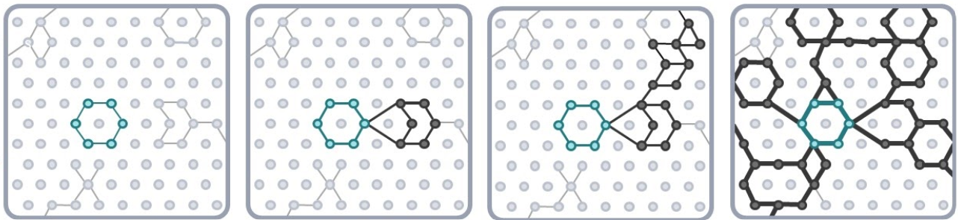
.

An illustration of how knowledge and understanding builds across a unit and over time through our units of work

A journey through the UKS2 unit ‘Who are the Windrush Generation and what is their legacy?’
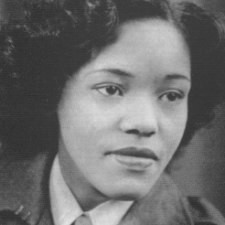

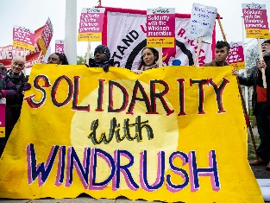
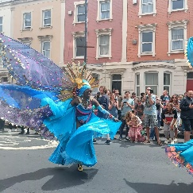
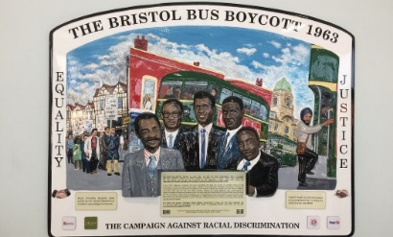
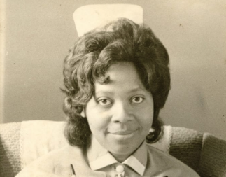
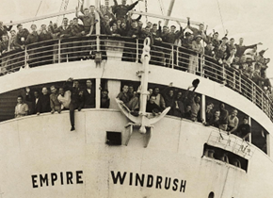

Applying the LSP pedagogy to history
At LSP our pedagogical approach is based on Barak Rosenshine’s Principles of Instruction. All lessons in the history curriculum are designed to be taught using this approach because when skilfully applied this will ensure that every pupil receives high quality, evidence informed teaching in every lesson, every day.

Our core pedagogical approach includes but is not limited to:

- A rigorous and sequential approach to the curriculum with a long-term approach to learning over time.
- All staff demonstrating through actions a culture of belief that everyone can achieve, succeed and master the taught programme of study.
- Teaching and learning which draws on cognitive learning theory and is demonstrated through action.
- An explicit instruction approach to teaching and learning which is implemented consistently and reflectively by all members of staff to enable mastery of the taught programme of study
- Use of ‘ I do, we do, you do’. This will ensure that children are clear what they need to do; have been shown how to do it; have appropriate scaffolds when needed and receive effective feedback to keep on track.
- Carefully planned adaptations to teaching and learning for those who need this.
- Regular, reflective, purposeful use of assessment for learning to ensure that teaching is effective so that children are successful.
- Active engagement and participation of all pupil throughout the learning journey.
- A collective approach to ensuring that children ‘keep-up’ with their learning as a result of well-planned and strategically implemented high-quality instruction.
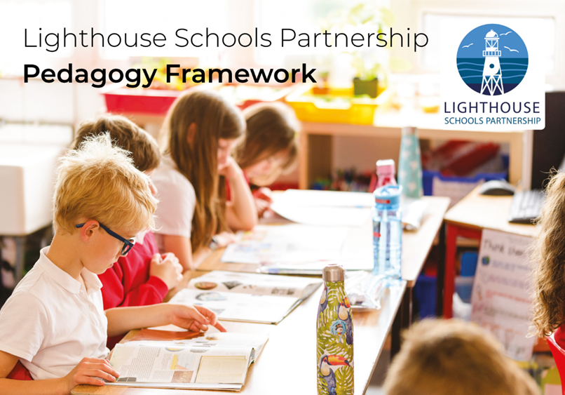
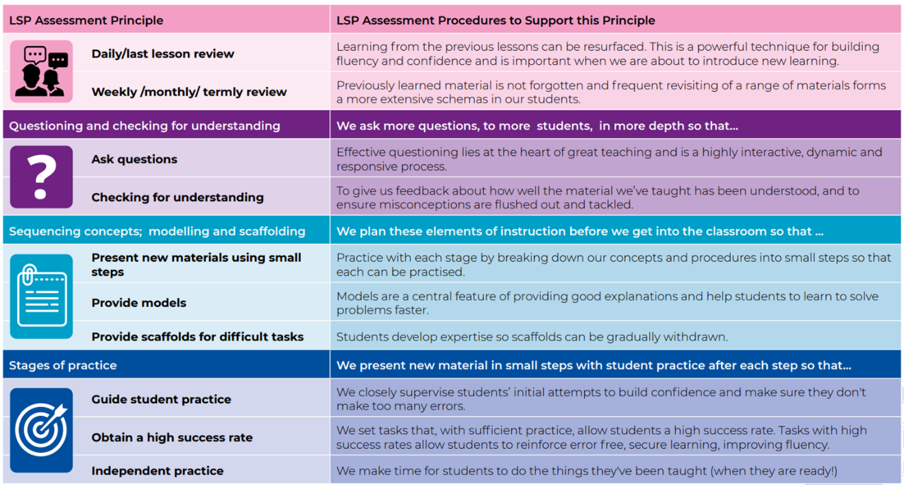

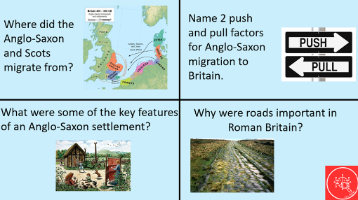
Retrieval practice
In LSP history lessons every lesson begins with a 5-10 minutes (including feedback) ‘Do Now’ activity. This is a retrieval practice starter based on the current and previous units of work. The principle of this is based on practicing what we did yesterday, earlier this week, last week and in the last unit.
Pupils complete these activities on whiteboards before moving on to the main session.
Knowledge organisers
Every unit of work has a pupil knowledge organiser, this is one of the resources which teachers use deliberately with pupils as part of the approach to practice and retrieval. It is recommended that the knowledge organiser is stuck into the history book at the beginning of a unit. These demarcates the beginning of the unit and means it is an accessible document for pupils during the unit. Knowledge organisers contain key information that children should have learnt by the end of a learning sequence, and contain key images; therefore, they act as a tool in supporting pupils to retain and retrieve knowledge and build a secure schema. They are designed to be quizzable (to build connections across knowledge rather than facts in isolation) and should be used with pupils during the unit particularly as part of ‘Do Now’s’ and during assessments at the end of the unit.
Assessment within History
Assessment should check that curriculum content is learnt and committed to long-term memory. Pupils should be able to demonstrate that they know more, remember more and are able to do more as a result of the explicit teaching they have encountered. Teachers should use formative and summative assessment to build an understanding of pupil’s prior knowledge and performance to help draw out common misconceptions or gaps which can be addressed in future curriculum planning and delivery.
When assessment and feedback is sharply focused on the curriculum, and used as a tool of good pedagogy, teachers can maximise its value to improve the responsiveness of their teaching. This is important because we need to capture information on pupil achievement of the range of historical knowledge and skills that pupils will have been taught and have learnt within the context and concept being studied.

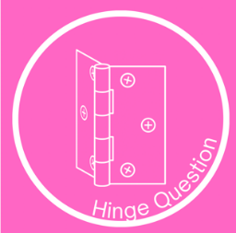


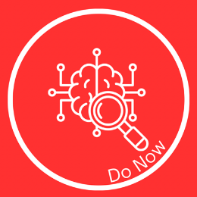

Regular formative assessment
Throughout units it is essential that teachers regularly check for understanding using a range of strategies. This enables teachers to identify gaps in pupils knowledge and understanding so they can respond in an appropriate way to secure achievement of core concepts, knowledge and skills. Lessons across units have been intentionally designed so that:
- pupils engage in regular low stakes testing of knowledge and deliberate practise of skills taught to date. This takes place at the beginning of each lesson through ‘do now’ tasks. These tasks have been crafted so that pupils retrieve knowledge from previous lessons and units; as a result, knowledge is more likely to embed in pupils long-term memory.
- teachers use a variety of ways to make sure that pupils are keeping up with the learning through opportunities for cold calling, think, pair, share, hinge questions and white board work etc. Teachers use the information gained to make in the moment decisions about next steps so that learning sequences can be adapted appropriately.
- pupils engage in ‘exit tickets’ based on knowledge gained during the session. This is another way to engage in low stakes quizzes or to make links in learning within and across sessions.
At the end of each session teachers review learning including outcomes produced by individuals, groups and the class as a whole and use this information to inform future sessions to ensure that pupils stay ‘on track’ throughout the unit.
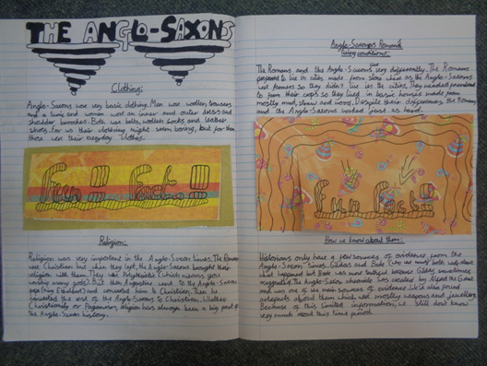
Summative assessment
Summative assessment in history allows teachers to identify whether curriculum goals have been achieved. When a unit of learning is completed, teachers collect and connect the information and evidence gained from: outcomes produced in sessions over time; active engagement and demonstration of understanding in lessons to assess whether pupils have achieved the defined knowledge and skills within the concept for the taught unit.
In history, pupils also work to produce a final outcome which allows them to demonstrate to what extent they have achieved the specified knowledge and skills set out in the medium term plan for the unit.
Information gained from these sources is used by the teacher to record using the assessment tracking grids pupils who are working at or above the age related expectations.
Adapting the curriculum for pupils with SEND in history

We believe that all pupils should be able to access a full curriculum offer. Teachers make adaptions for pupils with SEND based on knowledge of the pupils needs and in line with individual target plans. Examples of adaptions which may be taken include but are not limited to:

- Adaptive teaching takes place.
- For sensory or physically impaired pupils, history learning may necessitate enlarging texts, using clear fonts, using visual overlays, or audio description of images.
- Dyslexic pupils may benefit from well-spaced print.
- Teachers identify and break down the components of the subject curriculum into manageable chunks for pupils who find learning more difficult, particularly those with cognition and learning needs. These may be smaller ‘steps’ than those taken by other pupils to avoid overloading the working memory.
- A variety of additional scaffolds may be used in lessons, such vocabulary banks, additional visual stimuli or adult support.

