Federation of Yatton Schools Pupil Premium Policy and Guidelines

Document Information
Reviewed by: | PQA | Responsibility: | PQA
Last Review: | February 2026 | Next Review: | February 2028
Review Cycle: | Annually | Ratified by FGB | Not required
Signature (FGB) | Not required | Signature (Head) | Not required

1. Aims
This policy aims to:
- Provide background information about the pupil premium grant so that all members of the school community understand its purpose and which pupils are eligible
- Set out how Yatton schools will make decisions on pupil premium spending
- Summarise the roles and responsibilities of those involved in managing the pupil premium in schools.

2. Legislation and guidance

This policy is based on the pupil premium guidance (Dec. 2025)
https://www.gov.uk/government/publications/pupil-premium

within this we have used the following documents:

Pupil premium: overview

Using pupil premium: guidance for school leaders

3. Purpose of the grant
The pupil premium grant is additional funding allocated to publicly funded schools to raise the attainment of disadvantaged pupils and support pupils with parents in the armed forces.
The school will use the grant to support these groups, which comprise pupils with a range of different abilities, to narrow any achievement gaps between them and their peers.
We also recognise that not all pupils eligible for pupil premium funding will have lower attainment than their peers. In such cases, the grant will be used to help improve pupils’ progress and attainment so that they can reach their full potential.

4. Use of the grant

Use of the Pupil Premium Grant follow guidance from the DFE: https://assets.publishing.service.gov.uk/media/68e661e3dadf7616351e4f5b/Using_pupil_premium_guidance.pdf
The tiered approach aligns with the DfE's template for creating a Pupil Premium strategy as well as its ‘menu of approaches’ from the Education Endowment Fund.
EEF guide: https://educationendowmentfoundation.org.uk/using-pupil-premium

Our provision matches the tiered approach of high quality teaching, targeted academic support and eider barriers to learning.

EEF: A tiered approach to spending

Schools should use their Pupil Premium to address challenges their disadvantaged pupils face as identified in Step 1. Activities to develop high quality teaching, targeted academic support and wider strategies should guide your exploration of the evidence.
High quality teaching should be a top priority for Pupil Premium spending. Making sure an effective teacher is in front of every class, and that every teacher is supported to keep improving, is key.
Targeted academic support can have a strong positive impact on learning, and is an important part of any Pupil Premium strategy.
Wider barriers to learning are important to consider as part of your Pupil Premium strategy. While many challenges may be common between schools, the specific features of the community your school serves will affect which approaches you prioritise in this category.

The additional support and wider strategies costed carefully for each school, for example: Yatton Infant School

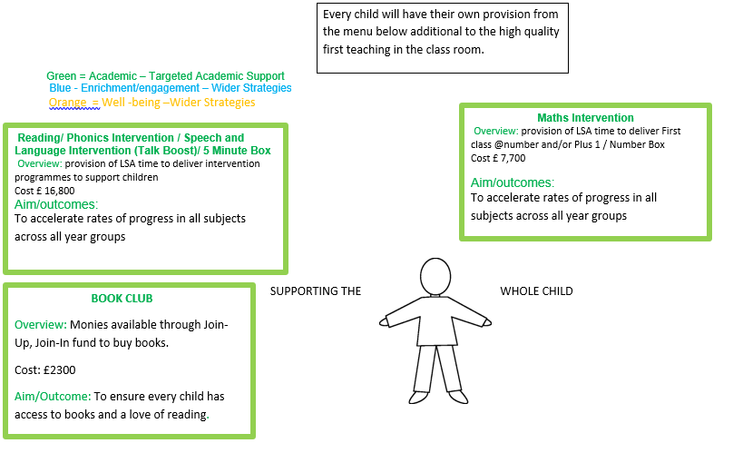

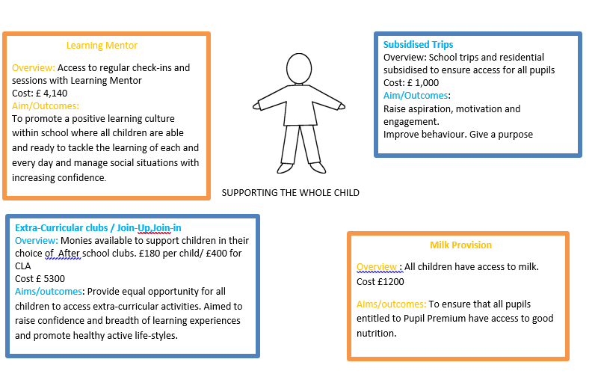

Our priorities are:
Our intention is that all pupils, irrespective of their background or the challenges they face, make good progress and achieve high attainment across all subject areas. The focus of our pupil premium strategy is to support disadvantaged pupils to achieve that goal, including progress for those who are already high attainers.
High-quality teaching is at the heart of our approach, with a focus on areas in which disadvantaged pupils require the most support. This is proven to have the greatest impact on closing the disadvantage attainment gap and at the same time will benefit the non-disadvantaged pupils in our school. Implicit in the intended outcomes detailed below, is the intention that non-disadvantaged pupils’ attainment will be sustained and improved alongside progress for their disadvantaged peers.
Our approach will be responsive to common challenges and individual needs, rooted in robust diagnostic assessment, not assumptions about the impact of disadvantage. The approaches we have adopted complement each other to help pupils excel. To ensure they are effective we will:
- ensure disadvantaged pupils are challenged in the work that they’re set
- act early to intervene at the point need is identified
- adopt a whole school approach in which all staff take responsibility for disadvantaged pupils’ outcomes and raise expectations of what they can achieve.

The governors also recognise that not all pupils who are socially disadvantaged are registered or qualify for FSM. The governors reserve the right to allocate the pupil premium to support any pupil or groups of pupils the school has legitimately recognised as being socially disadvantaged.

We will publish information on the school’s use of the pupil premium on the school website in line with the requirements set out in our funding agreement and the DfE’s guidance on what academies should publish online, using the templates on GOV.UK.
Information on how the school uses the pupil premium is available here: https://www.yattonschools.co.uk/page/?title=Pupil+Premium&pid=127 (Infants) and https://www.yattonschools.co.uk/page/?title=Pupil+Premium&pid=156 (Juniors).

5. Eligible pupils
The pupil premium is allocated to the school based on the number of eligible pupils in Reception to Year 2 in the Infant School and Year 3 to Year 6 in the Junior School.
Eligible pupils fall into the categories explained below.

5.1 Ever 6 free school meals
Pupils recorded in the most recent October school census who are known to have been eligible for free school meals at any point in the last 6 years (as determined by the DfE’s latest conditions of grant guidance).
This includes pupils first known to be eligible for free school meals in the most recent October census.
It does not include pupils who received universal infant free school meals but would not have otherwise received free lunches.
This includes pupils first known to be eligible for free school meals in the most recent January census.
It does not include pupils who received universal infant free school meals but would not have otherwise received free lunches

5.2 Looked after children
Pupils who are in the care of, or provided with accommodation by, a local authority in England or Wales for at least 1 day. Allocations will be provisionally based on the children looked-after data return in March of the previous year, and then confirmed in December of the current year based on the children looked-after data return in March of the current year.
5.3 Post-looked after children
Pupils recorded in the most recent October census who were looked after by an English or Welsh local authority immediately before being adopted, or who left local authority care on a special guardianship order or child arrangements order.
5.4 Ever 6 service children
Pupils recorded in the most recent October census:
- With a parent serving in the regular armed forces
- Who have been registered as a ‘service child’ in the school census at any point in the last 6 years (as determined by the DfE’s latest conditions of grant guidance), including those first recorded as such in the most recent October census
- In receipt of a child pension from the Ministry of Defence because one of their parents died while serving in the armed forces

6. Roles and responsibilities
6.1 Head teacher and senior leadership team
The head teacher and senior leadership team are responsible for:
- Keeping this policy up to date, and ensuring that it is implemented across the school
- Ensuring that all school staff are aware of their role in raising the attainment of disadvantaged pupils and supporting pupils with parents in the armed forces
- Planning pupil premium spending and keeping this under constant review, using an evidence-based approach and working with virtual school heads where appropriate
- Monitoring the attainment and progress of pupils eligible for the pupil premium to assess the impact of the school’s use of the funding
- Reporting on the impact of pupil premium spending to the governing board on an ongoing basis
- Publishing information on the school’s use of the pupil premium on the school website, as required by our funding agreement and in line with guidance from the DfE
- Providing relevant training for staff, as necessary, on supporting disadvantaged pupils and raising attainment

6.2 Governors
The governing board is responsible for:
- Holding the head teacher to account for the implementation of this policy
- Ensuring the school is using pupil premium funding appropriately, in line with the rules set out in the conditions of grant
- Monitoring the attainment and progress of pupils eligible for the pupil premium, in conjunction with the head teacher, to assess the impact and effectiveness of the school’s use of the funding
- Monitoring whether the school is ensuring value for money in its use of the pupil premium
- Challenging the head teacher to use the pupil premium in the most effective way
- Setting the school’s ethos and values around supporting disadvantaged members of the school community
6.3 Other school staff
All school staff are responsible for:
- Implementing this policy on a day-to-day basis
- Setting high expectations for all pupils, including those eligible for the pupil premium
- Identifying pupils whose attainment is not improving in response to interventions funded by the pupil premium, and highlighting these individuals to the senior leadership team
- Sharing insights into effective practice with other school staff
6.4 Virtual school heads
Virtual school heads are responsible for managing pupil premium funding for children looked after by a local authority, and allocating it to schools. Their responsibilities include, but are not limited to:
- Identifying the eligible looked after children and informing the local authority
- Making sure methods for allocating and spending ensure that looked after children benefit without delay
- Working with each looked after child’s educational setting to put together a personal education plan (PEP), agree how pupil premium funding will be spent to the meet the need identified in this plan, and ensure the funding is spent in this way
- Demonstrating how pupil premium funding is raising the achievement of looked after children
Virtual school heads are in charge of promoting the educational achievement of all the children looked after by the local authority they work for.

7. Monitoring arrangements
This policy will be reviewed bi -annually by the Head teacher and Pupil Quality Assurance Committee. At every review, the policy will be shared with the governing board.

