Text and Author: | 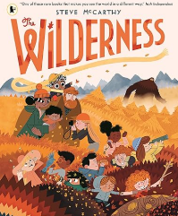  Steve McArthy | Year Group: | Year 3 | Term: | Spring 1
Text and Author: |  | Final Outcome: | Adventure Narrative

 | Key Learning | Spring Term
Vocabulary, Grammar and Punctuation | - Identify clauses in sentences.  - Explore and identify main and subordinate clauses in complex sentences.  - Use the comma to separate clauses in complex sentences where the subordinate clause appears first, e.g. Although it was raining, we decided not to take our coats. | - Explore and identify main (independent) and subordinate clauses in complex sentences where the subordinate clause is used in different positions.  - Explore, identify and create complex sentences using a wider variety of conjunctions e.g. before, after, since.  - With support, recognize where to use the comma to separate clauses in complex sentences where the subordinate clause appears first, e.g. Before he started making films, Walt Disney worked as an artist. After the bird had sprinkled the crumbs, a  magnificent forest sprang up.
Vocabulary, Grammar and Punctuation | - Use inverted commas to punctuate  direct speech (speech marks). | - Identify speech within a passage of text, e.g. highlight the words spoken by a character and the inverted commas (speech marks).  - Use inverted commas to punctuate some direct speech (speech marks)
Vocabulary, Grammar and Punctuation | - Identify, select and effectively use pronouns. | - Identify, select and effectively use pronouns e.g. second person in persuasion (you, your, yours).
Composition: Drafting and Writing | - Discuss and record ideas for planning using a range of formats, e.g. chunking a plot, story maps, flow charts, boxing up. | - Discuss and record ideas for planning,  e.g. for poetry, generating and refining vocabulary, experimenting with word combinations, rhyme, rhythm,  alliteration, syllable count etc.
Composition: Drafting and Writing | - Create and develop settings for narrative. | - Create and develop settings for narrative e.g. precise nouns, adjectives, noun phrases, details relating to the five senses
Composition: Evaluating and Editing | - Proofread to check for errors in spelling, grammar and punctuation in own and others’ writing. | - Proofread to check for errors in spelling, grammar and punctuation in own and others’ writing.

Lesson Objective: | Retrieval/ Introduction | Direct Instruction | Application/ Practice |  | Review/ Assessment
Immersion to introduce the text (could be as part of story time rather than English Lesson- use ideas on slides if you wish) | Mystery Box (filled with natural items: leaves, twigs, pinecones)  - Show the mystery box and ask:  “What do you think is inside? Where do these things come from?”  - Reveal the items and connect them to the idea of the wilderness  Ask the class if they have ever been on an adventure or gone camping in the wilderness. What would they need to survive in the wild? Discuss how nature can be both exciting and scary. On the board, draw two columns: exciting/scary  “What things about the outdoors might feel scary or dangerous? What things might feel exciting and beautiful?” Discuss how the same thing can feel both scary and exciting.  Show the cover of The Wilderness.  Ask: Which character looks worried? Why might he feel worried? What do you notice about him? What do you predict the story will be about? How do you think he feels about the Wilderness? What problems might he face? Do you predict this story will be scary, funny, adventurous, or something else? Why?  Read the story aloud, pausing to ask:  “How do you think Oktober feels now? What changed?” Encourage students to share personal experiences of trying something new.  Based on the title and the cover, what do you think this story is about? Who is the main character?  Read aloud The Wilderness.  As you read, pause and ask questions:  - What do you think will happen next?  - How do you think the character feels right now?  - What would you do if you were in the character’s shoes?
Lesson 1  LO: Identify, select and effectively use third person pronouns | Read p1 of the book : what can we tell about Oktober from this page?  Turn to next pages and read up to ‘Wilderness that Lurks’.  What do we think Oktober is thinking about? What is ‘The Wilderness that lurks? |   Look at the page of the children asleep. What do children notice about their names?  What word class is a name? Noun  Show the piece of writing, drawing on evidence from the text which describes January. Pick out that the repeated use of the proper noun- read aloud to children to make it clear the impact it has on the reader- boring and repetitive. Ask children to discuss in pairs what they might to do fix it.    Model rewriting the sentences with a mix of nouns and pronouns. Model thinking aloud how we could vary these and how the name is important to keep in certain places e.g. We want to use the proper noun January first so that our reader knows who we are talking about! January is an avid photographer. January Maybe I could use the pronoun ‘she’ to avoid repetition She can always be found with a camera in January’s hand. What pronoun can I use to show the camera belongs to her? She can always be found with a camera in her hand. Model re-reading to check for sense and variety.    Show description of February, all with proper nouns. Children to re-write on whiteboards with learning partners. Share responses and CFU before pupils start independent task (children not yet secure will need additional scaffold eg. Guided group).    Add more detail with ambitious adjectives. |   Give pupils pictures of March and April from slides so that they can use these for their descriptions.  Children rewrite the description of March independently, appropriately changing the proper nouns so the text is now a mix of nouns and pronouns.  Now write a new description of April drawing on evidence from the text and using an appropriate mix of nouns and pronouns.  Add some more detail and some ambitious adjectives. |  |   Sort the nouns and pronouns.
Lesson 2  LO: Use a wider variety of subordinating conjunctions |   Pupils to recap yesterday’s learning on pronouns- editing to avoid repetition. Share answers as class. | Remind pupils that they already know how to write complex sentences and know how to recognise subordinate clauses. Remind pupils of key information about complex sentences- main (or independent) clauses make sense alone whereas a subordinate clause doesn’t.  Remind pupils that they can spot a subordinate clause by looking for the subordinating conjunction at the start. Share both sentences, reminding pupils that subordinate clauses can be in different positions in sentences (expectation is not yet that they know how to punctuate fronted subordination but we will start to look at that in this unit. Pupils may want to use fronted subordination in this lesson when writing their sentences but don’t yet need to worry about commas).  Because she loved plants, February kept one by her bed.  February kept plants by her bed because she loved them.  Explain that we know quite a few sub conjunctions already and we are going to look at using two more today- until and while. These give more detail in sentences about when something was happening.  Share examples and model identifying the  While the others slept, Oktober hid under his covers to read his book.  Pupils identify subordinate clause. Check for understanding- are pupils recognizing sub conjunction and the entire clause?  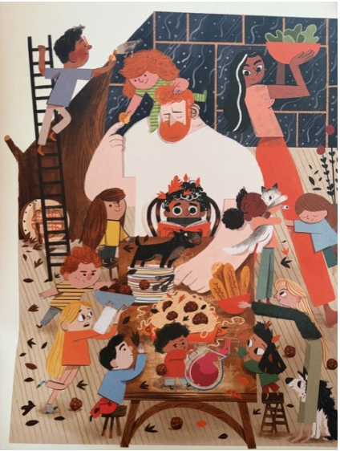    Model using one of the subordinating conjunctions we are looking at today to extend the main clause-  The children caused chaos while Mum prepared the dinner. | Children write their own complex sentences using until and while extending the main clauses on the slide- Oktober read his book. March stood precariously on the ladder. E.g. March stood precariously on the ladder while he fed the bird.  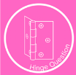Ask pupils to underline their subordinate clause and show their boards. CFU- which pupils need support writing their own complex sentences for today’s task.  Pupils to write complex sentences about the picture.  Use a variety of subordinating conjunctions. |  |   Pupils to share their best complex sentence. Teacher to select and discuss most effective examples and share any common misconceptions and unpick.
Lesson 3  LO: Use a wider variety of subordinating conjunctions in a setting description |   Do now retrieval- Chn to identify main and subordinate clause in sentence. CFU. Star challenge- to write own complex sentence about the picture. | Explain that we will be writing a short setting description today where we can apply our knowledge of pronouns and subordination. Pupils to discuss what they can spot in the picture.  Take ideas and generate noun word bank on flipchart. Explain that we want to expand these. Pupils to use the nouns to generate expanded noun phrases on whiteboards. Use word mat on tables or display to support. Encourage pupils to think about senses to add extra detail.  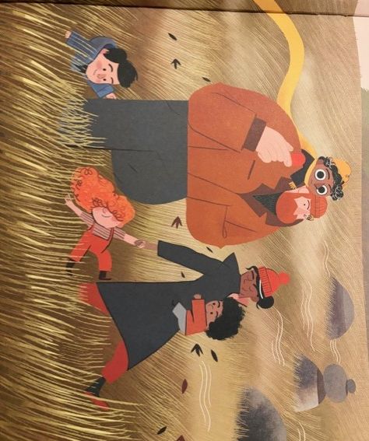  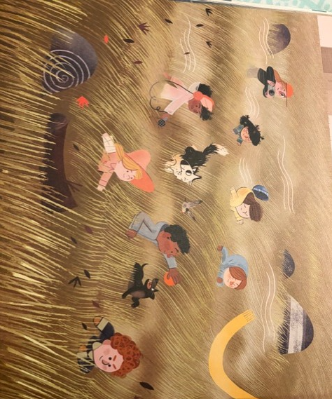  e.g. excited children, howling wind, tall grass, towering rocks, singing birds  Model improving the sentence with some of the expanded noun phrase ideas and extending the sentence using a subordinate clause. E.g.  I want to describe the grass and I want to think about what was happening at the same time using the subordination while Maybe I could describe the wind and use my senses. The untamed grass swayed from side to side while the wild wind howled. | Pupils improve the sentence using an expanded noun phrase and extend it using subordination. Cold call good examples and record these on flipchart if time. CFU- are pupils using subordination correctly? Explain that pupils can keep these ideas on their boards to use them when they come to write.    Children use the setting description on the slide as a starting point for their own description. Think about adding expanded noun phrases and a wider range of sentence types, practising using subordination in context. You may wish to provide pupils with an order of which to describe the setting to support them to structure their writing if needed.  Pupils to use a variety of subordinating conjunctions and ensure variety of sentence types including compound a simple. |  | Pupils to share examples of complex sentences used. Teacher to listen in to key pupils and share best examples. Use as an opportunity to unpick any misconceptions on how to use these in complex sentences.
Lesson 4  LO: To correctly punctuate subordinate clauses (fronted)  Strips of paper to model cutting and swapping clauses | Retrieval- pupils to rewrite the sentences as a complex (multi-clause) sentence using the given subordinating conjunctions. CFU and support pupils who need more help with this based on yesterday’s lesson. | Pupils to extend the simple sentence with a subordinate clause. Spot whether any pupils have used fronted subordination- some may try this without prompting. CFU again.  Oktober peered out of the window.  Share an example of the complex sentence based on the whiteboard work. Oktober peered out of the window while his family got ready for their adventure.  Explain that subordinate clauses can come at the beginning, in the middle or at the end of a sentence. We are going to look at using them today at the start of a sentence and we are going to focus on punctuating them accurately.  Explain that when the subordinate clause comes before the main clause, we need to use a comma to separate the two parts.  If the main clause comes before the subordinate clause, no comma is needed.  Model identifying the subordinate clause, moving the clause to the start and adding the clause after. You may wish to have the sentence written on a strip of paper, cutting the two clauses to separate them and physically moving them to illustrate the point. (If your class would benefit from physically moving the clauses, you may wish to get them to do this for their ‘we do’ activity).  While the family got ready for their adventure, Oktober peered out of the window.  Pupils to follow the steps to support them to swap the clauses. Ensure pupils are checking for CL at the start and comma following fronted subordination.  Pupils may need more examples or they may be ready to move onto some dictation.  Dictation  Teacher to read sentences aloud, pupils to transcribe and check for correct punctuation of fronted subordination. Encourage pupils to follow same steps- identifying subordinating conjunction and then the subordinate clause to follow it with a comma. Then check for the main clause following the comma- this should make sense as a sentence alone. | 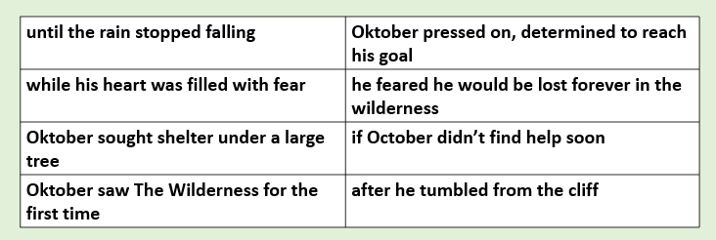  Compose complex sentences with subordinate clause first separated by a comma, using table to support.  You may wish to use this table to support further dictation sentences for pupils who need it.  Pupils to re-write sentences to add more detail, choosing interesting vocabulary to have impact on reader. |  | Show examples of complex sentences- children vote for which is correctly punctuated. Pupils to explain mistake.
Lesson 5  To write a cohesive character description  (Building cohesion with subordination and pronouns) |   Show pupils complex sentences with incorrect/ incomplete punctuation. Rewrite the sentences with the correct punctuation. | 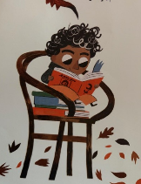  Using their knowledge of the story, pupils to discuss what Oktober is like. Cold call and share ideas.  Explain that we are going to write a short character description of him today to tell our reader all about him. We are going to practise using expanded noun phrases, pronouns and subordination again and show off all of our amazing learning so far this week.    Share WAGOLL and spot helpful expanded noun phrases and spot where subordination is used. Cold call pupils to share these ideas and record on flipchart if helpful.  Explain that we want to avoid repetition of Oktober’s name as we talked about earlier in the week. 2 minutes- generate pronouns for Oktober- the boy, the young child, he etc. Keep on flipchart to refer back to during writing.  Whole class role on the wall-5 minutes record adjectives/ expanded noun phrases to describe Oktober’s appearance around the outside and personality on the inside.    I want to begin with a sentence including expanded noun phrases to describe his appearance. E.g. Oktober is a young boy with dark eyes and tousled, curly hair. I’ll re-read it to check it’s accurate. I’ve used a comma to separate my 2 adjectives to describe his hair.  Children to write their own introductory sentence using expanded noun phrases to describe his appearance. | Dictation 2nd sentence  While his family love adventures, Oktober would rather stay inside and read his favourite books. (CFU- is fronted subordination correctly punctuated?)  Children to write the rest of the character description using the pronouns and role on the wall ideas to support. Use prompts on the board to support them to think about the order they can write in.  Use a variety of subordinating conjunctions and sentence types. |  | Read description aloud to a partner/ table. Teacher listen in. Encourage pupils to think about the image this builds in their head. Teacher to share excellent examples of well chosen expanded noun phrases to highlight how well this has been applied.
Lesson 6  LO: Identify and begin to punctuate direct speech | Give pupils time to respond to feedback on yesterday’s writing. Work with specific pupils needing extra support with last week’s learning. | What parts of the text are speech?  How do we know? Prompt pupils to recognize that the spoken words are indicated with inverted commas.  Task 1  Teacher underline speech and model writing speech into a speech bubble to demonstrate how the inverted commas surround the direct speech. “Let’s find out what’s out there,” said Mum.  Children write speech for mum and August into speech bubbles. Use this as a tool to support pupils to recognize just the words being spoken. They don’t need to use the inverted commas in the speech bubble- just take the words being spoken.  Task 2  Model reading the sentence aloud. Ask pupils to discuss which words they think are direct speech. Practise reading aloud a few times then cold call. Model underlining the direct speech and model rewriting the sentence with the 66 and 99 of inverted commas. Practise re-reading the punctuated sentence to check for sense.  Read the sentence aloud together and think about which words are being spoken.  It’s OK to be scared said Dad.  Pupils to read the sentence aloud, copy and underline the words being spoken to help them identify where they need to put inverted commas. CFU. | Task 1  Task 2  N.B. Pupils don’t yet need to know how to use the end punctuation within the inverted commas- they just need to identify the words being spoken and be able to add inverted commas. The sentences given include the end punctuation.  Star challenge- to write a sentence of their own with a character speaking based on the picture from the story. |  | Mark and check children’s work. Make a note of pupils who have not secured today’s learning to ensure they receive additional scaffolds tomorrow or post teaching.
Lesson 7  LO: Identify and use inverted commas to punctuate direct speech  (NB Another lesson may be needed on speech punctuation after this based on assessment) | Pupils to tell partners everything they know about punctuating speech using the expert vocabulary and sentence on board. Encourage use of expert vocab direct speech and reporting clause. | Recap of yesterday’s learning on inverted commas- Inverted commas are punctuation marks that are used in writing to show where speech begins and ends. Use sentence example again to reiterate expert vocabulary.  Explain that today we are going to start writing sentences containing direct speech. We will use speech bubbles to help us with the ideas and we will need to use reporting clauses to show our reader who said it.  Model converting the speech bubble and name into a sentence containing direct speech with a reporting clause. “Whooft!” said Mum. Make explicit how to form inverted commas- drawing pupils’ attention to 66 and 99 shape.  “I can see treasures all the way home!” August said. Pupils may begin to use a wider variety of verbs for the reporting clauses. CFU to see who needs more support.  Another example to demonstrate how to punctuate direct speech accurately. “The Wilderness isn’t a monster,” said Mum. N.B Pupils don’t yet need to know how to use end punctuation but the speech bubbles contain punctuation. You may wish to draw pupils’ attention to this when modelling but explain we just want to get the inverted commas correct to begin with.  Pupils have another example- CFU. “I can take you there,” The Wilderness said. | Task 1  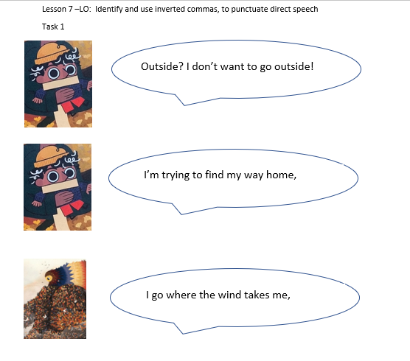  Mark together-CFU  Task 2  Dictation sentences  "Do you think we’ll find the perfect campsite here?" Oktober asked his dad.  “Look at that, Oktober!” his sister shouted excitedly.  Tick or fix- CFU  Task 3- Transcribing sentences from task sheet and correctly punctuating  Task 4 on sheet- correcting mistakes |  | Tick/ fix tasks
Lesson 8  LO: Discuss and record ideas for planning  (N.B you may wish to split this across two lessons depending on how much support pupils need) | Retrieval- pupils to punctuate direct speech within sentences on the board. |   Show pupils BBC bitesize video and discuss how The Wilderness fits the ‘typical’ story mountain structure. Ask pupils to discuss each part of The Wilderness and how each part fits into the structure. Cold call and discuss before showing the structure on next slide.  Share WAGOLL to show pupils what we are aiming for. Explain that we are going to be writing and publishing our stories to share with another year group in school. You may wish to chunk the WAGOLL and read appropriate parts to support each part of the planning process.  Show images from these pages and model talking your story then creating story plan using them.  Pupils create own narrative plan. First discussing with talk partner and then crating written version.  Scaffolding: group plan | Support pupils to plan their narrative, working through the paragraphs on the plan. Model filling in the plan or parts of the plan where pupils will need more support before they add to their plans. Work with guided group who will need more support to add to their plans.  The majority of the narrative will be very similar to the story and pupils can draw upon their ideas and writing from the sequence so far- character description and setting description for the opening and build up. For the resolution, pupils can be creative about what Oktober and The Wilderness encounter- use the pages from the book to show them the different creatures and plants. |  | Teacher model re-reading the plan (should have a plan from guided group work) Pupils to then re-read their plans, checking against SC and ensuring they have included all of the key SPAG from the narrative planner.
Lesson 9  (This lesson might be split across two lessons)  To write a narrative including dialogue  (Focus on opening and build up) | Pupils to read their plans aloud to their partners to support their internalization of the story structure. Encourage pupils to focus on their opening and build up as this is what we will write today. | Pupils to spot the mistakes in the paragraph on the board-they will need to focus on pronouns and accurate speech punctuation. Use as CFU opportunity/ support pupils to work on whiteboards with specific skills.  Read WAGOLL of opening and build up and pupils can add any ideas to help them onto their story planning sheet before we write today.  Model writing an opening sentence for the story. Explain that we want to introduce Oktober as a character maybe with some description of his appearance and personality.  Pupils to write their own introductory sentence and another sentence- CFU. Pupils to keep these on boards as they will have been checked/ had feedback and take them to tables to support. |  | Pupils to write their opening paragraph and independently proof read/ check against SC once they have finished writing.  Follow the I do/ We do cycle again for the build up paragraph with a sentence to introduce the setting. Refer back to teacher’s plan and flipchart work from lesson 3 to support. Focus on modelling a specific SPAG element the class needs and make clear how we can link this paragraph to the previous one. | Teacher model reading aloud opening paragraph (this could be a child’s example if appropriate to do so or the paragraph written during guided group shared writing) and then model how to check this against success criteria. What would pupils do if they have not included something? Model adding an extra sentence including a specific SPAG element if needed according to teacher assessment. Children assess against SC.
Lesson 10  To write a narrative including dialogue  (Focus on problem and resolution) | Opportunity for mini edit according to feedback. Pupils to tell their partner what they have changed and improved and share improvements with the class. | Share problem and resolution from the WAGOLL to remind pupils what we are aiming for.  Pupils to read through their planning sheet focusing on their problem and resolution sections, adding any extra detail they would like to include, particularly focusing on their resolution paragraph where they see the beautiful wildlife and plants.  Model writing an opening sentence for the problem section. Explain that we want to make sure we use a complex sentence to show something happening at the same time as something else as we’ve been focusing on. E.g. While he gazed at the beautiful butterflies, Oktober did not notice he was wandering away from his family.  Pupils to write their own introductory sentence and another sentence- CFU. Pupils to keep these on boards as they will have been checked/ had feedback and take to tables to support. |  | Pupils to write their problem paragraph and independently proof read/ check against SC once they have finished writing.  Follow the I do/ We do cycle again for the resolution paragraph with a sentence to introduce the setting. Refer back to teacher’s plan to support and to ensure pupils remember to use their planning sheet which contains their well planned ideas. | Teacher to share excellent examples from pupils’ writing (focus on examples using complex sentences or another key element that the class needs to focus on if needed) and allow time for pupils to add to writing if needed.
Lesson 11  To write a narrative including dialogue  (Focus on ending) | Pupils to re-read yesterday’s writing and respond to feedback. Teacher to focus on specific pupils/ group pupils to edit and improve. | Share example ending paragraph with deliberate mistakes in speech punctuation. Ask pupils to spot the errors.  Pupils to discuss their plans for their final paragraph today to ensure they are clear on the key content.  Model writing the first two sentences to introduce the ending. E.g.  I am going to use fronted subordination to explain what happened when The Wilderness led Oktober through a clearing.  When The Wilderness led Oktober to a familiar clearing, he spotted his family outside his home. I’ll just re-read it now to check I’ve punctuated my subordination correctly.  Now I can use my dialogue from my plan…  “Oktober!” March cried, racing towards him. |  | Pupils to orally compose their first two sentences where Oktober spots his family and what they say to him. Children to write on whiteboards- CFU- looking for accurate speech punctuation and subordination.  Once finished, pupils to re-read their whole narratives aloud to themselves. Swap with a partner- partners to read narratives aloud to each other so that they can hear their own writing back. Does it make sense? Have they forgotten any basic punctuation? Are there are spelling errors?  Pupils to self check and work with partners to check against success steps. | Pupils to identify mistakes in speech punctuation- listen in to key pupils and build in time to correct speech punctuation as needed.
Lesson 12  To edit and improve my own writing | Pupils to be clear on what their next steps are from the feedback they’ve received. Ensure they can explain what they need to do to make their writing even better. Cold call/ listen in to partner talk. | Follow ideas on slides to support pupils to see how to follow the edit and improve process according to success steps.  Share example paragraph with deliberate mistakes- can pupils use success steps to help spot next steps and help this person to improve?  According to feedback and whole class assessment, build in key focus for editing and identify any key spellings that need to be edited for. |  | Work with pupils to edit and improve writing, providing prompts and scaffolds where necessary. | Pupils to share key improvements they have made with their partner and with the class.
Final Lesson (optional)  Lesson 13  LO: to publish writing demonstrating handwriting objectives for this term (add in detail) | Recap handwriting objectives covered this / last term. | Explain that we are going to send our narratives to Steve McCarthy/ for different year groups so we need to ensure the presentation fantastic!  Model publishing part of your writing using objectives from handwriting this term.  You may want to create a SC for this. | Children publish writing.

Possible outcomes
Example setting description-
The children raced through the long, golden grass while the strong wind whipped around them. Leaves spun above their heads and their parents smiled at the children’s joyful laughter. The excited dogs leapt and barked because they wanted to join the fun. In the distance, the grey, smooth rocks lay still although everything else was moving quickly. Even the small birds darted through the swaying grass as the children kept running, their bright clothes flashing in the sunlight.

Example character description

Oktober is a gentle, thoughtful child with wide eyes and tousled hair. This young boy would much rather curl up inside than go on a wild adventure. While his family love exploring forests, rivers and mountains, he prefers to stay indoors where it feels safe and warm. He is a book-lover at heart and he dreams of adventures that take place between the pages of books.
He often feels nervous about the outside world because he imagines the wild is full of slimy tails, sharp teeth, and hidden dangers lurking behind every tree. When he speaks to his siblings about it, they make him feel even more frightened!
When he is separated from his family and lost in the woods, he shows that he is braver than he thought. He tries to stay calm and find his way. Even though he believes he is not brave enough, with the help of The Wilderness he overcomes his fears.

Example narrative- end write
Oktober was a thoughtful boy who lived with his lively family at the edge of a wide, wild forest. He loved listening to stories, but he often felt nervous about going outside. His mother and father were patient and warm-hearted, and his sister, March, encouraged him to explore more. Still, Oktober preferred to stay close to home, where everything felt safe.

When the morning sun lit up the sky, Oktober’s family packed their rucksacks for an exciting day out. They were going on an adventure into the Wilderness. The children raced through the long, golden grass while the strong wind whipped around them. Leaves spun above their heads and their parents smiled at the children’s joyful laughter. The excited dogs leapt and barked because they wanted to join the fun. In the distance, the grey, smooth rocks lay still although everything else was moving quickly.
“Come on Oktober. You never know what amazing things you might find,” said Mother gently.
“I’m not sure about this,” he replied. Before they reached the first clearing, March pointed ahead.
“Look, Oktober! A snake!” March squeaked excitedly. Oktober stared wide eyed at the creature while his sister waved happily.
While the family walked deeper into the forest, birds chirped overhead and leaves rustled beneath their feet. “This place is amazing and you are doing brilliantly!” Father said. Oktober’s steps grew slower. Everything felt so big, and he felt so small.

Oktober caught sight of some colourful butterflies dancing on the breeze. When he looked up, his family were gone.
“Mother? Father?” he called.
Only the wind whispered back. The trees felt taller than ever. The shadows seemed darker. Oktober hugged his arms around himself. He was lost, and he was scared. He stepped backwards and tumbled off a rocky ledge into a pile of autumn leaves while he squealed in terror.

Suddenly, a gentle voice drifted through the trees.
“Do not be afraid, Oktober.”
He spun around. Standing before him was a glowing figure made of leaves, sunlight, and soft wind. It was The Wilderness itself. It smiled at him. It was kind, peaceful, and…alive!
“Who are you?” Oktober whispered.
“I am The Wilderness and I will guide you my friend,” the figure said.
While his heart thumped quickly, Oktober followed as The Wilderness stretched out a shimmering arm. As they walked, the forest changed. Light pooled through the branches. Butterflies danced around him. A family of rabbits hopped across their path. Wildflowers nodded as if saying hello.
“See? Out here, there is beauty everywhere. There is nothing to fear,” The Wilderness said.
Oktober felt his worry melting away. The outside wasn’t frightening at all—it was wonderful.

At last, The Wilderness led him into a bright clearing. His family stood there, calling his name with worried faces.
“Oktober!” March cried, racing towards him.
“You found your way back!” Father exclaimed.
Oktober smiled. “I had help,” he said.
When he turned to thank The Wilderness, the shining figure faded into sunlight, rustling the leaves in a soft goodbye.
From that day on, Oktober wasn’t scared of the outdoors anymore because he knew The Wilderness cared for him.

