Text and Author: | 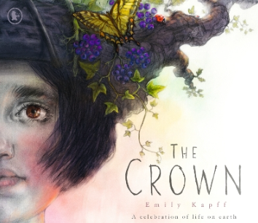The Crown by Emily Kapff | Year Group: | 4 | Term: | Spring 1
Text and Author: |  | Final Outcome: | Narrative

 | Key Learning | Spring Term
 | - Create sentences with fronted adverbials for when e.g. As the clock struck twelve, the soldiers sprang into action.  - Create sentences with fronted adverbials for where e.g. In the distance, a lone wolf howled. Use  commas after fronted adverbials. | - Create sentences with fronted adverbials for where e.g. In the distance, a lone wolf howled. Use a comma after the fronted adverbial.  - Use commas after fronted adverbials
 | - Use inverted commas and other punctuation to indicate direct speech e.g. The tour guide announced, “Be back here at four o’clock.” | - Use inverted commas and other punctuation to indicate direct speech  - Start a new paragraph (line) for a new speaker.
 | - Use nouns for precision, e.g. burglar rather than man, bungalow rather than house.  - Explore, identify, collect and use noun phrases e.g. the crumbly cookie with tasty marshmallow pieces. | - Explore, identify, collect and use noun phrases e.g. the pale-faced boy with hair like straw.
Composition: Planning | - Read and analyse narrative, non-fiction and poetry in order to plan their own versions.  - Identify and discuss the purpose,  audience, structure, vocabulary and grammar of narrative, non-fiction and poetry. | Identify and discuss the purpose and audience of the writing. Discuss the structure, vocabulary and grammar needed, e.g. logically sequenced steps and technical vocabulary.
 | - Use paragraphs to organise writing in fiction and nonfiction texts. | Begin to independently identify when to begin a new paragraph when planning and composing a longer piece of writing
 | - Discuss and propose changes to own and others’ writing with partners/small groups.  - Improve writing in light of evaluation. | - Discuss and propose changes to own and others’ writing with partners/small groups, e.g. more appropriate determiner. Improve writing in light of  evaluation.

Lesson Objective: | Retrieval/ Introduction | Direct Instruction | Application/ Practice | Review/ Assessment
Lesson 1 To engage with a new text | Share message (written on slides, but this would be nice to share as a message delivered to the classroom) from mystery character about their crown.  Pose questions-  Who could this be from?  Why might they have a crown?  What has happened to them?  What has happened to their crown?  Why might their future depend on you? | Teacher model designing a crown with symbolism, explaining why they might choose the different elements. Use template or draw outline and annotate a couple of the elements, explaining aloud why they have used them and their importance/ symbolism.  Pupils to work in pairs to design their own-  Using jewels, natural materials, flowers etc on information sheet- pupils design a crown in pairs, annotating the different elements to be ready to explain why they would include them and what they symbolize. | Teacher to take ideas from pupils after they have orally rehearsed sentences justifying their choices using subordination.  Pupils to write sentences in books to explain why they used different elements, using subordination for reasons. Use stem sentences on the board to support. |   Pupils to summarise and explain the message of the story, referring to the quote at the beginning of the book.
Lesson 2  To use fronted adverbials for where |   What was the message of our new book? What was the significance of the crown? | Explain that we will be writing a setting description based on the Earth as it is today.  Recap the job of fronted adverbials in a sentence- share video if needed. Share fronted adverbials of where - this will be our focus today. Share an example and ensure pupils recognise this is punctuated with a comma.  e.g.  In the warm shallows, the turtle swooped and swam.  Pupils to generate nouns and adjectives to match the setting. Record examples on flipchart. Use word bank scaffold. Support pupils to choose precise nouns to fit the setting  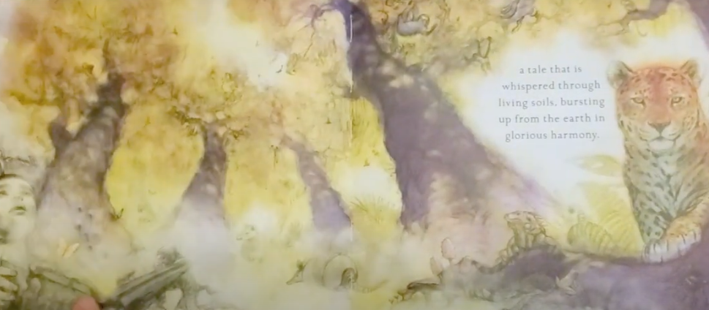  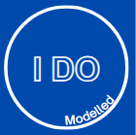  Model first sentence using fronted adverbial for where, referring back to collected nouns and adjectives on the flipchart.  I want to describe the sunlight as it makes the setting feel really warm and inviting. want to start with a fronted adverbial to show where the sunlight fell-  Beneath the towering golden trees,(model checking for punctuation) sunlight streamed through the dappled canopy and painted the forest floor with warm patterns.    Pupils to orally compose their first sentence, deciding on a fronted adverbial and a specific, interesting noun phrase to describe. Pupils to write their first sentence/ two sentences and CFU before moving onto independent work. |   Pupils to write their own short setting description using fronted adverbials for where and specific expanded noun phrases.  If needed, as a starting point, pupils to use simple paragraph on slides and improve.  Link paragraphs using fronted adverbials for time and place. | Teacher to model how to re-read a sentence and improve with an expanded noun phrase. Pupils to then do the same with their own writing.  Pupils re-read and check for accuracy of punctuation and improve at least one of their expanded noun phrases after reading aloud to themselves/ partner.
Lesson 3  To write a setting description using fronted adverbials | Respond to feedback on yesterday’s setting description. Can you improve any of your fronted adverbial or vocabulary choices?  Explain that we will be writing a contrasting setting description today- this description will be of the future, desolate Earth. | Pupils to discuss differences in contrasting settings and encourage them to think about how they will change the impact on their reader.  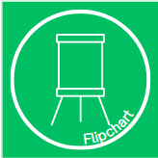  Following a similar structure to yesterday’s lesson, pupils to generate precise expanded noun phrases and apply fronted adverbials. Today, they will also work on applying their existing knowledge of adverbials of time to add some variety.  Support pupils to choose precise nouns to fit the setting- use of word bank as a scaffold.  Model first sentence using fronted adverbial. Show both time and place fronted adverbials and explain that some of these will be appropriate and some will not. Model trying a couple of fronted adverbials to see which fits best with the content of the first sentence. Across the cracked earth, piles of broken wood and rusted metal lay scattered like forgotten relics.  Pupils to draft first couple of sentences on their whiteboards, selecting appropriate adverbials and precise expanded noun phrases. CFU to inform guided group for teacher support. | As in yesterday’s lesson, pupils to use class word bank on flipchart, provided word bank on tables if given, fronted adverbials. Pupils can potentially use the basic paragraph on the slides as a basis to uplevel. | Pupils vote on the most appropriate fronted adverbial for the sentence.
Lesson 4 – To punctuate direct speech accurately  (Using a new line for a new speaker) | Pupils to correct speech punctuation and apostrophes. (Teachers may want to tweak this to include retrieval of another skill that the class needs to work on based on assessment)  Maya said “Where am I?  You shouldnt be here, said the boy”.  “Whats happening asked Maya? |   Explain that we will be writing our own narrative based on the The Crown over the next few lessons. Part of the narrative will include a conversation between today’s character and the character from the future. Read the WAGOLL to introduce the idea of how we will try and innovate our own narrative.  Share paragraph with pupils where new line, new speaker is not used. Discuss how this makes it confusing and difficult to make sense of who is speaking.  Model rewriting the first few sentences, following the rule of new speaker new line. Then show the ‘before’ and ‘after’ animated examples on the slide to illustrate how this helps make it a lot clearer to our reader.  Share explanation and another example of new speaker, new line with conversation between George and Molly.  Provide pupils with a few sentences where the dialogue does not follow the rule of new speaker, new line. Children re-write this to follow the rule- CFU.  Construct a short conversation between the two characters in the story, taking ideas from the class and modelling how to write the dialogue using the rule of new speaker, new line.  Use the prompts/ ideas to support the discussion as needed-  Maya sees the river looking different. What might she say first?  Pupils talk in pairs, cold call response/ scaffold discussion e.g.  "This doesn't look right," Maya murmured.  What might the boy say back?  Pupils talk in pairs, cold call response/ scaffold discussion e.g.  "It’s because you're in the future," the boy explained.  Continue with 1–2 more lines. | Pupils to write a short conversation between the two characters. Provide a couple of sentences to start them off on slides. Two possible scaffolds available in resources.  Use a variety of reporting clauses. | Teacher to model checking against success criteria, using a pupil’s writing if appropriate or using the class model. Pupils to self check against success criteria.
Lesson 5  L.O. To plan an innovated narrative  N.B. This may need to be split across two lessons to ensure sufficient time spent planning details for each paragraph to apply SPAG | Respond to feedback on yesterday’s setting description. Can you improve any of your fronted adverbial or vocabulary choices?  Re-read the story before we think about using it as inspiration to plan our own narrative. | In our narrative, a character from today will travel to the future and come back with the message about how to look after the Earth.  Pupils to discuss what the character from today would see when they travel to the future. What message will they return with?  Share WAGOLL again with pupils to demonstrate how we could innovate the story to swap the roles of the characters so that today’s character travels into the future.  Show pupils the structure of our story following a typical story mountain, highlighting the key events that will take place at each point. Stop, discuss and clarify where needed to ensure pupils are clear on the structure. | Support pupils to plan their narrative, working through the paragraphs on the plan. Model filling in the plan or parts of the plan where pupils will need more support before they add to their own plans. Work with guided group who will need more support to add to their plans.  The majority of the narrative will be very similar to the story and pupils can draw upon their ideas and writing from the sequence so far- setting descriptions they have written will provide them with some inspiration for their expanded noun phrases.  GDS- precise and effective noun phrases to impact the reader. Check plan for variety of reporting clauses (varying speech verbs) | Teacher model how to read through and check narrative plans, ensuring all key elements have been included. Build in opportunity to add to plan a particular element if needed based on whole class assessment. Pupils talk through their plans with partners. Check for correct speech punctuation and commas for fronted adverbials.
Week 2 Lesson 1  To write a narrative opening and built up | Pupils to write appropriate fronted adverbial and expanded noun phrase to match the pictures, ensuring contrast. | Pupils to discuss which of the fronted adverbials and expanded noun phrases fit with each setting. Record on flipchart if time to use as an extra scaffold for class while writing. Cold call, listen in to partner talk.  Share success steps (suggested steps in resources) and explain to pupils what we will be demonstrating in our writing. Suggested star challenge- including action for dialogue.  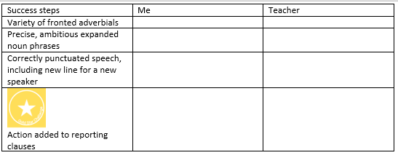  Pupils partner talk through their plan for opening and build up, ensuring they are clear on the key events today- opening including the setting, finding the crown and travelling to the future setting.  Teacher model writing start of opening.  Watch how I build my first paragraph. I’m going to start with a fronted adverbial to set the scene straight away. I want the reader to know it’s peaceful and bright.  Teacher writes:  On a warm spring afternoon,  Now I want a really precise expanded noun phrase to show how beautiful the river is.  Teacher writes:  the clear, glassy river sparkled quietly beneath the sunshine.  I’m choosing clear and glassy because they make the water sound pure and untouched.  Continue writing:  Maya strolled along the riverbank, enjoying the soft, emerald-green grass brushing against her ankles.  Pupils to write their own first sentence or two introducing the setting and character. CFU- check fronted adverbials and use of specific expanded noun phrases.  In an instant,  This tells the reader something changes suddenly.  Continue writing:  the world around her blurred like streaks of wet paint.  Now I’ll contrast the landscape using precise noun phrases.  Teacher writes:  When the wind finally settled, the bright riverbank had vanished.  Across the ruined landscape, thick, grey smoke drifted above a cracked, lifeless riverbed.  Across the…’ is a strong fronted adverbial choice to help build a picture in my reader’s head. And cracked, lifeless riverbed shows the damage clearly.  Talk about what you might include next- I might want to include details about the piles of rotting rubbish and the colour of the water- it’s murky and poisoned brown.  Pupils to write their introductory sentence/ two sentences using their plans to help, following the guidance from the model. | Pupils write opening and build up following ‘I do’ and ‘We do’ for both sections.  Use shared writing script to support working with guided groups, adapting as needed according to assessment and ensuring pupils use their planning structure to support. | Teacher model how to self check against success criteria. Pupils to re-read their writing from today and do the same. Build in time for pupils to add to writing if needed. Based on whole class assessment, pupils may need time to edit for a particular element.
Week 2 Lesson 2  L.O. To write a narrative problem including dialogue |  | Remind pupils of WAGOLL problem section- we are aiming to write the part of the story where the characters meet and have a discussion about what has happened to the planet.  Pupils spend time talking through this section of their plan to ensure clarity.  If it would be helpful, encourage pupils to act out/ roleplay the script in pairs to support them with the key points of the conversation and what the characters may be doing as they are speaking.  Modelled write at least the first line of speech for each character to ensure accuracy of punctuation and new speaker new line.  Now Maya is confused and frightened. I want her to ask a question. Watch how I punctuate this.  Teacher writes:  “What happened here?” Maya whispered, covering her mouth  I’ve put the actual words she speaks inside the inverted commas.  I used a question mark because she’s asking.  Then I ended the speech before adding my speech verb.  I chose whispered because the air is smoky—whispering fits the mood.  Now the boy is going to reply. Because he’s a different speaker, I MUST start a new line. Watch me do it deliberately.”  Teacher writes:  “What happened here?” Maya whispered, covering her mouth with her sleeve.  The boy tugged his mask tighter. “People stopped caring,” he said quietly.  “I included an action before the speech so it’s not just dialogue ping-pong.  I used ‘he said quietly’ because it matches the scene — he wouldn’t shout in this moment.” | Pupils write problem including dialogue following modelling, using their plan and referring back to scaffolds.  Use shared writing script to support working with guided groups, adapting as needed according to assessment and ensuring pupils use their planning structure to support.  Provide speech verbs word mat.  Star challenge- adding action in between speech and using more sophisticated speech verbs on word mat (ensuring they understand meaning!) | Teacher to model checking speech for all elements of punctuation. Pupils to check for this also. If a particular misconception arises, highlight this and unpick as a class before building in time to correct this in own writing.  Check against success steps support accuracy.
Week 2 Lesson 3  To write a narrative resolution and ending | Respond to feedback/ uplevel speech verbs to improve impact on reader. | Recap WAGOLL and key events.  Children to talk through plans for these two sections.  Resolution- Instead of modelled write today, pupils to practise putting their speech ideas into a similar paragraph structure to support them to move the action along- sharing the resolution through the conversation. When they come to independently write, they can build in the return to the present day. They will likely need most support with the dialogue here, so CFU while they practise on whiteboards. They can take these ideas to tables to support with independent writing. Children complete their writing independently.  Ending- Model and shared write ideas if needed. You may wish for pupils to work on ‘we do’ resolution and go to write independently before coming back together to talk through ending.  Modelled write – Ending  Teacher Script:  “Finally, I want to show that Maya doesn’t just feel differently — she acts differently.”  Teacher writes:  She spotted a plastic bottle lying near the path. Picking it up, she placed it carefully in the recycling bin, feeling that even one small action mattered.  Think-aloud:  “I’m linking her inner change to an outward action. Carefully and even one small action mattered reinforce the theme of responsibility.”  Share basic ending ideas to uplevel. Example uplevelled paragraph animated on slide. | Pupils write resolution and ending using their plan and referring back to scaffolds.  Use shared writing script to support working with guided groups, adapting as needed according to assessment and ensuring pupils use their planning structure to support.  As yesterday. | Check against success steps and peer assess to support accuracy.
Week 2 Lesson 4 L.O. To edit and improve my writing | Share some class specific errors/ examples with the class and pupils spend time discussing/ correcting on whiteboards. | This lesson will need to be adjusted according to your class assessment. Activities below and on slides may be useful according to what pupils need to edit. Pupils do need the editing process modelled to them and will need scaffolds to support/ guided group work with specific focus.  Teacher modelling editing activities using example paragraphs on slides which need specific improvements.  “Let’s look at a paragraph from my writing. First, I will check speech punctuation, new lines for speakers, and inverted commas.”  Maya gasped “This river is poisoned” she said the boy tugged his mask tighter “People didn’t care”  Think-aloud / Modelling  Add punctuation and capital letters  Insert new line for new speaker  Adjust speech verbs for variety  Teacher writes corrected version:  Maya gasped. “This river is poisoned,” she said.  The boy tugged his mask tighter. “People didn’t care,” he added.  Next, I’ll look for places to make the setting or actions more vivid using expanded noun phrases, fronted adverbials, and adjectives.  Original: The river was bad in the future, brown and dirty.  Write improved version, referring back to resources, plan, etc,  Across the ruined riverbank, the poisoned, murky water stretched under a sky choked with thick grey smoke. | Pupils to edit and improve according to feedback and using scaffolds/ guided group work to support. | Share improvements with partner/ class.
Week 2 Lesson 5  Publishing lesson if wanted or extra lesson if another lesson has been split across two. |  | Publishing- Recap handwriting from Y4

