Text and Author: | 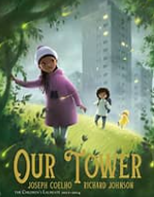 | Year Group: | Year 3 | Term: 4 | Spring 2
Text and Author: |  | Final Outcome: | Diary Entry

 | Key Learning | Spring Term
Vocabulary, Grammar and Punctuation | - Identify clauses in sentences.  - Explore and identify main and subordinate clauses in complex sentences.  - Use the comma to separate clauses in complex sentences where the subordinate clause appears first, e.g. Although it was raining, we decided not to take our coats. | - Use the comma to separate clauses in complex sentences where the subordinate clause appears first, e.g. Before he started making films, Walt Disney worked as an artist. After the bird had sprinkled the crumbs, a  magnificent forest sprang up.
Vocabulary, Grammar and Punctuation | - Explore, identify and create complex sentences using a range of conjunctions e.g. when, if because, although, while, since, until, before,  after, so. | - Explore, identify and create complex sentences using a range of conjunctions e.g. before, after, while, since and although

 | Key Learning | Spring Term
Composition: Planning | - Identify and discuss the purpose, audience, structure, vocabulary and grammar of narrative, non-fiction and poetry. | - Identify purpose and audience for writing, e.g.to entertain other Year 3 children with poems for a class anthology. Discuss the vocabulary, grammar and structural organisation needed.
Composition: Planning | - Identify and discuss the purpose, audience, structure, vocabulary and grammar of narrative, non-fiction and poetry. | - Identify purpose and audience for writing, e.g.to entertain other Year 3 children with poems for a class anthology. Discuss the vocabulary, grammar and structural organisation needed.

 | Key Learning | Spring Term
 | - Group related material into paragraphs.  - Use headings and sub headings to organise information. | - Group related material into paragraphs, e.g. write facts about a well-known subject on individual sticky notes and group these under headings provided by the teacher.

Lesson Objective: | Retrieval/ Introduction | Direct Instruction | Application/ Practice | Review/ Assessment
Lesson 1  LO: To explore and engage with a new text  Resources needed- book and book talk grid resource if using (otherwise draw grid in book) | Introduce the book.  Ask children- What do you notice about the front cover?  Watch the video introducing other Joseph Coelho books.  Read the book to the children, pausing to discuss and enjoy the language and content together. Consider the beautiful illustrations and make the link with similar texts. |   Modelling/I do – Using the Likes, Dislikes, Puzzles, Connections grid, model recording some of your personal responses to the text. Model using evidence from the text, using the conjunctions because, as and since to justify opinions and when to add extra information about time.  For example:  I like the different images because they really show the contrast between the different settings.  I don’t like the start of the story as it feels quite sad especially when they describe it as boring, hard and grey.  I wonder what it’s like to live on the top floor of a tall tower block?  This reminds me of some other stories when the character goes to another world like Narnia and Alice in Wonderland. It reminds me of Apple Tree House with the 3 characters and the community. | 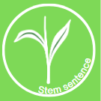    We do – taking responses from the children (using the sentence stems on the prepared slides), write further examples on the board under each category.    You do – pupils complete their own version of the sheet with personal responses (continuing to be supported by the sentence stems where necessary). | Teacher to share good examples from pupils’ work and write these on board. Address any common misconceptions in sentence structure.  Pupils’ responses will indicate the level of understanding they have of the text.
Lesson 2  LO: To describe a setting using adjectives  Recap of Y2 objective  Resources needed- setting pictures stimulus for books |     List nouns that you can see in the picture – add adjectives to describe them. | Refer to slides for purpose and boxed up plan for diary entry.  Read up to – ‘We creep away from Our Tower.’  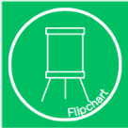  Ask pupils to give definition of a noun- CFU and ask pupils to repeat precise definition on slides if needed to reinforce.  Highlight and write down the precise nouns in this first part of the story e.g. bin chutes, satellite dishes  Teacher model writing one or two more precise nouns and scribe these on flipchart e.g balconies, stairwell. Pupils to write their own on whiteboards. Provide word mats to support pupils to select ambitious, precise vocabulary.  Follow the same process for adjectives and model adding carefully selected adjectives to nouns on flipchart. Model some expanded noun phrases with two adjectives and a comma before the adjective and others with just one carefully chosen adjective to show variety.  Model crafting a descriptive sentence using the nouns window and tower e.g.  Our looming, grey tower almost reached the clouds.  Faces appeared at the small, rectangular windows. | Give children a stem sentence to add appropriate adjectives.  Down below, the _________, ________ cars raced by.  The _________, ________ street lights shone through the rain.  Using the image from the flipchart, children independently write some descriptive sentences.  Word banks to support pupils to improve vocabulary choices. You may wish to give WTS pupils a word bank with adjectives matched to specific nouns to support them further. 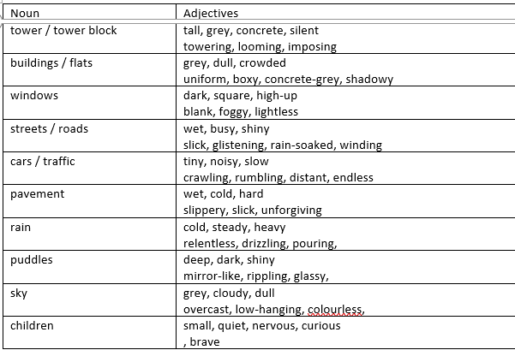  EXP/ GDS pupils could use word bank with a variety of adjectives to choose from. 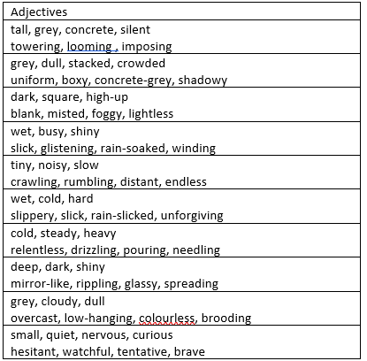 | 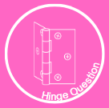  Which adjectives are appropriate to complete this sentence:  We walk down the ______, ______ stairwell.  - bright, cheerful  - narrow, steep  - dark, gloomy  - bare, concrete
Lesson 3  LO: To write a descriptive diary entry using senses.  Resources needed- senses word banks and success steps | Recap past tense. For context, this will support genre specific writing – diary entry.  - Change this sentence so that it is past tense.  The rain water runs down the window pain.  - What is the past tense of the following verbs?  drive, walk, falling, standing, search, see, leave  Tick or fix and give time for partner talk to recap the rule pupils know for regular past tense- add the suffix -ed. Pupils should also be able to explain that some verbs are irregular and therefore do not follow that rule. | Introduce purpose for writing and features of a diary entry.  - First person  - Past tense  - Descriptive and Emotive language  - Chronological order  Model writing the start of a paragraph using senses. What can the character see, hear and smell? Refer back to ideas from yesterday’s lesson where we gathered expanded noun phrases. E.g.  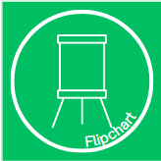  We will start by writing ‘Dear Diary’. I want to start by describing what I could see through the window and I can use a preposition to say where something is in relation to where I am.  From my small, rectangular window, I saw cars racing by down below. I felt excited to go on our adventure.  As I walked down the (model referring to word bank or yesterday’s whole class word bank to choose adjective) _______ stairwell, I I think I will use a different sense here – maybe I can hear the rain and build a picture in my reader’s head of how bad the weather was! heard water dripping from the leaky roof. While we hopped and jumped down the stairs, we could smell the cold air filled with freedom. Model re-reading for sense and for vocab choices. | Using stem sentences the children draft chronological sentences about leaving the tower.  From my window, I saw……  As I left my front door, I heard ……  Once outside, I felt ……  CFU and support pupils to choose best adjectives. Share some good examples aloud and ensure pupils keep ideas on whiteboards to scaffold independent writing.  Children independently write the first paragraph of their diary entry. Provide senses word banks to support.  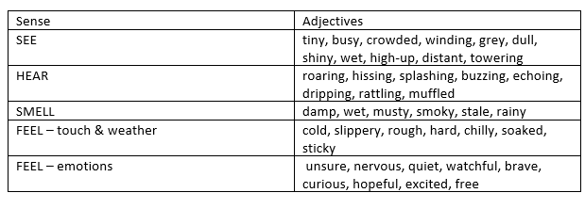    Star challenge based on GDS descriptor- ‘Settings and character are described in increasing detail.’- Pupils working at greater depth need to also select their vocabulary to have impact on the reader. |   Display example sentences with errors on board. Pupils to discuss in pairs any errors in spelling/ past tense. Listen in to partner talk and cold call key pupils.  Teacher model identifying these errors in past tense/ spelling and correcting them.  Pupils to check their own writing- identifying verbs and checking for past tense.
Lesson 4  LO: To generate and effectively use prepositions for where  Recap of Autumn Y3 KPI prepositions  Resources needed- prepositions workheet |   How many features of a diary entry can you name?  Editing time- pupils to respond to feedback from yesterday’s writing and teacher to spend time addressing common misconceptions. You may wish to display anonymous examples of errors to model correcting.  Read the text again up to ‘a world deeper than anything Our Tower has ever seen.’ and explain that today we are going to focus on the journey to the tree. |     Recap prepositions, specifically prepositions of where. Today, we will look at these in the context of prepositional phrases. Spend time sharing examples of prepositional phrases and explain how the group of words explain where something is in relation to something else.  Using images from the text and a given prepositions, children complete sentences. Remind children we are writing in the past tense and first person.  Over the bumpy roots,  Under the trees,  Pupils to write own sentence independently if they have completed given sentences accurately.  Give main clauses and ask children to add a prepositional phase.  I looked through my binoculars.  I wrote in my notebook  Pupils who finish the provided sentences confidently and accurately to write own sentence independently with prepositional phrase.    Check for understanding with a dictation on whiteboards. Can children correctly punctuate?  Far from the tower, we entered the woods. Identify pupils needing more support with the correct punctuation of fronted prepositional phrases. |   Using prepared images, children write sentences including prepositions. Scaffold with a list of prepositions if required.  Based on depth descriptors, pupils to choose sentences to improve with a variety of carefully chosen prepositional phrases and added detail about how they felt with high quality vocabulary choices. | Which of these sentences are correct?  In the forest, we could no longer hear the busy roads.  We travelled further, through the iron gate.  Near, the tree we began to feel excited.  This may highlight any misconceptions around punctuating fronted prepositional phrases.  Discuss how prepositional phrases can be used in different positions, not just fronted.    Give time for children to go back and restructure some of their sentences.
Lesson 5  To write a descriptive diary entry using prepositions.  Resources needed-Lesson 5 success steps | Identify the prepositional phrases in this paragraph. Children to write them down on whiteboards- check for understanding. Do pupils have the whole phrase or just the preposition?  Far from the tower, we entered the enchanting woods. All around, we heard the wind whistling and birds calling. It was so peaceful. We continued on, under the leafy canopy. We saw many trees that didn’t have big, leafy bows. We travelled further, through the dense forest. Finally, we heard the singing that we’d been searching for. | Recap purpose for writing and features of a diary entry. Explain to pupils that we will continue our diaries today, focusing on the next part of the story.  - First person  - Past tense  - Descriptive and emotive language  - Self-reflection  - Chronological order  Share success steps for today, which include prepositional phrases so that we can apply this skill. Remind pupils that these are helpful to build a picture in our reader’s mind of where something is in relation to something else.  Re-read the part of the story up to ‘a world deeper than anything Our Tower has ever seen.’  Share a paragraph which overuses prepositional phrases to begin sentences. Explain that we want to use these to build cohesion but don’t want to use them to begin every sentence. We could use them in different positions in sentences or we could use conjunctions/ adverbs to link sentences.  Model writing two sentences using prepositional phrases to describe the pictures on the board. E.g. Across the wet, windswept fields, we made our way closer to the singing tree. As we walked, our shoes squelched in the sticky mud. Model checking for comma following prepositional phrase.  Pupils to write their own, thinking carefully about including prepositions and selecting ambitious vocabulary. (Vocab on slides is also included on word mat). | Building on their ideas from yesterday, children describe their journey from their gate to the crack in the tree.  Use list of adjectives and prepositions to support WTS children as required.  Vary prepositional phrases and their positions within sentences, building cohesion. | With teacher guidance, and according to CFU throughout the independent writing task, children check their writing against the agreed SC:  First person  Past tense  Descriptive and emotive language  Chronological order  Prepositions
Lesson 6  LO: To write and punctuate complex sentences.  Resources needed- Lesson 6 complex sentence task | Write a main clause to describe what is happening in each picture.  Check for understanding of main clause- this is a simple sentence containing a verb and no conjunction. Note down pupils who will need extra support with this in the rest of the lesson.  Build editing time into this lesson, focusing on key aspects needing extra practice. If needed, share some anonymous examples from yesterday’s writing and work on improving these as a class, modelling how to use success steps to focus this editing. | Read the book from ‘there are creatures lurking…’ to ‘sing and whoosh and weep…’  Follow input on slides to recap the structure of a complex sentence and the explain that we are aiming to use a wider variety of subordinating conjunctions e.g. ‘when, because, as, if, after, before, since’.  Recap our learning from The Wilderness- remind children that we looked at how we can vary the position of subordinating conjunctions. N.B. We don’t expect pupils to use the comma accurately for fronted subordination independently yet but we will today model this to support pupils to recognise where the comma should go to separate fronted subordination.    Pupil discussion- can they spot the varied position of subordinate clause and how the comma has been used for fronted subordination?  Explain that pupils are going to create simple sentences/ main clauses to match each picture. We will use these to build some complex sentences as a class.  Model writing complex sentences based on class’s main clauses. If using fronted subordination, model correct use of commas e.g.  While I swung on the swing, I heard bewitching noises.  Before we jumped across the stepping stones, we tasted the sweet deliciousness of the steaming pudding fruits.  After he told us his story, he gave us a precious stone. | Using prepared subordinate clauses and main clauses, children orally rehearse a complex sentence with teacher to support discussion for key pupils. Then children continue with other sentences on whiteboards- teacher to use this as an opportunity to CFU for main clauses being added to complete sentences.  Before we entered the tunnel, …….  While we tumbled down, …….  After we ate, ……  Pupils then generate subordinate clauses to complete the complex sentences e.g. Again, orally rehearse first sentence and then teacher CFU with the next two.  While he talked, we listened carefully.  After we crossed the stepping stone, the water rippled.  Before we entered, we peered inside  Pupils vote for the two correct sentences. CFU.  Children write and punctuate complex sentences, using prepared strip of pictures.  Star challenge for pupils working at depth- these pupils may be confident to independently work on punctuating fronted subordination correctly. Vary the position of your subordinate clauses and punctuate them correctly. | Match the correct subordinate clause to the main clause.  Before we continued, we drew careful drawing so we wouldn’t forget.  After he gave us the stone, we knew it was special.  While we crossing the bridge, we balanced carefully.
Lesson 7  LO: To write a diary entry using a variety of sentence types.  Resources needed- Lesson 7 success steps | Correctly punctuate the complex sentences. (N.B you may wish to build in a different Do Now based on outcomes from yesterday’s lesson on complex sentences e.g. varying conjunctions or checking for complete sentences instead of just subordinate clauses). | Recap purpose for writing and features of a diary entry. Can they remember what we’ve done so far?  - First person  - Past tense  - Descriptive and emotive language  - Chronological order  - Prepositions.  - Complex sentences  Read the book from ‘there are creatures lurking…’ to ‘sing and whoosh and weep…’ Explain that we will be writing this part of our diary entry today.  Share with pupils a basic example of a diary entry for today. Discuss in pairs and feedback. What could be done to improve- better choices of expanded noun phrases, description of senses, building cohesion with subordination and prepositional phrases. Pupils could redraft sentences on whiteboards to support whole class redraft. E.g.  Beneath the ground, we found mysterious tunnels under the roots. We jumped onto the slippery stepping stones and tried not to fall into the water.  As we explored further, the roots were big and went everywhere. In the shadows, we met the tree man. He was old and quiet and knew things about the woods. I felt brave but my heart was beating fast.  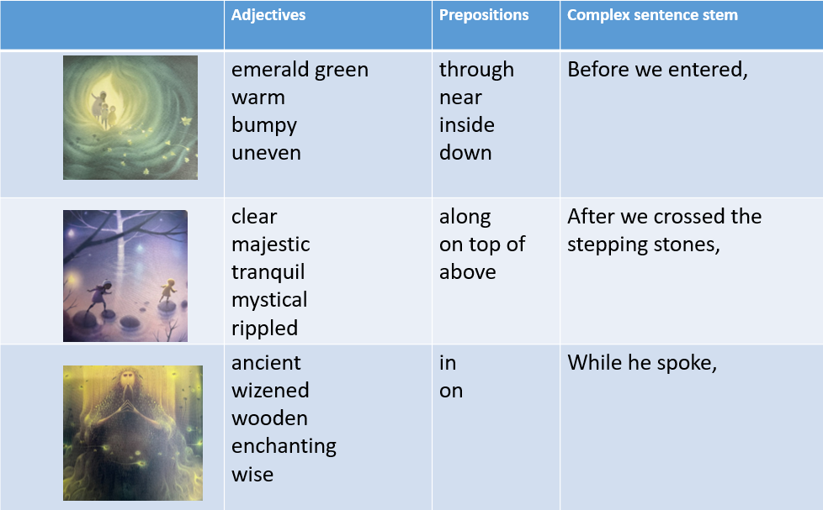  Share word bank with pupils and discuss to ensure clarity. Give a copy of this for pupils to support during writing.  Using this word bank, pupils to write first sentence/ two sentences, including subordination. CFU and share some good examples before pupils move onto independently writing this part of their diary. | Using their work from yesterday, pupils to write the part of their diary entry where they go underground and meet the magical man.  Children describe their journey from entering the tunnel to climbing back out again.  Use list of adjectives, prepositions and stem sentence to support WTS children as required. | Pupils to read their writing aloud quietly to themselves to check for sense. Teacher to guide children through checking their writing against the agreed SC:  First person  Past tense  Descriptive and emotive language  Chronological order  Prepositions  Complex sentences  Children to share their best complex sentence with their partner. Teacher to listen in and share good examples aloud with the class.
Lesson 8  LO: To write and punctuate complex sentences with a wider variety of conjunctions  (Practising comparison using before, after, and introduce using even though and although and since) | Read from ‘…we gaze upon Our tower’ to the end of the story.    How have the characters changed from beginning to end?  Explain that the final paragraph is going to focus on how the children’s mindset has changed since leaving the tunnel. This paragraph will be more challenging but more interesting as we will be comparing our feelings now that we have been on our adventure compared to the beginning. Discuss the shift in tense we may use here as well- comparing the past to the present now that we see Our Tower differently. | Introduce the 2 different conjunctions that we’ll be using today: since and although and explain how we use each one.  Share two examples of how we could show this comparison for our diary entries. Pupils to identify subordination, prepositions and description,  I gazed upon Our Tower with loving, grateful eyes. Since returning home, I felt different. Although it was the same tower block, I saw more than grey, hard concrete. While I looked around, I saw magic dancing everywhere. I felt the power of my home.  When we came back up into the light, I looked back at our tower. It didn’t seem grey and dull anymore. It stood tall and strong, watching over everything around it.  I realised our tower was more than just a building. It was our home, full of stories, adventures and memories. I felt proud to live there and lucky that it was ours.  Give some subordinate stem sentence for the children to make into complex sentences.  Since I left the tunnel,  Although it’s the same tower block,  Since listening to the man,  Although it looks the same, |   Pupils to write their own descriptive, comparative sentences using given subordinating conjunctions. Pupils to practice writing about their contrasting feelings- comparing how they felt about Our Tower before the adventure vs after. Explain that we will use these ideas to draft a whole class paragraph to help us when we finish our writing tomorrow.    Collectively draft a WAGOLL final paragraph for the diary. E.g.  E.g.  When we came back up into the light, I looked back at our tower. It didn’t seem grey and dull anymore. It stood tall and strong, watching over everything around it.I realised our tower was more than just a building. It was our home, full of stories, adventures and memories. I felt proud to live there and lucky that it was ours. | Underline the subordinate clauses from the WAGOLL  I gazed upon Our Tower with loving, grateful eyes. Since returning home, I felt different. Although it was the same tower block, I saw more than grey, hard concrete. While I looked around, I saw magic dancing everywhere. I felt the power of my home.
Lesson 9 L.O. To write a descriptive diary entry including contrasting feelings | Read the first section and the last section of the stories. | Model comparing how the children describe the tower at the beginning and what they notice at the end. Use words and phrases from the text where appropriate e.g.  Boring, hard and grey vs the power that resides in the smiles of our neighbors.  Complete two more examples together. Encourage pupils to use their most ambitious vocabulary. Refer back to ideas from yesterday. Scribe good examples on flipchart to refer back to. | Remind pupils of WAGOLL from previous day and children write their own. Explain that this paragraph could be quite extensive, giving lots of detail about the tower (refer back to Lesson 2 ideas where we identified nouns to describe).  WTS can use a cloze procedure as required.  I gazed upon Our Tower with loving, grateful eyes. Since _______, I felt _____. Although it was the same tower block, I now saw ______. While I looked around, I felt ________. | Children check their writing against the agreed SC:  First person  Past tense  Descriptive and emotive language  Complex sentences
Lesson 10  L.O. To edit and improve my own writing | Pupils to be clear on what their next steps are from the feedback they’ve received. Ensure they can explain what they need to do to make their writing even better. Cold call/ listen in to partner talk | Follow prompts on slides to explain differences between proof reading and editing.  According to assessment, this lesson will need to be adapted to suit needs of class.  Follow examples on slides to model how to identify areas needing editing and proof-reading. | Pupils to edit and proof read their own writing according to feedback and whole class modelling/ discussion throughout the lesson.
Lesson 11  Optional publishing/ handwriting lesson including edits | You may wish to use this opportunity to publish the diary entry as a whole, combining each of the sections we have worked on this week.

Example outcomes for each section of the diary-

1. In the Tower
Dear Diary,
Today I stood at the window of our tower and looked out across the city. From high up, the cars below looked tiny and the roads shone with rain. The sky was grey and everything felt quiet, even though I knew the streets were busy.
I made my way downstairs, past the long corridors and down the cold steps. As I reached the bottom, I felt small but excited to see what was waiting outside.

2. Through the Fields and into the Woods
Across the wet fields, we walked carefully through the tall grass. Along the muddy path, our shoes squelched with every step.
Between the bare trees, the wind whispered and the branches creaked above our heads. Under the dripping leaves, we stopped and listened, trying to find the tree we could see from our tower window.
Near the edge of the woods, one tree stood taller than the rest, and I knew it was the one we had been looking for.

3. Underground Adventures
Beneath the ground, we explored the dark tunnels under the roots. Over the stepping stones, we jumped carefully, trying not to slip into the water below.
Around us, thick roots twisted and curled like giant fingers. Then, in the shadows, we met the old, wizened tree man. He was quiet and calm, and he seemed to know all the secrets of the woods. I felt brave for meeting him, even though my heart was beating fast.

4. Seeing the Tower Differently
When we came back up into the light, I looked back at our tower. It didn’t seem grey and dull anymore. It stood tall and strong, watching over everything around it.
I realised our tower was more than just a building. It was our home, full of stories, adventures and memories. I felt proud to live there and lucky that it was ours.

