Text and Author: | Hidden Figures by Margot Lee Shetterley  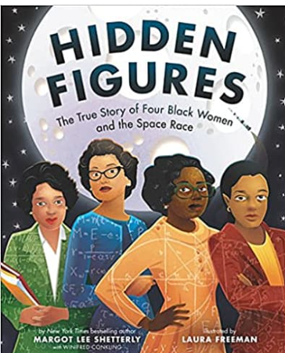 | Year Group: | Year 5 | Term: | Spring 2
Text and Author: |  | Final Outcome: | Persuasive Letter

 | Key Learning | Spring Term
Vocabulary, Grammar and Punctuation | - Create complex sentences by using relative clauses with relative pronouns who, which, where, whose, when, that  e.g. Sam, who had remembered his wellies, was first to jump in the river. The thief broke into the house which stood on the top of the hill. | - Using relative pronouns who, which, where, whose, when, that, create complex sentences by using relative clauses, both at the end of sentences and embedded within.
Vocabulary, Grammar and Punctuation | - Use devices to build cohesion within a paragraph e.g. firstly, then, presently, this, subsequently. | - Use devices to build cohesion within a paragraph e.g. firstly, then, presently, this, subsequently.
Vocabulary, Grammar and Punctuation | - Identify and use commas to indicate parenthesis | - Identify and use commas to indicate parenthesis e.g. The lighthouse, which had been abandoned for years, towered above the town.
Vocabulary, Grammar and Punctuation | - Use a colon to introduce a list  - Punctuate bullet pointed lists consistently | - Create a bullet pointed list which is consistently punctuated
Vocabulary, Grammar and Punctuation | - Use different verb forms appropriately e.g. active, passive, modal, imperatives | - Explore, identify and use modal verbs correctly to indicate degrees of possibility
Composition: Planning | - Identify the audience and purpose  - Select the appropriate language and structures | - Identify the audience and purpose for a piece of writing and consider this carefully when selecting the language and structures to use
Composition: Drafting and Writing | - Use different sentence structures with increasing control | - During composition, use different sentence structures. Orally compose alternatives and select from these according to the effect created.
Composition: Evaluating and Editing | - Assess the effectiveness of own and others’ writing in relation to audience and purpose. Suggest changes to grammar, vocabulary and punctuation to enhance effects and clarify meaning.  - Proofread for spelling and punctuation errors | - Proofread and suggest changes to grammar, vocabulary and punctuation to enhance effects and clarify meaning.

Lesson Objective: | Retrieval/ Introduction | Direct Instruction | Application/ Practice | Review/ Assessment
Lesson 1  LO: To engage with a new text and explore key themes and events  (You may wish to read the text and explore the vocabulary as part of a reading lesson before beginning this unit. In this case, you could start the sequence with the response task) | Share slide 2- the blurb from the back of the book, giving the children an overview of the text.  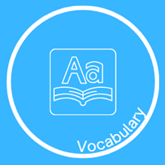  Read the book to the children. The vocabulary slides (4-8) have been produced to accompany the read, with the words listed in the order in which they appear in the text. It may be beneficial to print and display these around the classroom for reference. |   Read several reviews of the book (either those displayed on slide 9 or others found). Give thinking time. Discuss to what extent the children agree with these, giving opportunities for the sharing of personal responses and reactions.  Explain, using slide 10, what key themes are (big, universal ideas, messages or underlying meanings).  Think-pair-share: What do you think the key themes are in this text? List these onto the slide.    Using slide 11, model recording a personal response to the text, relating to the reviews. For example:  I agree with reviews of Hidden Figures which describe it as an inspirational story. I feel that Katherine Johnson, Dorothy Vaughan, Mary Jackson and Christine Darden can be described as role models, providing readers with the sense that anything is possible when you display resilience and determination to succeed. |   For the ‘We do’ work with the children, using the stem sentence displayed to craft a response identifying and explaining one of the key themes of the text.  I have identified discrimination as one of the key themes in the book Hidden Figures. I think this because the four women were treated unfairly – not only because of the colour of their skin but because they were women. They lived during a time when equal opportunities did not exist. Despite this, their resilience and skills resulted in remarkable achievements that changed space travel forever.    Children are provided with stem sentences as a starting point for their own reflections. These are recorded in their books. | Teacher identify several strong responses to share beneath the visualiser and discuss.
Lesson 2  L.O. To use embedded relative clauses to add extra information |   Retrieval of yesterday’s vocabulary learning.  Display slide 16. Children are required to match each term to its definition – capturing their responses on whiteboards.  Star challenge: To identify whether each word listed is a noun or verb. |   Use slides 17 –19 to recap relative clauses and introduce how these can be embedded.  Complete two, ‘I do’ and ‘We do’ cycles for embedding relative clauses (firstly focusing on where as the relative pronoun and then using who). It is important to explain and model how the commas help to demarcate this embedded clause. Use slides 20-23. | Children use the prepared resources to craft sentences with embedded relative clauses. A teacher model of how exactly to do this can be completed on slide 25.  Children identify the noun at the start of the sentence and select a suitable relative pronoun to help them embed the additional information provided.  Scaffolded task could involve children identifying the correct relative clause to embed based on the pronoun included. See page 2 word document. |   Use the question taken from a SPAG paper to give the children the opportunity to apply today’s learning to a different context. See slide - 26
Lesson 3  To add extra information using relative clauses using a variety of relative pronouns.  To suggest changes to enhance effects and clarify meaning. | Retrieval- Children write the sentence displayed onto their whiteboards, adding the embedded relative clause correctly. | Read the text again up to the pages displayed on slide 29.  Explain to the children that to apply their relative clause learning, we are going to imagine that we work for the engineering department at Langley and are supporting with the creation of a job advertisement for a new engineering position. A first draft has been written but it needs some editing – we will be repsonsible for that.  Look at the example job advertisement, which will give the children a basic understanding of the format and content. See slide 30. Explain that the first part gives possible applicants an understanding of the business, in this case, Rolls-Royce. Draw their attention to the use of embedded relative clauses - these have been included in bold.  On slide 31 we see the next section of the advert and aim to briefly draw the children’s attention to the use of a colon and bullet pointed list. This will be our focus tomorrow.  Use slide 32 to share an initial draft of the ‘Who are we’ section for a job advertisement for the Langley Laboratory. Explain that our task today is to improve this passage by including some embedded relative clauses.  On slide 33, model how to identify a noun which could be clarified with further detail. Decide whether this is a person, object, place, time and therefore which relative pronoun will be needed. Model generating a little additional detail to add and then rewriting that sentence. If needs be give out the Facts to support us in generating relative clauses from slide 36 to help the children who may have limited background knowledge to support them. | Work together with the children to identify a couple of other places where a noun could be further clarified with additional detail. Good places for adding relative clauses have been included on slide 35 – this one is for use by the teacher. Children could highlight their sheets at this point, identifying where they will add their relative clauses.  Children write the first part of the job advertisement into their books, adding two or three examples of embedded relative clauses.  Possible scaffolds:  Have listed some additional pieces of information about the nouns (slide 35).  Children annotate a version of the text where the spacing allows for this neatly (removing the need for rewriting and reducing scale of task). | Teacher to identify a couple of strong examples to share beneath the visualiser. This could also include one example that is not as successful.  Children work on whiteboards to support their peer to improve the sentence as their exit ticket.
Lesson 4  To use colons and bullet points for a list. | Slide 37  Children to identify and list on whiteboard, an appropriate relative pronoun to complete each relative clause.  List as follows:  1 whose  2 which or that  3 where  4 who  5 which | Teach the children about where a colon should be used correctly using slides 39-43. These slides also cover how a bullet pointed list should be punctuated. Hinge questions have been taken from previous SATs papers and are included on slides 40 and 41 to support with checking for understanding.  Use the information on slide 44 to model to the children how to create a main clause, followed by a colon and then a correctly punctuated bullet-pointed list. Do this on a drywipe board or under a visualiser.  Duties during your working hours will be varied and interesting:  - working with other engineers  - communicating  - planning group meetings  - problem solving  - using complex maths  - exploring scientific theories  Share slide 45 which shows how each bullet point can be further developed to add further details. | Work with the children to begin to expand the bullet pointed list displayed on slide 46. This could be done as a shared writing task with children recording on whiteboards.  E.g  - testing airplanes by simulating turbulence and exploring wind effects in a wind tunnel
Lesson 5  To use colons and bullet points for a list | Print small copies of slide 46 for children to complete as a retrieval task upon entry to this lesson. Teaching point: the colon comes after a main clause that makes sense on its own.  Answers:  Joshua had mastered two new skateboarding skills: he could do a perfect aerial jump and execute a complete 180 degree turn.  There are two places that I have always wanted to visit: the Arctic and Antarctica. | Explain that in today’s session the children will be completing the job advertisement that was started earlier in the week. We will write all three sections today- the introductory paragraph, list of duties and list of desired qualities. We will be applying our learning about colons and bullet points to write our lists- one will be of the duties of a flight engineer, the other of the personal qualities needed.  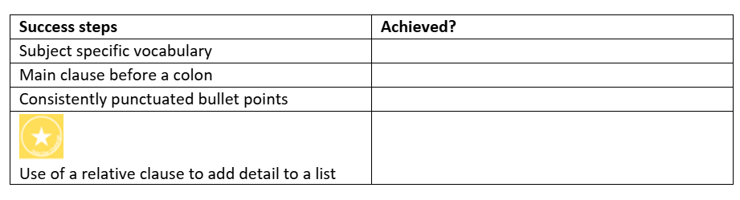  Share success steps for our adverts, which combine all of our learning this week-    Children use the prepared mind map on slide 49 to write a main clause and simple bullet pointed list to scaffold their writing for today. Use this opportunity to CFU- do they have a correct main clause? Is punctuation consistent?    Pupils to begin working on their adverts, using the prompts on the slides to write their introductory paragraph and first bullet pointed list.  Can children challenge themselves to add a relative clause into one of the detailed bullet points?  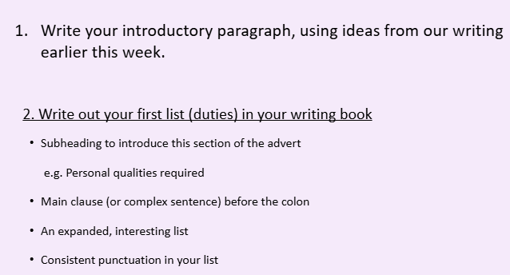  Stop children to check in and build in an opportunity for a mini-edit. According to teacher assessment, there may be key errors/ misconceptions that need to be discussed/ modelled corrections before moving on to final section of advert.  Careful cohort-specific scaffolding may be needed in this lesson.E.g. Introductory paragraph with no relative clauses or guided group to support creating a main clause. |  | Children to read through their completed job advertisement.  This should be an opportunity for self-assessment against success criteria.
Week 2
Lesson 1  L.O. To evaluate and improve persuasive writing using modal verbs  Resources needed- modal verb scales  (If needed, could split this across two lessons) | Pupils to edit their job advert writing according to feedback with modelling from teacher where appropriate for common misconceptions. | Using slides, introduce purpose of this week’s writing. Explain that to write our letter, we already have lots of ideas as we took on the role of the employer by writing a job advert. Our letter will need to respond to the advert and we will know exactly what the NACA are looking for! We just need to make our letters extra persuasive.    Share WAGOLL letter with pupils to introduce what we are aiming for. Ask pupils to discuss what words/ phrases/ ideas make the letter sound persuasive. Ask pupils to put themselves ‘in the shoes’ of the NACA- what would convince them to employ her? (NB Don’t worry about specifics at this point- just share ideas and discuss before we move onto focus on specific SPAG skills today).  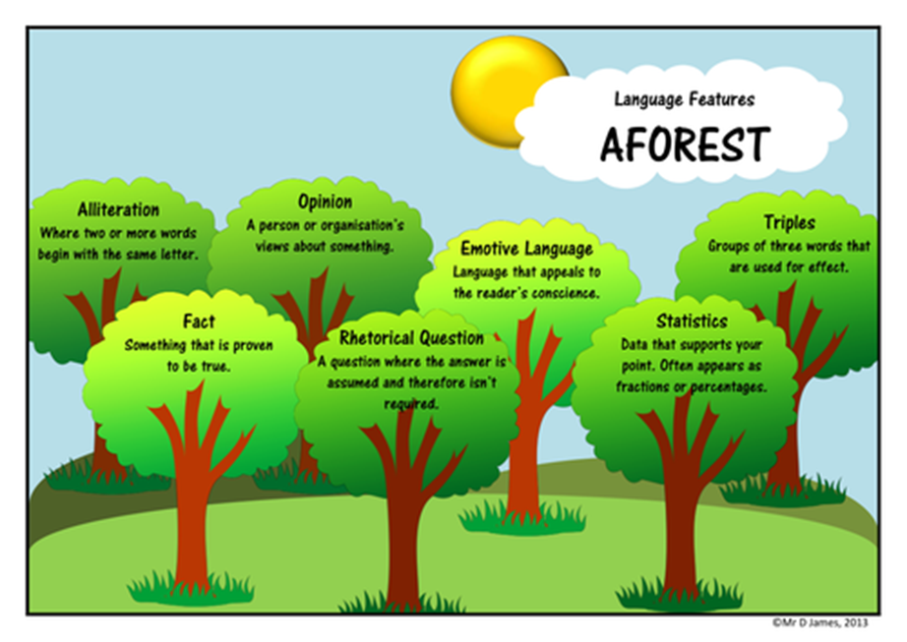  Share the ‘AFOREST’ picture with pupils and explain that there are many ways people might make their writing persuasive. Give a brief overview. We are going to be very selective with these features but we may spot a few examples in the WAGOLL (we will be able to use some emotive language to make our employer feel excited and to share some of the struggles we have experienced. Some pupils working at GDS may include more of these features such as triples or alliteration as an extra challenge.)  Share some examples of these from the WAGOLL- show how it uses alliteration and groups of three. Again, explain that this may be an extra challenge for pupils to try and include one of these.  Explain that we will be focusing on a particular group of words today that we can use to be persuasive (modal verbs).    Show the two example sentences.  I might be a good engineer.  I will be a good engineer.  Ask pupils to discuss which is more persuasive. Share another example and ask pupils to do the same.  If I join your team, we might win the Space Race.  If I join your team, we will win the Space Race.  Share some of their initial ideas as to what makes these most persuasive.  Share definition of modal verbs and examples, showing how they change the certainty.  In pairs, pupils discuss which modal verb would work best to make the sentences more persuasive.  I ______ bring many great skills to your company.  I _______ apply my exceptional math knowledge to the role of engineer.  Write ideas on flipchart to refer back to.  Pupils work on whiteboards to rewrite the sentences with more persuasive modal verbs. Check for Understanding and share good examples with the class.  I am confident that I could be the perfect candidate for the role.  Moreover, I might bring some great qualities to your company.  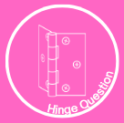  Pupils to vote on which sentence uses the most persuasive modal verb (A). | Provide modal verbs scale on tables to scaffold.  Independent Task 1  More scaffolded task where pupils select modal verbs to make sentences and paragraph more persuasive. Check in before moving onto next task where pupils need to compose sentences themselves.  Independent Task 2  Pupils to draft sentences that they could use to persuade the NACA that they would be a good candidate for the role.    Star challenge to reflect GDS descriptor- using a range of different modal verbs, selecting the most appropriate and persuasive. |   Pupils to vote on most/ ;east likely according to modal verbs.
Lesson 2  L.O. To plan a persuasive letter in role  Resources needed- A3 planning sheet for teacher modelling  Pupil planning sheets (* may need adapting*)  Modal verb scales for tables if needed  Scaffold- word bank and sentence building | Modal verbs retrieval- pupils to list modal verbs. Possible misconception- pupils not using modal verbs in the negative e.g. would not, could not | Re-read the part of the book where Mary wants to become an engineer and convinces the NACA to let her take advanced level maths classes.  Try and elicit from pupils that this would make Mary an excellent candidate because she is passionate, she perseveres and she has great maths skills.  Ask questions e.g. What does this tell us about Mary as a person? Why does this make her a good candidate for the role? How would you feel if you were her?      Pupils to listen to the WAGOLL letter (read it through once to allow them to listen carefully and read again for them to make notes). Ask pupils to make notes on what key qualities Mary has and what relevant experience she has that would make her a good engineer. Model note taking using simple spider diagram as shown on the slides. Collect ideas alongside pupils on flipchart to keep referring to.  Pupils to keep ideas on whiteboards to support them with paper planning.  Share with pupils the structure of our letters, which we will be planning today.  Share with pupils that we will be applying our knowledge of relative clauses and modal verbs in our plans to support us in our writing. Remind pupils that emotive language will also be included. An extra challenge- group of three or alliteration. | Share planning sheet structure with pupils. N.B The planning sheet includes a section for a complex sentence to ensure application of subordination/ relative clauses. It also includes a section for expert vocabulary.      Work through the planning sheet, modelling how to add key information, a complex sentence and key vocabulary. If some pupils are confident, you may wish to move them on to complete the plan independently for Point 2 and the conclusion while working with some pupils more closely to complete.  Model adding key points- notes- to the plan on a large teacher version. Model adding a complex sentence to ensure pupils are practising using subordinate or relative clauses. Add any expert vocabulary and any other persuasive features as a challenge- example on the slides but live modelling would be beneficial here.  Provide word banks/ sentence building scaffold sheets | Exit ticket-  Pupils to write a persuasive sentence they will use in their letter using their plan. Children to use relative clause and modal verb. Check for Understanding and share some strong examples.  Teacher to check plans to ensure pupils are ready to write tomorrow. Provide written feedback if needed/ group pupils to work with as necessary tomorrow.
Lesson 3  L.O. To write a persuasive letter in role  Resources needed-  Completed teacher a3 planning sheet for modelling  Pupils’ planning sheets  Persuasive Letter sentence starter sheets  (Relative clauses and modal verbs application) | Pupils to spend a few minutes reading back through their plans and ensuring they are familiar with the key SPAG and information to be included-  What are your relative clause examples?  Which modal verbs will be the most persuasive?  What are your key qualities and skills that make you right for the job?  Teacher check in with key pupils. | Explain that we will write the introduction and first main point of our letters today.  Share the WAGOLL introduction with pupils. Ask them to spot modal verbs and CFU. Ask pupils to discuss where a relative clause could be added for more information. Select a sentence as a class to rewrite including a relative clause for more detail.  Share the WAGOLL for point 1 again to remind pupils of the key content.  Modelled write introduction  Using completed teacher plan, model writing the introductory paragraph, demonstrating modal verb and complex sentence use. E.g.  “We need to sound formal straight away because Mary is writing to someone in authority. I’m going to open with a clear purpose so the reader knows exactly why I am writing.  I will start with ‘I am writing to apply for…’ because that sounds professional and confident .I want to include a modal verb to show certainty, not hope.”  I am writing to apply for the position of engineer at NACA, as I believe I will be a strong and capable candidate for this role.  Re-read and ask:  - Does this sound formal?  - Have we made our purpose clear?  - Which words make this sound confident?  Pupils to write their own introductory sentence on whiteboards. Spend time checking these carefully to ensure they are concise and include modal verb. Pupils who need extra support can refer back to the teacher’s model and adapt.  Teacher model talking through the rest of their plan to ensure pupils understand to keep the introduction concise and to share why they are writing.  Modelled write point 1  “In this paragraph, I want to focus on Mary’s personality and character, not her qualifications.  I need to sound confident but still professional, so I’m going to avoid emotional language that sounds too informal.  I’ll start with a clear topic sentence so the reader knows what this paragraph is about.”  I bring a range of personal qualities that make me well suited to the role of engineer.  (Continue with another sentence if needed to show use of embedded relative clause-)  I am a determined and resilient individual, who remains focused and motivated when faced with challenges, and I will apply this mindset consistently in my work. | Pupils to write introduction.  Pupils to write point 1 paragraph. | Model reading back through paragraph written during shared writing with guided group. Model this for the whole class before giving pupils time to do the same, checking against success steps as needed.  E.g. “I’m going to re-read this paragraph to check that it sounds formal and persuasive, and that each sentence links back to why Mary would be a good engineer.”
Lesson 4  L.O. To write a persuasive letter in role  Resources needed-  Completed teacher a3 planning sheet for modelling  Pupils’ planning sheets  Persuasive Letter sentence starter sheets | Share a paragraph or example sentences with common errors/ misconceptions from yesterday’s writing.  Work together on whiteboards to make corrections to support pupils to improve on errors from yesterday’s writing. Remind pupils of success steps and model how to use an element of success steps if more examples need to be included today. | Share WAGOLL paragraph of point 2- relevant experience and expertise. Ask pupils to discuss key points we need to include. Then spot any key persuasive words/ phrases and spot where modal verbs have been used effectively.  Teacher to model beginning this paragraph before pupils practise their opening sentence or two on whiteboards to check they have a clear and concise opening.  Modelled write point 2 e.g.  “Now I want to explain how my experience and skills mean I am a good candidate for the job.  I’m going to use a modal verb to show certainty and a relative clause to add detail.”  My mathematics and science skills, which I use to solve complex problems, would support my work as an engineer at NACA.  Ask pupils to check that relative clause is correctly punctuated- deliberately omit commas if needed to prompt pupils to identify where they need to go.  Pupils to use their plans to write their first sentence or two, allowing for CFU before we move onto independent writing. Encourage use of relative clauses and challenge pupils to use embedded relative clauses with correct punctuation. Pupils to re-read aloud and in pairs to check. Teacher to CFU.  Explain to pupils that we want our conclusion to summarise our key points. A strong conclusion sounds confident, not desperate. We are politely reminding the reader why they should say yes!  Follow prompts on the slides for shared writing for conclusion. |  | Model reading back through paragraph written during shared writing with guided group. Model this for the whole class before giving pupils time to do the same, checking against success steps as needed.  E.g. “I’m going to re-read this paragraph to check that it sounds formal and persuasive, and that each sentence links back to why Mary would be a good engineer.”
Lesson 5  L.O. To proofread and suggest changes to grammar, vocabulary and punctuation  L.O. To publish my writing using legible, joined handwriting |  | Pupils to publish letters following traditional format for addresses, salutation and sign off. Follow tips here-  https://www.bbc.co.uk/bitesize/articles/zkq8hbk#zsrxm39  For pupils who need it, provide a scaffolded sheet with layout provided.

Example outcomes

Advert
Who are we
Langley Laboratory is looking for a skilled engineer to join our team. We offer flight engineers the opportunity to learn new skills, explore advanced technology, and contribute to inventions that will be used around the world. The successful applicant will design and test new machines that will improve the world of aviation. They will also have the opportunity to work on projects that may one day change the way people travel by air. Langley Laboratory is currently working on advanced wing designs and on high speed flight. The Hampton site has an intensely focused work environment and welcomes applicants only from those with graduate-level experience.
Duties during your working hours will be varied and interesting:
- Working with other engineers to develop better systems, which will influence the future
- Communicating with a range of job roles, including computers, designers, scientists and mathematicians
- Planning group meetings to discuss upcoming technology
- Problem solving and fixing any issues that arise
- Using complex maths to develop future aircrafts
- Understanding scientific theories and applying these to a range of situations
All about you
We are looking for people who have a range of key skills:
- Confident communicators who are happy to deliver presentations to small groups or large audiences
- Organised and can work to a deadline
- Driven, motivated and courageous
- A forward thinking leader
- A team player who can adjust to different groups
- Good understanding of new technology

Persuasive letter
Dear Sir,
I am writing to express my interest in the role of engineer for NACA. My name is Mary Jackson and I am extremely enthusiastic, hard-working and determined. Having read the advertisement, I am confident that I will be a brilliant candidate for the role. Below, I will explain why I believe you ought to hire me.
As an African American woman, I have broken boundaries and gone above and beyond to change people’s perceptions of me. In addition, I refuse to take no for an answer since I believe that equality is important for all people. In recent months, I was granted permission to enter the white building, which was a challenge in itself, to begin advanced math classes. As you can see, this shows great resilience, perseverance and motivation. Moreover, I can bring many key qualities to your company. For example, I pride myself on being courageous and fearless. When faced with problems, I will use my initiative to overcome them and succeed. According to your advertisement, these are crucial qualities that an engineer must have.
Furthermore, my understanding of science and math is beyond that of my peers. In spite of being told I could not attend high level math classes, I continued to ask for the opportunity and I now feel that I am capable of using mathematics well at engineer level. Also, I am a confident communicator who works well with other employees and stakeholders. While working as a computer, I had to relay crucial information to other members of my team. We were working on testing aircraft during turbulence and the experiments I have worked on undoubtedly saved lives. I have proven myself to be organised, with good time management when working to a deadline.
All in all, I consider myself a strong candidate for this post and I look forward to hearing your reply. Thank you for your consideration.
Yours sincerely,
Mary Jackson

