Text and Author: | Toys in Space by Mini Grey  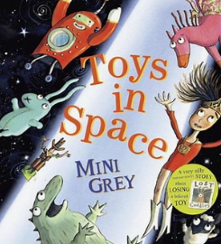 | Year Group: | 2 | Term: | Autumn 1
Text and Author: |  | Final Outcome: | Narrative

LSP Writing Progression Learning Objectives:
 | Key Learning | Autumn Term
 |  | 5a (spelling recap)  5b Mastery
Spelling | Follow the progression of your Spelling Programme to ensure pupils have sufficient practice to master the Y2 Spelling objectives.
Handwriting | Follow the progression of your Handwriting Programme to ensure pupils have sufficient practice to master the Y2 handwriting objectives.
Vocabulary, Grammar and Punctuation | - Say, write and punctuate simple and compound sentences using the joining words and, but, so and or (co- ordination). | - Say, write and punctuate simple and compound sentences using the joining words and and but (co-ordination).
Vocabulary, Grammar and Punctuation | - Secure the use of full stops, capital letters, exclamation marks and question marks. | - Secure the use of full stops, capital letters, exclamation marks and question marks.
Composition: Planning | - Plan and discuss what to write about  e.g. story mapping, collecting new vocabulary, key words and ideas. | - Discuss and plan what to write about e.g. story mapping, innovating on a known story, generating and developing vocabulary and ideas.
Composition: Drafting and Writing | - Orally rehearse each sentence prior to writing. | - Orally rehearse each sentence prior to writing including simple and compound sentences.
Composition: Drafting and Writing | - Proofread to check for errors in spelling, grammar and punctuation. | Proofread to check for errors in taught spelling, grammar and punctuation.

Lesson Objective: | Retrieval/ Introduction | Direct Instruction | Application/ Practice | Review/ Assessment
Lesson 1  L.O. To discuss and express views about a story.  Resources needed:  Toys in Space text  LO strips for pupils to glue into books  Lesson support sheet with picture cues and stem sentences  Stem sentences to glue in as scaffold if needed  SSP GPC and CEW mats | Hook  Discover toys in classroom. Give children time to explore. What toys have appeared?  Where have they come from?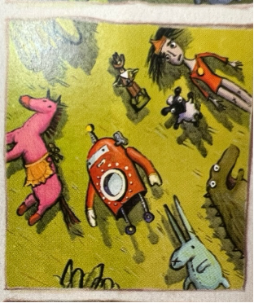  Introduction  Explain that we will be exploring Toys in Space by Mini Grey over the next two weeks. Today we will read the story and then discuss and express our views about it. | Read the story.  Explain that when we read a story, we form opinions about what we like and dislike. Share definition of opinion.    Teacher to share something they liked and disliked. Refer back to story thumbnail pictures as a prompt (children can use these when they have their discussions).  E.g. I liked when the toys looked up at the night sky because the stars were mesmerising.  I disliked when Hoctopize was crying because I felt sad for him.    Share slide which displays the stem sentence, ‘I liked when... because’. Ask chn to use the stem sentence and tell their LP something they liked about the text.  Share slide which displays the stem sentence, ‘I disliked when... because’. Ask chn to use the stem sentence and tell their LP something they disliked about the text.  Use next slide to explain that we can also make links with other texts we know. Ask, ‘does Toys in Space remind you of anything you’ve read before?’ Teacher to model with examples relevant to their class (book examples on the board e.g. Toys in Space reminds me of The Smeds and The Smoos because they both have a rocket/ spaceship in them.)  Next explain that stories can remind us of experiences we’ve had. Ask, does Toys in Space remind you of any experiences you’ve had? Teacher to model an example e.g. It reminds me of when I lost one of my favourite toys.  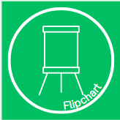  Teacher to model writing a response on flipchart paper. Model sticking in LO (if you do this) . Then model skipping a line and writing while thinking aloud:  ‘I liked when (be explicit that you are copying this from the stem sentence resource) the toys helped Hoctopize (now I want to give a reason using my conjunction) because it was kind.’  Reference resources that can help (GPC/CEW mat, word bank). Reference –ed suffix for ‘helped’. Model using GPC mat to spell ‘kind’.  Verbally share what you plan to write for the star challenge, ‘It reminds me of Toy Story because the toys are alive in that story too.’ Add this to flipchart when children are moving to tables so that they have this to refer back to. |   Pupils to stick LO into books at the top of the page  Use resources to help generate their response.  Sentence stems:  I liked... because  I disliked… because  It reminded me of  Scaffolding: Stem sentences to stick in.  Ensure SSP specific resources are accessible to all pupils to support with spelling and writing. | 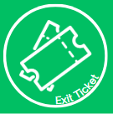  Pupils to share an idea in pairs/ with the class.  If necessary, have an example response that contains a common error that children have made in their writing. Ask them to check their own work for this error.  Ask pupils if they know any other books by Mini Grey. Explain that there will be a basket with other Mini Grey books for children to access and explore throughout the next couple of weeks.
Lesson 2  L.O. To understand and use expanded noun phrases.  Resources needed:  Teacher’s own A3 version of adjective word bank printed  word bank sheets  LO strip for pupils to glue into books  A character strip for each child |   Retrieval  Ask chn, ‘What is a noun?’ LP talk.  Share noun definition: a noun is a word that names a person, place or thing. Repeat definition.  Share purpose of our learning today- to help writing character description of Hoctopize.    Noun and adjective retrieval on whiteboards.  Show words – which is not a noun?  Ask chn, ‘What is an adjective?’ LP talk.  Share adjective definition: a word that describes a noun.  Show words – which is not an adjective?  Use responses to elicit which children are not secure in this learning. | Share slide with image from book and create a list of all the nouns on the page with the children. Model the first one: ‘A noun is a word that names a person, place or thing so I’m going to choose the ‘horse’. Tell your LP another noun that you can see. Cold call pupils to identify all nouns (characters) on page.  Explain that Mini Grey didn’t just use nouns for her characters. She used adjectives to describe them. This made the story more interesting and helped us to visualise the story. An adjective is a word that describes a noun. Share the word bank filled with adjectives.  Remind children of their Y1 learning where they created expanded noun phrases using noun + adjective.  Explain that we are now in Y2 so we can make even more interesting expanded noun phrases using two adjectives. adjective + adjective + noun  Model using ‘rabbit’. Show picture of rabbit and model looking for adjectives on teacher’s own printed word bank. The adjective long-eared describes the rabbit well and so does blue. I’m going to choose blue and long-eared.  Use slide to read full expanded noun phrase: blue, long-eared rabbit. Explain that to be punctuation experts, we must use a comma to separate our adjectives!  Model writing expanded noun phrase:  blue, long-eared rabbit    Ask chn to write two expanded noun phrases on their whiteboards- one for the cowboy and one for the horse.   Challenge  Improve one of their phrases. Ask pupils to show whiteboards and use this to inform who you will support during the lesson. | Explain chn’s task: to write at least three expanded noun phrases into their books.  Model gluing LO strip onto top of page (if you do this) . Teacher to work with guided group who need support.  Challenge- write a sentence including the expanded noun phrase about one of the characters. This could be about something they do in the book or about their appearance. | Choose expanded noun phrases from key children and model writing them with commas. Keep this to refer back to during the week.  NB: ensure expanded noun phrases are modelled without capital letter/full stop as they’re phrases and not a sentence.
Lesson 3  L.O. To understand and use expanded noun phrases.  Resources needed:  LO strips for pupils to glue into books  Word bank support sheet for use at tables  SSP GPC and CEW mats | Retrieval  Display slide with page from book showing characters and blanked out expanded noun phrases as well as expanded noun phrase prompt. Ask pupils to write two expanded noun phrases on their whiteboards. Once complete, ask pupils to show you and use this to inform your AfL.  Then, reread the text, asking the chn to pay particular attention to Hoctopize. | We will be writing a character description about Hoctopize this week. To ensure we have all the tools we’ll need, we’ll need to describe Hoctopize using expanded noun phrases. Share L.O. again for today.  Retrieval- Chn to remind partner of definition of a noun. Repeat as a class.  Think, pair, share- What nouns can we spot? We’ll need to identify the nouns/the things that we can describe about Hoctopize. Let’s focus on Hoctopize’s appearance, what he looks like. He is an alien, we could describe his eyes, his skin, his fingers, his clothes, his slippers..  Display slide with expanded noun phrase prompt and adjective word bank. Talk through adjectives within the word bank then ask pupils to share two expanded noun phrases verbally with their LP. Cold call some responses and note some good ones on a post-it for use later.  Explain that we will now think about what he is like as a character, as a person. We know he is sad – why is he sad? LP talk. What other words could we use to describe his personality? Talk through personality adjectives discussing which are appropriate to describe Hoctopize and which are not based on what we know from the story.  Share slide displaying appropriate adjectives to describe Hoctopize’s personality.  Tell your LP something about Hoctopize’s personality.  Can you extend your sentence using because?  Hoctopize is ______ because ____________.  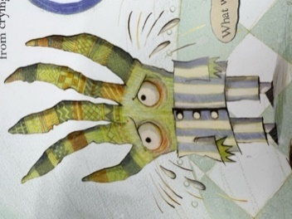 | Model sticking LO  Model writing two expanded noun phrases:  small, green alien  soft, patterned skin  Then remind children that their challenge model writing a sentence to describe Hoctopize’s personality and read example sentence aloud. Keep on board.  Hoctopize is organised because he labelled all the toys he collected.  Chn to stick LO in at top of page (if you do this) . Then children write expanded noun phrases about Hoctopize’s appearance  Ensure SSP specific resources are accessible to all pupils to support with spelling and writing. | Chn to read their work back with a table partner and make edits to spelling/punctuation if needed.
Lesson 4  L.O. To write a character description  Resources needed:  Character description success steps x30  SSP GPC and CEW mats | Do now  Display slide and ask chn to share some of the expanded noun phrases they used to describe Hoctopize yesterday. (Also redisplay yesterday’s flipchart model.) | Today we will be writing our character descriptions about Hoctopize. We will be using the expanded noun phrases we created yesterday and putting these into full sentences.  Use slide to share success steps for today’s writing. Explain that to be successful in today’s writing task, we will need to remember and use: walk chn through success steps.  Display slide with two expanded noun phrases from yesterday’s lesson. Explain that we will need to think carefully today to put the expanded noun phrases we created yesterday into full sentences.  Model on flipchart.  Write the title Hoctopize and underline this with a ruler.  Then model putting the first expanded noun phrase into a sentence. Explain that we will need to begin our first sentence with Hoctopize and explain that you are using the verb ‘is’ to create a full sentence. For the sentences that follow this we can use the sentence stem ‘He has…’.  Hoctopize is a small, green alien (and what extra description could I add? Maybe I can explain what shape he is...) who looks like a hand.  When modelling, model carefully copying Hoctopize’s name to ensure it’s spelt correctly. Model finding ‘who’ on a common exception word mat.  I think I will start by describing his skin. I will look at my ideas from yesterday on our flipchart paper. I used the adjectives patterned and soft so I can put that into a whole sentence. He has patterned, soft skin.  Display slide with two further expanded noun phrases created yesterday. Ask pupils to put the two expanded noun phrases displayed into full sentences using the sentence stem ‘He has…’ Use AfL from this to inform who needs support during this lesson.  Explain that once children have finished describing his appearance, they will describe his personality and they can refer back to yesterday’s work to help them.  Then model a sentence describing Hoctopize’s personality extending this sentence using ‘because’.  He is organised because he labelled the toys he took.  Now model explicitly reading writing back and checking off the success steps once you’re confident you’ve included everything. | Model a further sentence describing Hoctopize’s appearance.  Children have access to SSP resources, yesterday’s work, yesterday’s whole class expanded noun phrases and modelled sentences from today.  Teacher to have access to full WAGOLL to refer to during work with guide group-further sentences can be verbally shared or modelled if time.  Hoctopize is a small, green alien who looks like a hand. He has patterned, soft skin. He has bright red eyes because he is sad. He has blue, silky clothes and warm, fluffy slippers. He has sharp, pointy fingers. He is organised because he labelled the toys he took. | Chn to read their work back and tick off success steps once they’re sure they’ve included each element. Success steps to be stuck in.  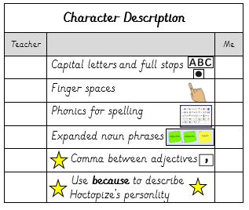
Lesson 5  L.O. To orally rehearse and retell a story  Resources needed:  15 x story maps  1 x A3 story map to display on board | Do now  Display pictures from the book and ask children to tell their partner how much they remember about the events of the story.  Explain that next week we will be retelling the story of Toys in Space in our writing lessons. To ensure we have all the tools we’ll need, we must make sure we know the story well and have practised retelling it.  Re read the story. | Explain that you have created a story map to help with orally retelling the story. Explain that we will be retelling the story from Wonder Doll’s perspective.  Teacher model orally retelling.  One summer night there were seven toys left out in the garden: a pink horse, a small sheep, a blue rabbit, a little cowboy, a green dinosaur, a wind – up robot and me, Wonder Doll. We thought we saw a bright star but it was a spaceship! It beamed us up and we saw an alien. He looked like a hand with red eyes. He was sad because he lost his toy. He took lots of toys trying to find his. We told him they had to go back to their homes so we helped him return them. We had a party to cheer him up. Then, we went home and said goodbye to our new friend.  Teacher to retell again and add conjunctions onto teacher story map to keep on board as reference.  Pupils to chorally re-tell with the teacher. Go through this two or three times as needed. Add notes on flipchart around story map for children to refer back to. Keep conjunctions on board to remind children to include these to link ideas. | Chn to use story map and orally retell Toys in Space with their table partner. | Pairs retell to another pair on table.
Lesson 6  L.O. To understand and use conjunctions.  Resources needed:  1 x A3 story map to display on board  A3 Lesson 6 sheet to be stuck on flipchart  Lesson 6 sheets 1 per child |   Do Now  Children retell the story in pairs using story map on board/ story map at tables | Share learning objective and explain how this will help with our learning this week-  This week, we will be retelling the story of Toys in Space in our writing lessons. To ensure we have all the tools we’ll need, we need to be confident to understand and use conjunctions to extend our sentences.  Explain that conjunctions are words that connect words or groups of words. Conjunctions can join two sentences together.  We use conjunctions to add extra information or detail to our sentences.  Next use the slide to explain the different use of conjunctions.  and – more than one idea  but – two opposite ideas  because – to explain why  so – to explain why  Explain that we have two sentences from the story here. The sun went down. And, the toys saw the stars for the very first time. Model joining the sentences with ‘and’, ‘but’, ‘because’ and ‘so’. Explain that ‘and’ is the best conjunction to join these sentences.  Model writing this on flipchart using ‘and’. When modelling, think aloud your adjustment to the punctuation: because we are joining two sentences using the conjunction ‘and’, I’ll need to remove the full stop from the end of my first sentence, write my conjunction to join the sentences and change the capital letter for the second sentence to a lower case letter as it won’t be at the beginning of the sentence anymore.  Next model using the two sentences on the following slide. Practise attempting to join the sentence with and, but, because and so. Encourage children to listen to the one that sounds like it fits best. Explain that ‘because’ is our best choice this time because the second sentence explains why the toys were worried. Model writing this on flipchart using ‘because’.  When modelling, think aloud your adjustment to the punctuation: Because we are joining two sentences using the conjunction ‘because’, I’ll need to remove the full stop from the end of my first sentence, write my conjunction to join the sentences and this time, I don’t need to change the capital letter for the second sentence because it is Hoctopize’s name – a proper noun – so this needs a capital letter wherever we use it in our writing.  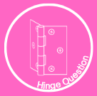  Read each sentence displayed and ask the chn to finger vote to tell you which conjunction is the best choice. Use this AfL to inform who you support during guided practice.  Share slide and ask chn to select the most appropriate conjunction to join the two sentences: He looked at all the toys. None were the one he was looking for. Once they have chosen the best conjunction, ask them to rewrite the sentences as one, adjusting the punctuation to ensure it’s correct.  AfL when pupils show whiteboards. | Chn to glue in LO + activity and then rewrite the sentences joining them with an appropriate conjunction and adjusting the punctuation to make sure it’s correct.  Model gluing in sheet at top of page and then model the first one. | Chn to check their work against the answer sheet and edit any mistakes.
Lesson 7  L.O. To retell a familiar narrative.  Resources needed  Teacher copy of story map  Children’s copies of story map  Success steps one per child | Children to write the displayed sentences onto their whiteboards with the correct conjunction used and correctly adjusted punctuation. | Today, we will begin our retelling of Toys in Space. We will be retelling the story from Wonder Doll’s perspective.  Share LO.  Chorally retell the story using the story map. T do this in a group/ with specific pairs needing support.  Teacher Modelling:  Talk children through success steps to explain how we will be successful in our writing. Explain that we are going to focus on the first 3 pictures on our story map today.  Teacher to model writing first sentence onto flipchart – title: Toys in Space and model underlining with a ruler.  Leave a line and begin writing:  One summer night, there were (model finding words in bold on CEW mat) seven toys left out in the garden. Children copy modelled sentence into book, paying close attention to CEW mat. (M in the margin)  Pause here and explain that you will be dictating the next part of the story for the children to help them to focus on their best handwriting and accurate spelling and punctuation. (TW for transcriptional write in the margin if this is the code your school uses) Remind children of commas between adjectives.  Orally rehearse the sentence and get children to orally rehearse. Ask children which adjectives have been used to help them identify where the commas go.  There was a kind, pink horse and a small, fluffy sheep. | Children to continue writing about the toys using expanded noun phrases. Ensure they orally rehearse their next sentence using their expanded noun phrases and scaffold on the board.  There was ___________ and a ____________. There was also a _________ and a _________. And finally there was me! My name is WonderDoll and ____________________-.  Bring children back together to write the next sentence.  Teacher to model writing on flipchart:  We thought we saw a bright star but it was a spaceship!  Model continuing from where you left off – finding your full stop that finished the last sentence yesterday and beginning just after this.  Model explicitly using the CEW mat to ensure you spell ‘thought’ correctly.  Model using phoneme fingers to segment the word ‘spaceship’, explicitly count phonemes and share that there are 7 graphemes you need to write this word – model using GPC mat to identify graphemes. You could model a best bet: spaisship, spaseship, spaceship and carefully thinking about which one looks right.  Cover up modelled sentence and children write their own.  Scaffolding: guided group dictated writing for example-  One day we were left in the garden. We saw a bright star. It was a rocket ship! It beamed us up and we saw an alien.  Ensure SSP specific resources are accessible to all pupils to support with spelling and writing. | Pupils to read aloud what they’ve written so far to their table partner.  Teacher model how to check against success steps.  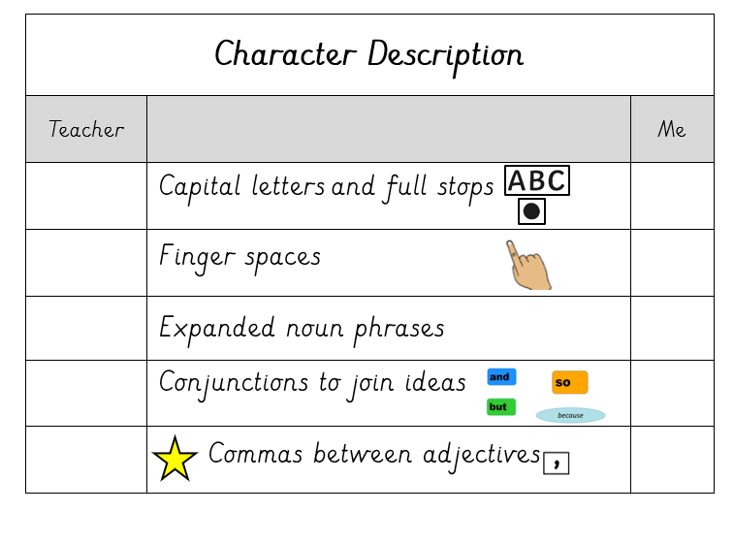
Lesson 8  L.O. To retell a familiar narrative.  Resources needed  Completed teacher WAGOLL on flipchart to show writing from yesterday- this will help when we model re-reading and checking where to begin writing today.  Teacher and children story map  For example-  One summer night there were seven toys left out in the garden. There was a kind, pink horse and a small, fluffy sheep.  There was blue, long-eared rabbit and a clever cowboy. There was also a shy, green dinosaurand a caring, red robot. And finally there was me! My name is WonderDoll and I have scruffy hair. We thought we saw a bright star but it was a spaceship! | Chn to write some expanded noun phrases on their whiteboards to describe Hoctopize. (Could do this in pairs)  T to cold call pupils asking them to share one expanded noun phrase with the class. | Today, we will continue our retelling of Toys in Space.  Share LO.  Where are we picking up the story following on from yesterday’s writing?  Ask pupils to retell the story with their LP and spot where we’ll be picking up from for today’s writing. T do this in a group/ with specific pairs needing support. Cold call to share. Teacher model oral retell if needed.  One summer night there were seven toys left out in the garden: a pink horse, a small sheep, a blue rabbit, a little cowboy, a green dinosaur, a wind – up robot and me, Wonder Doll. We thought we saw a bright star but it was a spaceship! It beamed us up and we saw an alien. He looked like a hand with red eyes. He was sad because he lost his toy. He took lots of toys trying to find his. We told him they had to go back to their homes so we helped him return them. We had a party to cheer him up. Then, we went home and said goodbye to our new friend.  Remind pupils of the things we need to include to be successful when writing our retelling of Toys in Space. Remind children that we need to refer to our classroom phonics resources.  Model thinking aloud- ‘We will write one more sentence about the spaceship. Yesterday we saw the spaceship and now we want to talk about how we got into the spaceship. Then we will move on to describe Hoctopize.  Dictate: It beamed us up (now I want to add a bit more information about what we saw before we describe Hoctopize- I will use the conjunction and for a bit more information) and we saw an alien. ‘ | Cover/hide model when pupils begin writing to ensure they are encoding independently.  Dictated sentence-  He looked like a hand with big, red eyes.  Show sentence stem to support  He was sad because _________. Children finish writing about Hoctopize.  Pupils to continue writing about Hoctopize using expanded noun phrases in their story to make it more interesting.  Scaffold: guided group dictation:  He looked like a hand with big, red eyes. The alien was sad because he had lost his toy. He took lots of toys trying to find his.  Ensure SSP specific resources are accessible to all pupils to support with spelling and writing. | Pupils to read their work aloud to check it makes sense and that their spelling and punctuation is correct so far. Use Success Steps to support.
Lesson 9  L.O. To retell a familiar narrative  Resources needed teacher WAGOLL from yesterday on flipchart  e.g.  We thought we saw a bright star but it was a spaceship! It beamed us up and we saw an alien. He looked like a hand with red eyes. He was sad because he lost his toy. He took lots of toys trying to find his. One summer night there were seven toys left out in the garden. There was a kind, pink horse and a small, fluffy sheep.  There was blue, long-eared rabbit and a clever cowboy. There was also a shy, green dinosaurand a caring, red robot. And finally there was me! My name is WonderDoll and I have scruffy hair.  Teacher story map  Children’s story maps | Ask pupils to retell the story with their LP and spot where we’ll be picking up from for today’s writing. T do this in a group/ with specific pairs needing support. Cold call to share. | Today, we will continue our retelling of Toys in Space.  Share LO.  Ask the chn to discuss the displayed questions with their LP:  - How did Hoctopize return the toys?  - What did they do at the party?  - Why did the party end?  - How did the toys return home?  T to listen in to target pairs/ support discussion for those children who need support. Cold call and make quick notes on flipchart if necessary to support.  Teacher to model writing onto flip chart: Model thinking aloud how we want to answer the first question on the list and looking back at story map. How did Hoctopize return the toys? We told him they had to go back to their homes so we helped him return them. – think aloud your spelling of ‘their’, ‘helped’ (-ed suffix that sounds like ‘d’) and GPC mat for ‘return’. (When using GPC mat, model using phoneme fingers to segment word and count how many phonemes there are. Explicitly share you need to write 5 graphemes to represent the 5 phonemes in the word ‘return’. | Transcriptional write/ dictated sentence  We told him they had to go back to their homes so we helped him return them.  You do  Before children complete their story, teacher model orally rehearsing sentences while referring back to their story map to answer the questions. This will help support children to think about their own sentences.  e.g.  We had a party to cheer him up. Then, we went home. Then we said goodbye to our new friend. Could I use a conjunction to join those last two ideas? Then, we went home and said goodbye to our new friend.  Extend  : use support sheet to add extra detail to their ending. Prompt them to use conjunctions.  Support: guided group dictation:  We helped him return the toys and had a party to cheer him up. We went home and said goodbye to our friend.  Ensure SSP specific resources are accessible to all pupils to support with spelling and writing. | Pupils to reread their work aloud and to self assess their writing against the success steps. Success steps should be glued in underneath writing.
Lesson 10  L.O. To make simple corrections to my writing.  Resources needed:  Modelled write (with mistakes) prepared on flipchart to model editing process. | Chn to correct spellings of CEWs displayed on slide. | Today we will be editing our retelling of Toys in Space to make corrections. Share LO.  T to model editing process by carefully reading aloud model from flipchart with mistakes. Firstly, read through and model correcting all missing capital letters and full stops. Then read through again and correct CEW spellings using mat. Model spotting a missing grapheme and edit the spelling of this. Model adding some extra description.  After modelling the first sentence, ask for pupils to put their hands on their head when they spot a capital letter or full stop missing.  When going through the second time focusing on spotting CEWs, model editing the first mistake and then ask pupils to put their finger on their nose when they spot a misspelt CEW.  Ask for pupil’s input when modelling adding extra description. Children refer back to own stories/ pieces of writing in the build up and partner talk before sharing. |   Chn to edit their stories.  - Read your work back through to self and partner  - Check your capital letters and full stops  - Check the CEW spelling  - Check you have used your phonics for spelling words.  Star challenge: add some extra description.  Ensure SSP specific resources are accessible to all pupils to support with spelling and writing. | Identify some pupils who have edited well and share what you like about these using a visualiser.

Teacher WAGOLL story retell:
One summer night, there were seven toys left out in the garden. There was blue, long-eared rabbit and a clever cowboy. There was also a shy, green dinosaur and a caring, red robot. And finally there was me! My name is WonderDoll and I have scruffy hair.

We thought we saw a bright star but it was a spaceship! It beamed us up and we saw an alien. He looked like a hand with red eyes. He was sad because he lost his toy. He took lots of toys trying to find his. One summer night there were seven toys left out in the garden. There was a kind, pink horse and a small, fluffy sheep.

We told him they had to go back to their homes so we helped him return them. We had a party to cheer him up. Then, we went home and said goodbye to our new friend.

