Text and Author:  Last stop on Market Street. |  | Year Group: | 2 | Term: 3  15 lessons | Spring 1
Text and Author:  Last stop on Market Street. |  | Final Outcome: | Recount in the first person

 | Key Learning | Spring Term
Spelling | Follow the progression of your Spelling programme to ensure pupils have sufficient practice to master the Y2 spelling objectives.
Handwriting | Follow the progression of your Handwriting Programme to ensure pupils have sufficient practice to master the Y2 handwriting objectives.
Vocabulary, Grammar and Punctuation | - Say, write and punctuate simple and compound sentences using the joining words and, but, so and or. | Say, write and punctuate simple and compound sentences using the joining words and, but, so
Vocabulary, Grammar and Punctuation | - Secure the use of full stops, capital letters, exclamation marks and question marks. | - With prompting, edit and improve own writing using full stops, capital letters, exclamation marks and question  marks.
Vocabulary, Grammar and Punctuation | - Use subordination for reason using because and if e.g. I put my coat on because it was raining. Because it was raining, I put on my coat. | - Use subordination for reason using because and if e.g. I would go on an exotic holiday if I won the lottery. If I won the lottery, I would go on an exotic holiday.
Vocabulary, Grammar and Punctuation | - Use present and past tense correctly and consistently.  - Explore the progressive form of verbs in the present tense (e.g. she is drumming) and past tense (e.g. he was shouting) to mark actions in progress. | - Explore the progressive form of verbs in the past tense, orally and in writing, to mark actions in progress, e.g. He was singing at the top of his voice. They  - were flying through space.
Vocabulary, Grammar and Punctuation | - Select, generate and effectively use adjectives | - Generate, select and effectively use adjectives.  Edit and improve own writing by strengthening the use of adjectives to create simple noun phrases, e.g. the ferocious green dragon.
Composition: Planning | - Plan and discuss what to write about  e.g. story mapping, collecting new vocabulary, key words and ideas. | - Discuss and plan what to write about  e.g. story mapping, innovating on a known story, extending vocabulary and ideas.

 | Key Learning | Spring Term
Composition: Drafting and Writing | - Orally rehearse each sentence prior to writing. | - Orally rehearse every sentence before writing, including compound sentences using the joining words ‘and’, ‘but’ and ‘or’.and those which have been extended.
 | - Proofread to check for errors in spelling, grammar and punctuation.  - Proofread to check for correct form of verbs within sentences, e.g. correcting he walking to the shop to he walked to the shop. | - Proofread to check for errors in spelling, grammar and punctuation, including the correct form of verbs,  e.g. spotting and changing he walking to the shop to he walked to the shop.
Performing | - Read aloud their writing with intonation to make the meaning clear. | Read aloud their writing with intonation taking note of punctuation to make the meaning clear e.g. pausing at commas which separate items in a list.

Lesson Objective: | Retrieval/ Introduction | Direct Instruction | Application/ Practice | Review/ Assessment
Week 1  Lesson 1  To discuss and express views about a story. | Explain that we will be exploring Last Stop on Market Street by Matt De La Pena & Christian Robinson over the next few weeks.  Today we will read the story and then discuss and express our views about it.  Explain that our final write will be writing a recount as if we’re CJ. To be successful, we’ll need to know the order of the story really well.  A recount is when you write about your day after it happened. Diary entries are written in chronological – or time – order. | Look at the front cover. What do you notice? What do you wonder? What do you predict?  Share a definition of prediction for clarity -prediction is an expert reading skill. A prediction is what someone thinks will happen.    Partner talk- Hone in on key pupils during conversation to scaffold discussion. Cold call responses.  Read the first half of the story. Stop at ‘So did CJ and the spotted dog.’ Pause at the end of part one and model noticing the buildings, church and people doing different things.  Teacher model opinion on the story so far using stem sentence before partner talk.  E.g. I loved the descriptive language in the story because it helped me slow down and appreciate all the things happening. E.g. ‘he watched water pool on flower petals’. This made me feel calm.  What do you think so far? Provide stem sentences for discussions- I liked… The book made me feel… I didn’t like…  Ask if the story reminds them of any others they know or of any experiences they’ve had.  It reminded me of… because  (experiences they have had)  (The book links nicely with It’s a No Money Day Invisible and I am the Subway.) Does the story remind them of any experiences they’ve had?    Model writing one or two sentences on flipchart using stem sentences and ideas gathered as a class. E.g. ‘I liked when CJ’s nana said the trees were drinking through straws because this made me laugh.’ When modelling, think aloud the writing process. Reference resources that can help (GPC/CEW mat, word bank). Reference –ed suffix for ‘liked’. Model using CEW mat to spell ‘because’ or ‘laugh’. | Display stem sentences and ask pupil to write their I liked/My favourite part sentence. Ensure pupils extend their sentence using ‘when’ or ‘because’ to give more information.    Chn to take whiteboard to table so they have their first sentence ready. Complete a number of sentences using sentence stems in books.    Extend sentences using ‘when’ and ‘because’ | 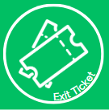  Teacher to model re-reading one of their sentences on the flipchart, modelling their checking for CL, full stops and a conjunction. Model talking this aloud before pupils whisper read their sentences aloud to themselves checking for the same things.  Chn to reread writing and edit any errors in spelling, grammar, punctuation.
Lesson 2  To understand and correctly use the -ed suffix.  N.B This lesson and next lesson may need tweaking depending on whether the double, drop, do nothing rule has already been taught or whether this is the first time it’s being taught. Snip from English Appendix 1 statutory requirements included for reference. |   Retrieval  What can you remember from the story so far? What were your thoughts/ opinions?  Explain that next week, we will be writing a recount as if we’re CJ. Because it is a recount of a day that’s already happened, we’ll need to write in the past tense. This means we’ll need to practise how we can use the –ed suffix correctly. | Ask pupils what they already know about verbs and ask them to discuss examples. Share definition of verbs to ensure clarity.  Re-read the text and pupils to think about what verbs they can hear. You may wish for pupils to jot these down on whiteboards.    Pupils to note down the verbs from this page on their whiteboards. CFU- are there any misconceptions? Support pupils who need it during this task.  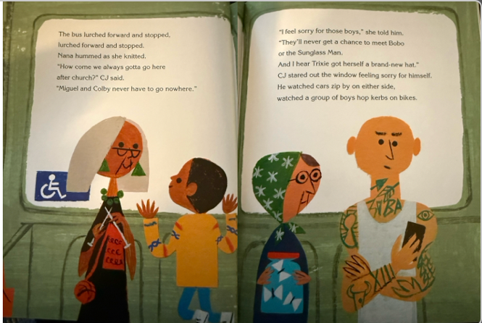  Waved, talked, hummed, knitted, (the bus) stopped, lurched etc…  Can they think of any of their own that aren’t in the text… looked, smiled, asked (questions)  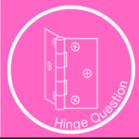  Hinge Question  Which word is not a verb? Pupils to finger vote response.  English Appendix 1 for reference-  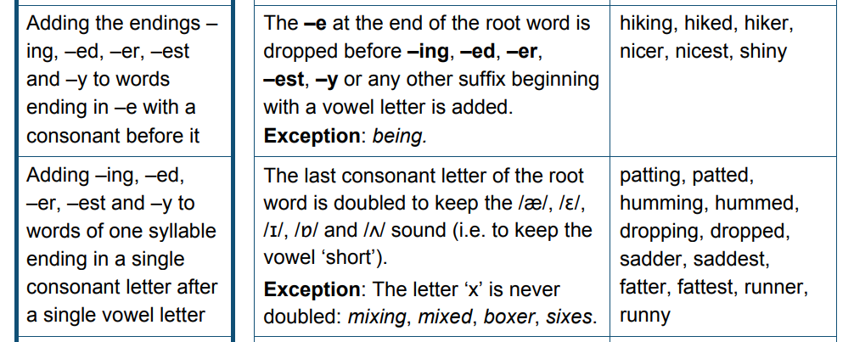  Explain that when we write verbs in the past tense, we mostly use the –ed suffix (though there are some exceptions). A suffix is a group of letters added to a root word.  Display ‘listen’ (root word) and ‘listened’. Explain that in this example we have not had to change the root word. We have simply added the –ed suffix. We haven’t had to do anything because there is a long vowel sound in this word. Some words however, do require us to do something. Let’s look at another example:  Display ‘skip’ (root word) and ‘skipped’. Ask pupils, what do you notice? LP talk. Cold call responses. Explain that here we have had to double the consonant before adding the suffix. We need to double the consonant if the word ends in a consonant and has a short – baby – vowel sound in it.  Explain that there’s another change we might need to make depending on our root word. Display ‘wave’ and ‘waved’ and invite pupils to notice what’s changed. Explain that in this example we have had to drop the ‘e’ from the root word and then add the ‘ed suffix. This one’s easy to remember, if our root word ends in ‘e’, we drop the ‘e’ and then add the suffix.  Pupils practise adding -ed suffix using double, drop, do nothing rule. Support pupils who need more help with this and use CFU to inform guided group for this lesson. Pupils tick or fix with answers on board. Cold call-ask pupils why they have spelt the word in this way according to the rules.  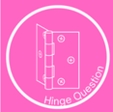  Pupils to write verbs in the past tense. CFU and use to identify pupils needing further support following the -ed rules. | Model task for pupils. Pupils to copy task from task sheet into their books rewriting the verbs provided so that they’re in the past tense using the –ed suffix.  Model how to lay out the work -re writing the first two verbs with the -ed suffix concentrating on the  Double  Drop  Nothing rule.  Task 1  Model sticking picture strip into book and writing each of the verbs in past tense with the -ed suffix, referring back to rules discussed today.  Children write the rest of the verbs in past tense. Keep prompts on the board if needed or use this as a scaffold for some pupils.  Star challenge: can they add their own?  Tick or fix with answers on the board.  Task 2  Then come back together – we are going to put the -ed words into sentences.  Model writing the first sentence using the first two verbs  CJ smiled and waved to his friends as it rained.  Dictation:  CJ looked and listened to all the people on the bus.  Then children write their own sentences using the verbs (or their own -ed verbs that they added) | Tick and fix -ed endings. Teacher check for/ share any common errors.
Lesson 3  To use coordinating conjunctions correctly. | Retrieval  -ed suffixes- CFU and identify pupils who will need more support with this.  Explain to pupils how this lesson will support us with our extended writing- next week, we will be writing the first part of our recount as CJ. To be successful, we’ll need be confident to extend our sentences using conjunctions. Share LO. | Remind pupils that conjunctions are words that connect words or groups of words. Coordinating conjunctions can join two sentences or main clauses together. We use conjunctions to add extra information or detail to our sentences.  We are going to write some compound sentences today in the past tense, practising our learning from yesterday and extending our sentences. Share an example of compound sentences using each of the conjunctions for today. Unpick why the chosen conjunction is used in that sentence in particular- is it because there is more than one idea? Two opposing ideas? To explain why? To give two options?  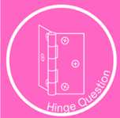  Use hinge question to assess understanding of most appropriate conjunction based on discussion so far.  1 It started raining so I sheltered under my umbrella.  2 He did a funny trick but it made me laugh.  3 He played his guitar or I closed my eyes.  We do  Display clauses for pupils to practise selecting the correct conjunctions. Pupils to write sentences using conjunctions on their whiteboards. CFU. | 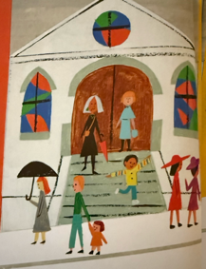  Model writing sentence under picture 1 use a coordinating conjunction.  CJ skipped down the stairs and happily jumped off the last one.  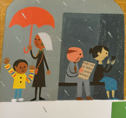  Dictation  It started raining so Nana put up her umbrella.  Pupils to complete task independently.  e.g.  CJ and Nana stood under the umbrella but the rain still splashed. | Read your sentences to your LP. Do they make sense? Share strong examples or unpick any common misconceptions.
Lesson 4  LO: to write in the first person  Setting description of the bus  Resources-  Photocopied pages from book of bus section  Success steps | Retrieval:  Write a sentence(s) based on the picture that starts with a coordinating conjunction.  When we write our recount we will be writing as CJ so we need to use the first person to write as him. Today, we are going to write a short setting description about what it was like on the bus. | When we are writing in the first person we use  I, me, my and we  Before we write in role let’s talk in role.  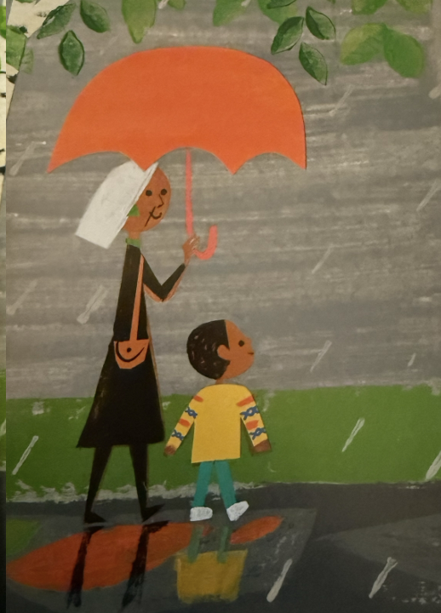 Teacher model talking in role.  “Nana and I walked in the rain. We hopped over puddles. We did not want to get wet”.    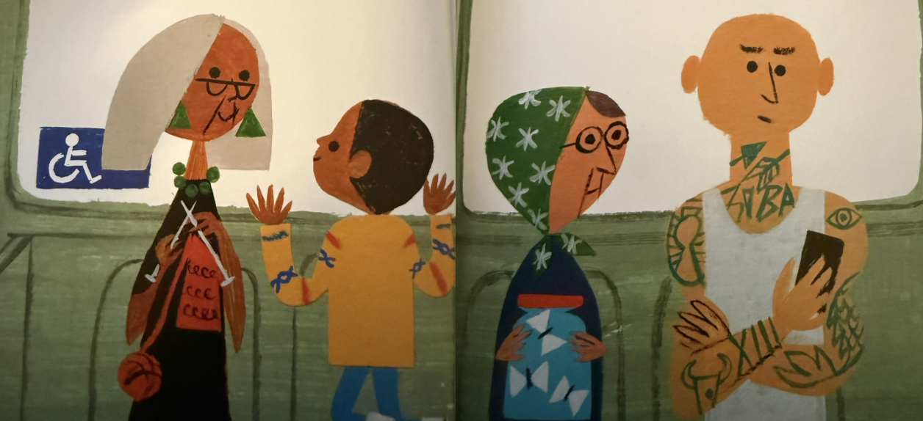  My gran hummed and knitted. I stared out the window. I wished I didn’t have to get the bus. talk in partners and listen in.  CFU to ensure class understand which sentences are written in first person.  Re-read two pages from the book about the bus (these could be printed double sided in front of the children at their desks). Children listen for senses and as a class note down ideas- 3 columns for senses (felt as an extra challenge) on flipchart paper to refer back to.  Practise in pairs orally rehearsing sentences about senses in first person and past tense. Encourage children to use a co-ordinating conjunction.  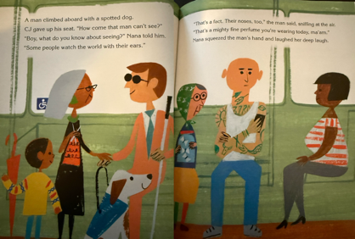  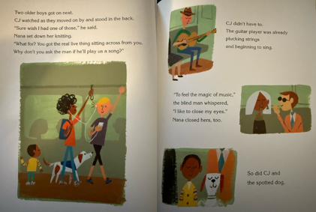 | Model writing an introductory first sentence in first person and past tense with a conjunction, thinking aloud. e.g. I want to introduce our setting so I will write about when we got onto the bus and met Mr Dennis. I could write two simple sentences. We got onto the bus. Mr Dennis pulled a coin from behind my ear. But I know we’ve been practising joining our simple sentences with conjunctions so I’ll try and create a compound sentence with those two ideas. We got onto the busy bus and Mr Dennis pulled a coin from behind my ear.  Dictated sentence(s). Encourage children to refer to phonics/ CEW displays.  We sat right up front so we could see all of the people.  Nana smiled at them and she told me to say hello. (remind children of drop rule for smile)  I smelt her mighty fine perfume and… children to complete  Prompt them with an idea- e.g.aybe you could finish the sentence with an idea about her knitting.  You do  Children continue the  Saw, heard, smelt sentences.  I felt…. | Pupils to read their writing aloud to a partner.  Teacher to model how to check against success steps using the model write (potentially with a planned error included to ensure pupils know how to self-edit for a particular element based on assessment during the lesson)
Week 1 Lesson 5  To use subordinating conjunctions correctly. | Retrieval- Change the sentences to first person. CFU- identify pupils needing more support.  Explain that we will be looking at different sentence types today to help us to think about ordering events when we write our recounts next week. | Explain that subordinating conjunctions are different to coordinating conjunctions because they join an independent or main clause ) with a subordinate clause that wouldn’t make sense on its own.  Share examples on board with subordinating conjunctions. Highlight main clause and explain how this makes sense as a sentence alone. Highlight how subordinate clauses begin with a subordinating conjunction and they don’t make sense alone.  Display simple sentence I skipped down the steps. Model adding a subordinate clause to add more information E.g. What detail could I add to my sentence? When did I skip down the steps? After the doors opened? Let’s rehearse that sentence- I skipped down the steps after the doors opened. My subordinate clause is after the doors opened. Does that make sense as a sentence alone? No. |   Give pupils stem sentences to complete with subordinating conjunction given. Children to orally rehearse the sentences before writing and then re-read to check for sense.  Children to add subordinate clause to given main clause. Pupils to keep their ideas on their whiteboards to support with independent task. CFU to inform guided group work.  Pupils to write complex sentences to match the given pictures. Star challenge- pupils to write additional sentences for pictures, independently selecting a different sub. conj for variety | Vote on which sentence uses subordinating conjunction (correct= no 2)
Week 2 Lesson 1  Write recount– see success steps  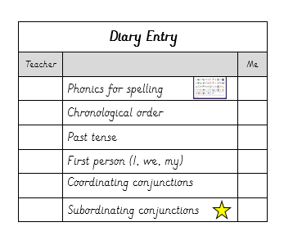 | Retrieval  Double, drop or do nothing whiteboard activity.  Retrieval  Display picture prompts which will be today’s focus for writing. Pupils to share with their LP what happened in these first parts of the story. Pupils to challenge themselves by including what CJ hears, smelt and saw. How did he feel at these points?  Purpose  Today, we will be writing the first part of our recount  Because we’ll be writing from CJ’s perspective, we need to imagine we are him and think about how he felt at each point in the story. | Explain that when you write a recount you are writing about a day in the life of a character. The recount needs to sound as if the character has written it, so it needs to be written from their point of view.  Next explain that recounts are written in chronological order. (So, our sequencing of the story’s events will come in handy!)  Explain that because we’re writing about our day that’s already happened. We will need to write in the past tense.  Invite pupils to share with their LP which suffix we’ll need to use a lot in our recount.  Let’s think carefully together about how we can begin our recount. Model imagining that you are CJ pushing through the church doors.  I was so excited to leave church that I skipped down the steps and towards the bus stop. (Think aloud: I want my reader to know that I was safe and that Nana was behind me so I’m going to add..) Nana was walking behind me.  Next share a sentence you’re going to include that’s not shown on the picture prompts: It started raining after we turned the corner. I slowed down and sheltered under Nana’s umbrella. Explain that you challenged yourself to extend your sentence using the conjunction ‘after.  Invite the pupils to orally rehearse and share a sentence with their LP as if they are CJ pushing through the church doors. Cold call some responses.  Display the second picture prompt and explain that CJ’s feelings changed when he saw Colby getting into his car. Explain that you’re going to think carefully about how you can include a subordinating conjunction: When we were at the bus stop, I saw my friend Colby and he got into his car. I smiled and waved but I felt jealous because we don’t have a car.  Invite the pupils to share a sentence with their LP as if they are CJ waiting at the bus stop with Nana.  Walk pupils through the success steps for our diary writing. | Modelled write  Writing following similar ideas to oral rehearsal with deliberate thinking aloud for -ed suffixes and subordination.  I skipped (think aloud: short vowel sound so I need to double the consonant) down the steps and towards the bus stop because I was so excited. It started raining after I turned the corner.  I saw my friend (model forgetting this spelling and finding it on a CEW mat) Colby when we were at the bus stop.  Pupils to have GPC mats, CEW mats, first two picture prompts and large success steps accessible on tables.  Dictation for your children who need additional support before writing independently:  I was so excited to leave church that I skipped down the steps and headed for the bus stop.  It started raining so we sheltered under Nana’s umbrella. When we got to the bus stop …  Children to then carry this on themselves., | Pupils to reread their writing to check it makes sense. Teacher model doing so with their modelled write.  Pupils vote on which sentence is written correctly in 1st person.
Week 2 Lesson 2  Write recount – see success steps | Retrieval  Pupils to reread their writing from last lesson.  Purpose  Today, we will be writing the next part of our recount  Because we’ll be writing from CJ’s perspective, we need to imagine we are him and think carefully about how he felt at each point in the story. | Display picture prompt focuses for today. Explain that we’ll be writing about these two parts of the story in our recount today.  Invite pupils to tell their LP what happened at these parts of the story.  Remind pupils that we will be writing in first person. Ask them to recall the pronouns they will use- ‘What sorts of words will we use when we write in first person?’ Take responses.  Remind pupils we will also write in chronological order and past tense.  Display slide with picture prompts for today’s writing. Model oral rehearsal of sentences to match the pictures. E.g. Remember we must think carefully about how CJ is feeling and we’re speaking and writing as if we’re him. CJ is excited to see Mr. Dennis because he always has a trick for him.  I ran to the bus because I was excited to see Mr Dennis. He always plays tricks on me so he is one of my favourite people.  Explain that you’re going to show his excitement by using the verb ‘ran’ to describe how he got on the bus.  Invite pupils to share a sentence with their LP as if they are CJ excited as the bus creaks to a stop. Cold call some responses.  Display the second picture prompt and explain that CJ’s feelings change again. He’s curious about all the people now. Model: There were lots of interesting people on the bus. We met a man who said he watches the world with his ears. Then a man started playing a song on his guitar. I closed my eyes as I listened.  Invite pupils to share a sentence with their LP as if they are CJ curiously looking at all the people on the bus. Cold call some responses. | Modelled write  The bus arrived (think aloud: drop the e) and I ran aboard to see Mr. Dennis. He did a funny magic trick because he loves to make me laugh. There were lots of interesting (model using phoneme fingers then referencing GPC mat to segment and spell) people (model finding word on CEW mat) on the bus. We met a man who said he watches the world with his ears. Then a man started playing a song on his guitar. I closed my eyes as I listened.  Pupils to have GPC mats, CEW mats, next two picture prompts and success steps ready to glue in at the end of today’s writing.  Possible dictation for pupils needing further support  As the bus arrived it creaked and sighed. I ran on to see Mr Dennis. He did a magic trick which made me giggle. There were lots of interesting people on the bus…  Children to then carry this on themselves., | Pupils to reread their writing to check it makes sense, following teacher model as yesterday. Unpick any misconceptions from assessment in the lesson.  Pupils to share a past tense verb they used today in their writing on whiteboards.
Read the whole story before the next session.
Week 2 Lesson 3  Use expanded nouns to describe. | Retrieval:  How did the text end?  Tell your learning partner about the picture.  Purpose: use simple noun phrases to describe the different neighbourhoods in the book. This will add description to our recount. | Explain that we are going to use expanded nouns to describe and compare the neighbourhoods at the start and end of the story.  What is a noun?  Children voting 1 or 3 are your spotlight children.  What is an adjective?  An adjective is a word that describes a noun.  Children voting 1 or 2 are your spotlight children.  Remind pupils that they already know a lot about expanded noun phrases- remind them of their learning from Toys in Space. What was the important piece of punctuation between the two adjectives before the noun?  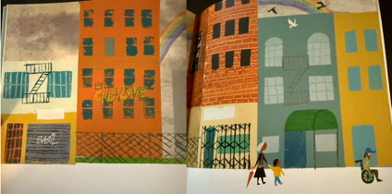  Share some expanded nouns written about the street scene at the end of the story.  Can children spot the adjectives and the nouns?  Split the flipchart in half.  Children to collect nouns they see from each neighbourhood. And then adjectives. Collect these on the flipchart. Children will use these words to support their expanded noun writing.  Using the nouns and adjectives collected, model putting some into expanded nouns phrases using the adjective, adjective noun rule for just the second picture.  Teacher to do  broken, dim streetlights  beautiful, colourful rainbow  Pupils to use lists of nouns and adjectives on flipchart to write a few expanded noun phrases to describe the picture. Encourage children to choose ambitious and appropriate adjectives. CFU- which pupils will need more support generating expanded noun phrases and punctuating them correctly. | Children to keep ideas on whiteboards for one of the settings to help them.  Independent task- pupils to write expanded noun phrases to describe both pictures.  Star challenge- pupils to write a few descriptive sentences using conjunctions. Possibly use stem sentences to support e.g.  The neighbourhood at the start is / has…  The neighbourhood at the end is / has … | Discuss difference in neighbourhood at the start and the end,  Did the nouns change? Or was it just the adjectives?  Share expanded nouns.
Lesson 4  LO: write in the first person using conjunctions and expanded noun phrases | Retrieval:  Write the sentences with the correct subordination.  Purpose: For our recount we need to write in the first person as we are writing as CJ. | Today we are going to practise writing in role thinking about how CJ felt towards the end of the story.  Re-read pages on screen and pause to discuss CJ’s feelings at each point.  Give children sentence starters to partner talk in role with a focus on feelings.  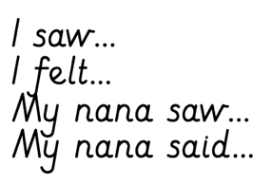  Repeat for picture two.  Using the given sentences, pupils to decide on the most appropriate subordinating conjunction. Pupils to orally rehearse, share and teacher to CFU.  Sentence starters given including subordinating conjunction. Model first sentence if needed and pupils then to complete their own on whiteboards.  If finished, pupils to write their own.  Ask children to show you their wb, check for children who are not writing in role or understanding CJ’s feelings.  CJ is feeling – spotlight. | Children take whiteboards to their table and copy their sentences into their books  Then write their own using sentence starters.  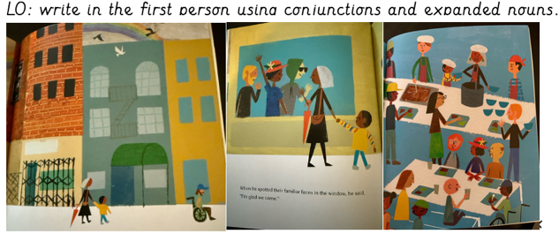 | Pupils to re-read sentences to check for sense.
Lesson 5  Write recount in the first person– see success steps. (N.B. different success steps for this half of the recount as pupils can now apply their subordination knowledge. Star challenge (GDS) to independently use most appropriate subordinating conjunction so the star challenge on success steps is to carefully choose them) | Retrieval  Pupils to extend sentences using subordination. | Remind pupils that our recount is written in chronological order, past tense, first person.  Let’s think carefully together about how we can begin our recount. Model imagining that you are CJ jumping off the bus and saying goodbye to Mr.Dennis.  I threw a coin in the man’s hat and suddenly it was our stop. The bus creaked to a stop and I jumped off the bus saying bye to Mr. Dennis.  (Think aloud: I want my reader to know that I had enjoyed the bus journey and was ready to jump off)  Next  We walked off the bus and through an abandoned, dirty street. The buildings were crumbling and everything was closed. I felt nervous walking with just Nana.  Explain that you challenged yourself to include an expanded noun and extend your sentence using the conjunction ‘and’  We do  Invite the pupils to share a sentence with their LP as if they are CJ jumping off the bus onto the new neighbourhood. The last stop on market street.  I do  Display the next picture prompt and explain that CJ’s feelings start to change when Nana points out the rainbow.  Explain that you’re going to think carefully about how you can include a subordinating conjunction: When we got off the bus , I saw dull, dirty streets. I felt nervous in the abandoned street. Nana pointed out the rainbow because she likes to find beauty and that started to cheer me up. I want to find beauty in things like Nana does.  We do  Invite the pupils to share a sentence with their LP as if they are CJ are spotting the rainbow. | I threw a coin in the man’s hat and suddenly it was our stop. We walked (think aloud: Explain that in walk we have not had to change the root word. We have simply added the –ed suffix. We haven’t had to do anything because there is a long vowel sound in this word) off the bus and through an abandoned, dirty street (expanded noun to describe the street)  When we got to the soup kitchen, we looked up and saw a vibrant, beautiful rainbow that lit up the dreary, dull street. Through the window we could see our friends. I felt happy that we came.  Pupils to have GPC mats, CEW mats, first two picture prompts and large success steps accessible on tables.  Dictation for children who need additional practice before independent work:  We jumped off the bus and we were on a dirty, dull street. I felt unhappy as I saw broken, dull lights and battered, wooden doors.  I felt sad that we always had to come here but Nana pointed out the beautiful, vivid rainbow. When we arrived at the soup kitchen…  Children to then carry this on themselves., | Pupils to reread their writing to check it makes sense.
Or – recount in one sitting and then - To make simple corrections to my writing.

Making simple corrections:

Check -ed spellings.
Check full stops and capital letters,
Improve adjectives used in expanded nouns.

