Text and Author: | Night Flight by Katie Cottle  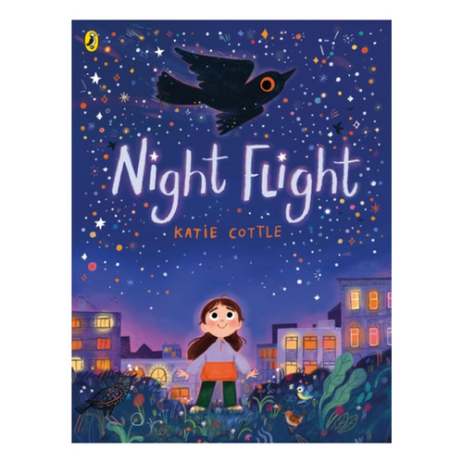 | Year Group: | 1 | Term: | Spring 2
Text and Author: |  | Final Outcome: | Descriptive sentences

 |  | Key Learning |  | SpringTerm
 |  |  |  | 5 a (Mastery plus Y1 NC requirements)
 | Spelling |  | All validated SSPs will teach the requirements of the Year 1 National Curriculum for spelling.
 | Handwriting |  | Follow the progression of your Handwriting Programme to ensure pupils have sufficient practice to master the Y1 handwriting objectives.

Vocabulary, Grammar and Punctuation | - Say, and hold in memory whilst writing, simple sentences which make sense.  - Write simple sentences that can be  read by themselves and others. |  | - Say, and hold in memory whilst writing, sentences that can be read by themselves and others.
Vocabulary, Grammar and Punctuation | - Separate words with spaces |  | - Separate words with spaces of a roughly consistent size
Vocabulary, Grammar and Punctuation | - Use capital letters for names of people, places and days of the week. Use capital letter for the personal pronoun I. |  | - Use capital letters for names of people, places and days of the week
Vocabulary, Grammar and Punctuation | - Use punctuation to demarcate simple sentences (capital letters and full stops). |  | - Use capital letters and full stops to demarcate simple sentences.
Composition: Drafting and Writing |  | - Orally compose every sentence before writing. | - Orally compose every sentence before writing, including compound sentences using the joining word ‘but’ e.g. say the sentence three times to fix it in working memory.
 |  | - Compose and sequence their own sentences to write short narratives. | - Orally compose and write sentences to form short narratives.
 |  | - Re-read every sentence to check it makes sense | - Independently re-read every sentence to check it makes sense.
Composition: Evaluating and Editing |  | - Discuss their writing with adults and peers. | - Discuss their writing with adults and peers, e.g. using speaking frames such as ‘The best word I have used is…’; ‘My handwriting is good because…’; ‘I am proud of my writing because…’

CEW from the national curriculum are highlighted in blue throughout dictation

Spellings: city, village, sky, pollution, window, Ellie
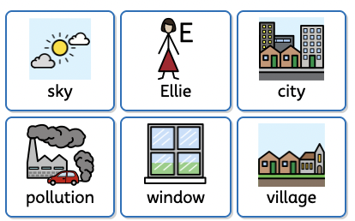

Lesson Objective: | Retrieval/ Introduction | Direct Instruction | Application/ Practice | Review/ Assessment
Lesson 1:  LO: To become familiar with our focus text  To spell words containing phonemes already taught  To punctuate sentences with capital letters and full stops and finger spaces | Hook  Play video of stars in the night sky. Then introduce the image of Ellie with her help the birds poster.  Reveal the front cover  Q: What clues can we see on the front cover?    Q: What is a noun?  I do:  star  bird  (explain that the type of bird this is a starling) starling  We do: highlight section of the picture and collect nouns together.  Collect the nouns.  Teacher to collect list of nouns on flipchart/ whiteboard.  N.B. Book links with ‘Look Up’  Nathan Byron. | Transcription (with children sitting at tables)  Model annotating on lined paper in writing books.  Ensure clear modelling of writing behaviours including:  - letters sitting on the line  - finger spaces  - neat presentation  Children write sentences to describe what they can see on the front cover. Teacher to heavily model thought process    Teacher modelled  I can see a girl.  I can see the lights in the flats. | As done in phonics lessons, model:  - Stretching out words  - putting on fingers  - counting phonemes  - discuss graphemes needed  - using your schools SSP phonics displays and phonics mats    Transcription  I can see a starling.  I can see bright stars.      Independent (for example)  I can see green grass  I can see little birds on the ground.  *Star challenge  I wonder if….  I wonder why… |   Model how to read back through work checking for:  - use of GPC  - finger spaces  - letters sitting on the line  Children to read back own work.  Read the story  Q: What did you notice? What do you wonder? What puzzled you?  Use book talk sentence starters discuss the book.  I like…  I dislike…  It reminds me of….
Lesson 2  LO: To use adjectives to describe a setting |     1 minute – handwriting-  Can use https://ictgames.com/mobilePage/writingRepeater/index.html  to support    Retrieve: nouns  Display picture from the book and ask children what nouns they see.  Q: What is an adjective?  We use an adjective to describe a noun. | 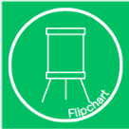    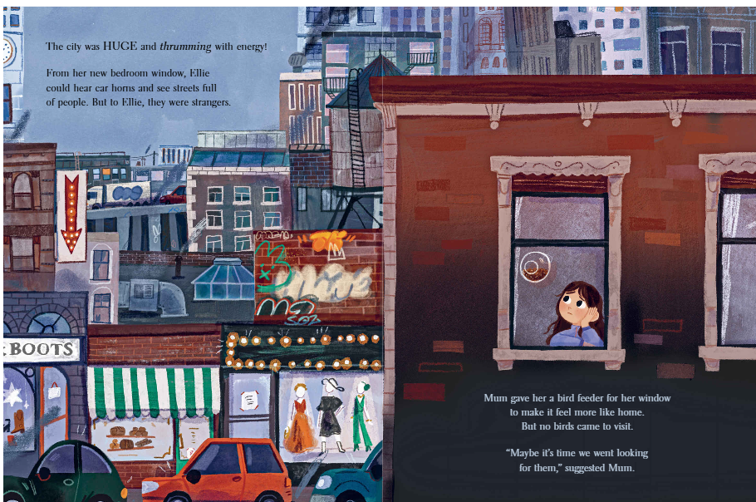  Using picture of Ellie looking out of the window, generate adjectives to describe the city. E.g.  grey  dark  huge  bustling  thrumming  Teacher to collect adjectives on the flipchart.  Introduce what an expanded noun phrase is.  Model putting the adjectives into phrases orally, using the nouns on the slides to support. E.g. dark sky, huge towers  Children to orally compose their own in pairs.  Teacher scribe some WAGOLL examples onto flipchart.  Teacher modelled  crowded streets  beeping car | Explain that we will create expanded noun phrases to support with tomorrow’s setting description.  Give children noun and build the noun phrases together  Nouns  clouds  flats  Scaffold: can give children nouns to write expanded nouns about  Word bank strips if needed to support.  Nouns:  flats / tower blocks  clouds  sky  street  people  shops  traffic  Adjectives:  loud  dull  drab  crowded  bustling  concrete  restless  Phrases:  beeping horns  tall windows  maze of buildings | Share your favourite expanded noun – read it aloud to the class. Check for understanding and collect good examples to add to collective list.  KPI: Read aloud their writing clearly enough to be heard by their peers and their teacher. DEPTH: Read with expression.
Lesson 3:  LO: To write a setting description  (Third person) |   1 minute – handwriting  Can use https://ictgames.com/mobilePage/writingRepeater/index.html    Retrieval- adjectives.  What adjectives would you use to describe the picture? Check for understanding- ensure pupils understand that adjectives are used to describe the nouns.  Explain that today we are going to be writing a short description of Ellies view from the window.  The setting description will be written in the third person.  Third person is when you tell a story about other people, not yourself.  So, we are telling a story about Ellie and her move to the city. | Share WAGOLL   From the bedroom window the outside was unlike her old house. The sky was full of dark clouds and the streets were thrumming with bustling people. Ellie looked out but there were no birds or green to see. The tall flats towered over her. Ellie could hear the beeping horns and traffic jam.    Teacher modelled  Write a short description of the city using expanded noun phrases from yesterday  Retrieve expanded nouns from working wall/flip chart and model putting them into a write.  Think aloud, using the picture from yesterday and describing the different nouns.  E.g. I am thinking about what Ellie can see and hear.  I am writing in the third person, telling a story about what Ellie can see so I am going to start with Ellie, she looked out of her window and she saw…  Ellie looked out her window and saw the crowded streets. She could hear the beeping horns.  sky  clouds  Give children the spelling for the word ‘could and’ display it on the board and draw attention to it. Use is and show how during the I do. | Transcription  There were (the sounds of)  (links with sounds that she can hear – beeping horns, bustling traffic, thrumming people)  Consider modelling using an and  There were screeching traffic and bustling people.  Join two children’s ideas with and.  Sentence starters  Ellie saw  Ellie could hear  Ellie felt  Challenge-  Ellie wondered  Ellie wished  Picture stimuli for children with labelled nouns if needed.  tower blocks  flat  shops  cars | Using writing on flipchart, teacher model how to check writing for capital letters and full stops. Find examples of adjectives in sentences and encourage pupils to find their best adjective to share with table/ class.  Read your work back and check it makes sense. Have you got capital letters and full stops.?
Lesson 4  L.O. To use the conjunction but to link words and clauses | 1 minute – handwriting  Can use https://ictgames.com/mobilePage/writingRepeater/index.html  Retrieval- adjectives.  What expanded noun phrases would you use to describe the picture?  Today we are going to be using the conjunction but to join two opposite ideas.  We are going to be comparing  (What does compare mean? To compare means to look at two things and see how they are the same or different.)  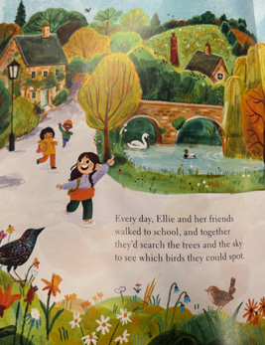  Display both contrasting images. | Model thinking aloud- Compare the village and the city with conjunction ‘but’ to contrast.  Give pupils time to make some comparisons in pairs and share.  Conjunctions focus- oral composition using ‘but’  Model oral composition e.g.  The village was green but the city was dull.  The village had lots of birds but the city has none.  The sky was bright blue but now it is dark and drab.  The houses are quaint but in the city they are tall.  The houses are brick but in the city they are tall and concrete.  Then display written sentences and ask children to join them orally with but.  The village was green. The city was grey.  The village was hushed. The city was loud.  There were birds and streams in the village.  There are cars and lots of people in the city.    Teacher model writing sentence combining two independent clauses and joining them with the conjunction but.  Model joining the sentence on flipchart / under visualizer in writing. Model removing the full stop and capital letter of the second sentence.  The village was green. The city was grey.  The village was green but the city was grey.  There were birds and streams in the village.  There are cars and lots of people in the city.  The were birds and streams in the village but there are cars and people in the city.  Pupils to practice combining two independent clauses into one sentence using the conjunction but. Ensure accuracy when removing CL and full stop to insert the conjunction.  The village was hushed but the city was loud.  Pupils to keep this on their whiteboards to scaffold writing in books.  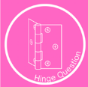  - But the village was green. The city was dull. (Conjunction doesn’t join two clauses)  - The village was small but the city was huge ✓  - The city was loud but the city was noisy. (Clauses don’t disagree)  Correct use of ‘but’ – contrasting ideas. | Following the modelled writing, practice on whiteboards and hinge question, the transcription encourages pupils to use their own ideas to finish a sentence as opposed to transcribing an entire sentence.  Transcription  The streets were bright and green but…  Independent (for example)  Scaffold:  Give a list of nouns you can compare.  There were birds and streams in the village. There are cars and lots of people in the city.  The village streets were hushed but (the city streets were)  There were flowers and trees in the village but in the city….  There were lots of birds but now there are no birds.  The sky was bright blue but in the city it is dark and dull.  The houses were little and brick but in the city they are tall and concrete. | Teacher model how to re-read sentences and check for sense.  Pupils re-read every sentence to check it makes sense.  Share your best sentence with your partner.
Lesson 5  L.O. To write descriptive sentences | Retrieve:  Nouns  Adjectives  Expanded nouns.  Re-read book.  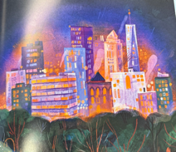  Orally contrast and discuss the sky before and after.  I do:  The city was glowing but the birds could not find their way.  The lights were distracting and the birds could not find north.  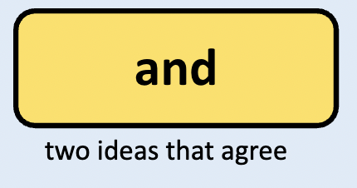  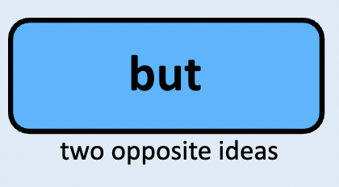  Touch on light pollution. Explore and discuss this page.  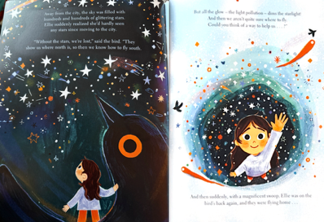 | Explore this page.  Collect nouns and adjectives.  Suggested Nouns: bird, city, sky, stars, lights, Ellie, window  Suggested Adjectives: brilliant, black, dark, shining, ablaze, tiny  Can we add any more of our own adjectives?  I do:  Teacher modelled  The brilliant starling and the bright stars sparkled.  The stars sparkled but the clouds were dark.  Challenge if you wanted to model a few sentence starters:  *Under the stars  *In the air/sky | Build phrases together / in partners on whiteboards.  The bird  The stars/ the clouds  WAGOLL: (The stars were bright but the clouds were dull)  Independent (for example)  The bird was black but the stars were bright.  The shooting stars sparkled and lit up the night.  Sentence starters:  The bird  The stars  The sky  The flats  Star challengge:  In the air (sky)  (WAGOLL: In the sky the stars were bright)  Under the stars  (WAGOLL: Under the stars the black bird swooped.) | Teacher model how to re-read sentences and check for sense.  Pupils re-read every sentence to check it makes sense.  Share your best sentence with your partner.
Simple retell script example for week 2
Ellie moved from a green village to a grey city. She missed the birds she used to watch. Her mum bought her a bird feeder, but no birds came. One night Ellie heard a tapping at her window. She saw a black starling. The bird showed her the bright city lights and explained that they confused birds. Ellie shared an idea to turn off the city lights at 8 o’clock. People agreed and helped. The lights went out, the stars appeared, and the birds returned. Ellie finally felt at home.

Week 2 Lesson 1  L.O: To write descriptive sentences including verbs. | Q: What is a verb? Remind pupils that we have already learnt about verbs.  Elicit a few examples. Give a few examples first if extra reminders needed- walk, run, drink, draw. | Re read the story and collect the verbs on whiteboards in pairs.  Share ideas as a class and create a shared class word bank on flipchart.  Verbs in book:  Grew, walked, search, spot, move, loooking, peeked, thought, jumped, peering, blinked, cooed, opened, climbed, soared, flew, landed, fly, swoop, beeping, sighed,turned off, crossed (her fingers), drew back (curtains), plunged, winked, meeting,    Pupils to sequence the story and practise saying a sentence to match each one. As they do so, encourage them to think about the verbs they are using.  Pictures from the book to order in pairs.  Then simple oral retell of the story.  Match verbs collected to pictures from the text.  Ask children to orally compose verbs to match pictures from the book.  Then put them into sentences.  Teacher could have sequenced pictures on the board and collect verbs underneath as a word bank.  Teacher modelled  She skipped through the village.  She laughed with her friends.  She looked for birds but found just one. | Transcription  She spotted a starling.  They flew out of the city.  They landed on a hill.  Independent (for example)  Final four pictures.  Verbs – planned, made, sighed, turned off, peeked, drew back, saw  Sequenced answer: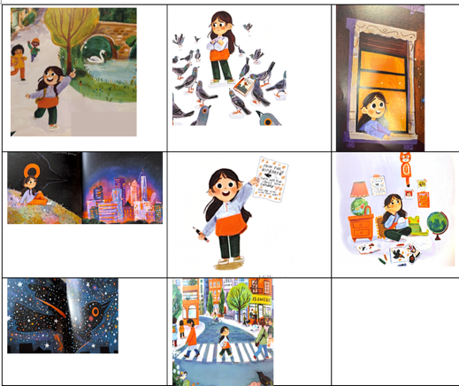 | Teacher model how to re-read sentences and check for sense.  Pupils re-read every sentence to check it makes sense.  Share your best sentence with your partner.
Week 2 Lesson 2  L.O. To write sentences about a character’s feelings | 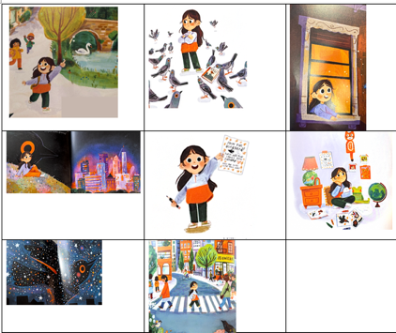  Retrieval:  Can order the pictures and tell your partner a sentence for each one.  Using yesterday's pictures, we are going to be thinking about Ellie’s feelings at different points of the story.  Showing the different pictures from the text (and yesterday's sequencing activity)  Ask children to orally compose emotions to match pictures from the book.  Q: What do you think Ellie is feeling in the picture (and why)  Then put them into oral sentences.  Ellie felt…  Ellie wondered…  Ellie missed…  Ellie wished…  Ellie hoped… | Using visualiser or flipchart: model sticking picture strip down the side of the page and model writing next to picture 1.  Teacher modelled  Ellie liked the stream and birds. She enjoyed looking at all the different birds.  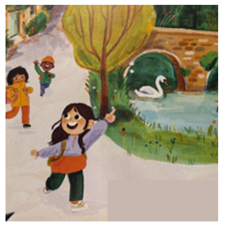  The dull birds made Ellie feel fed up.  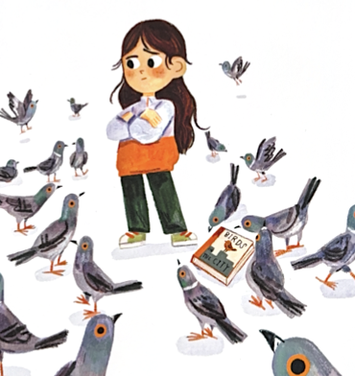 | Sentence stems and build endings together, then do a few in pairs if needed.  Ellie saw  Ellie found  Ellie felt,  Ellie wondered,  Ellie missed,  Ellie wished,  Ellie hoped,  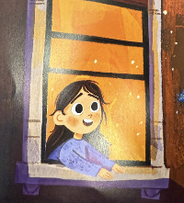  Ellie planned to help the birds. She felt hope.  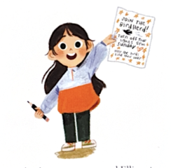  Independent (for example)  Sentence stems  Ellie felt,  Ellie wondered,  Ellie missed,  Ellie wished,  Ellie hoped, | Teacher model how to re-read sentences and check for sense.  Pupils re-read every sentence to check it makes sense.  Share your best sentence with your partner.
Week 2  Lesson 3:  LO: To write a descriptive narrative | Display three pictures from the book and give children sentence starters to orally finish with their talk partner.  Ellie enjoyed,  Ellie loved,  Ellie wished  Discuss:  Use of proper noun, Ellie, needs a CL. | 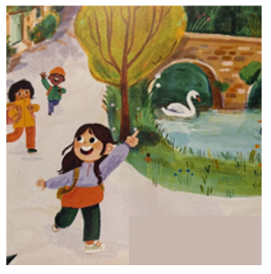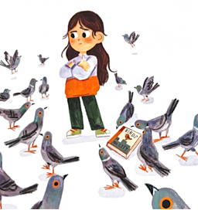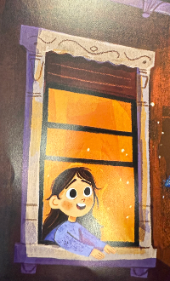  Children to retell this section using these three pictures.  1.  Ellie moved from her green village with streams and flowers to the drab city. In her village she loved watching birds. In the dull city she missed the birds. Mum got her a bird feeder to help her feel at home but it did not work. No birds visited. One night she heard a tap tap tap at her window. Outside she saw a midnight black starling. She felt joyful but the bird needed her help.  Talk through how the story moves and talk aloud writing the opening of the story and using phonics for words home, new, enjoyed, birds and flowers.  Ellie left her old house for a new one in the city. In her old house she loved the birds and flowers. | Transcription  Her new house had no birds.  Mum got her a bird feeder but no birds visited.  Independent (for example)  Provide sentence starters for children to finish.  One night there was…  Outside she saw…  She felt…  There was a tap tap tap at her window. | Teacher model how to re-read sentences and check for sense and model sharing what they like about a particular sentence.  Children to use sentence stems to tell their partner/ table what they like about their writing.  Opportunity to read aloud their story so far to partner/ group.
Week 2  Lesson 4:  LO: To write a descriptive narrative | Re-read your work back from yesterday. Does it make sense? Are you missing any words? Do you have capital letters and full stops?  Show pictures from yesterday's lesson. Ask children to retell the story up to today's task  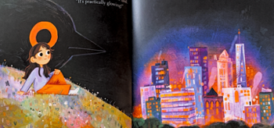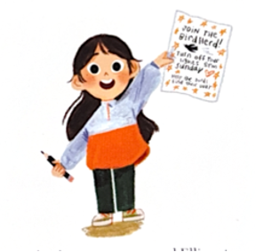  Show pictures from today's writing task  Ask children to discuss what is happening at this part of the story. | 2.  The bird flew her out of the city. From high up she saw houses and green trees. They landed and the starling told her about the light pollution. The city was glowing with lights but the birds could not find their way. Ellie thought lots about the problem and formed a plan to help the birds.  The starling flew her out of the city. She saw little houses and green trees. | Transcription  They landed on a hill outside the city.  The starling told her about the light problem.  (spoke about / explained)  The lights stopped the birds…  Ellie felt  Ellie wished | .  Teacher model how to re-read sentences and check for sense and model sharing what they like about a particular sentence.  Children to use sentence stems to tell their partner/ table what they like about their writing.  Opportunity to read aloud their story so far to partner/ group.
Week 2  Lesson 5:  LO: To write a descriptive narrative | Re-read your work back from yesterday. Does it make sense? Are you missing any words? Do you have capital letters and full stops?  Show pictures from yesterday's lesson. Ask children to retell the story up to today's task  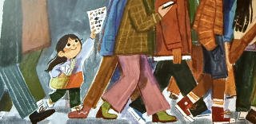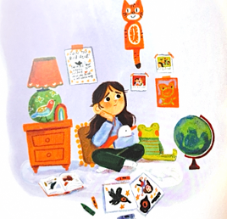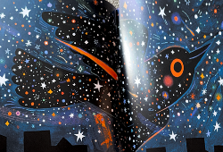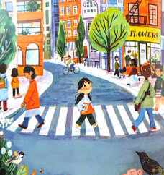Show pictures from todays writing task  Ask children to discuss what is happening at this part of the story. | 3.  She made a handout and tried to hand it to the bustling people. No one spotted her but when she got to the park they loved her plan. They told their friends and the plan was out. They needed to turn their lights off across the city at 8 o’clock. She waited and felt nervous but her plan worked. They sky was alight with hundreds of bright stars. It was a big win and the city began to feel like home.  Ellie made a handout. The people were rushing past her. | Use sentence stems and build endings together,  In the park...  Her friends thought...  Independent (for example)  They needed too  Ellie waited  Ellie felt  When the time was right… | Teacher model how to re-read sentences and check for sense and model sharing what they like about a particular sentence.  Children to use sentence stems to tell their partner/ table what they like about their writing.  Opportunity to read aloud their story so far to partner/ group.

Simple oral retell:
Ellie moved from a green village to a grey city. She missed the birds she used to watch. Her mum bought her a bird feeder, but no birds came. One night Ellie heard a tapping at her window. She saw a black starling. The bird showed her the bright city lights and explained that they confused birds. Ellie shared an idea to turn off the city lights at 8 o’clock. People agreed and helped. The lights went out, the stars appeared, and the birds returned. Ellie finally felt at home.



