Year group and term | EYFS Profile KUW ELG Statements | Substantive Knowledge | Disciplinary Knowledge | Enquiry Question | Vertical Concepts
Reception Autumn Term 1 | Talk about the lives of the people around them and their roles in society  Know some similarities and differences between things in the past and now, drawing on their experiences and what has been read in class  Understand the past through settings, characters and events encountered in books read in class and storytelling  Know some similarities and differences between different religious and cultural  communities in this country, drawing on their experiences and what has been read  in class | Myself, my family, my friends | Similarity and Difference | Who am I? | Trade and Settlements

The progression of learning
Prior learning | Building to
In Nursery pupils will have already begun to talk about their basic physical features and will have begun to express preferences. They will have begun to make sense of their own life story by naming adults who are important to them. | In the next unit in EYFS pupils will explore the question ‘Who are the people who help us in our community?’ Pupils will explore the different occupations of people who work in the local community. They will think about why you may visit these people including looking at pictures and stories from the past and present.  In KS1 pupils will learn about the events of the Great Fire of London including the initial cause through the unit ‘What were the causes of the Great Fire of London and why did it spread so quickly?’. They will compare the settlement of London at the time of the fire with London today to understand some of the reasons why the fire spread so quickly. They will also learn about the impact of the fire on how London was rebuilt as well as on how fires are now fought.

By the end of this unit pupils who are on track should
Key substantive knowledge | Key disciplinary knowledge
- Describe themselves physically and make comparisons in appearance with other people  - Talk about things that are important to them, they like and dislike  - Define what a family is and who is in their family  - Talk about similarities and differences between their family and others  - Talk about features of my home  - Sequence key events from their own life  - Recognise things that have changed during their life | Past and present  - Talk about members of their immediate family and community  - Name and describe people who are familiar to them  - Comment on images of familiar situations in the past  - Compare and contrast characters from stories, including figures from the past  People, culture and communities  - Recognise that people have different beliefs and celebrate special times in different ways
Communication and language |  | PSED
- Understand how to listen carefully and why listening is important  - Learn new vocabulary  - Ask questions to find out more and to check they understand what has been said to them  - Articulate their ideas and thoughts in well-formed sentences  - Connect one idea or action to another using a range of connectives  - Describe events in some detail  - Use talk to help work out problems and organise thinking and activities, and to explain how things work and why they might happen  - Listen to and talk about stories to build familiarity and understanding  - Use new vocabulary in different contexts  - Engage in non-fiction books  - Listen to and talk about selected non-fiction to develop a deep familiarity with new knowledge and vocabulary |  | - See themselves as a valuable individual  - Express their feelings and consider the feelings of others  - Think about the perspectives of others

Key vocabulary | Suggested opportunities to practice knowledge and skills in provision | Key texts
Skin, eyes, hair, tall, short, curly, like, don’t like, favourite, toy pet, mum, mummy, dad, daddy, brother, sister, auntie, uncle, grandma, grandad, family, adopted, birthday, holiday, friend, same, different, baby, toddler, teenager, adult, older, younger | - Use mirrors to help children observe their own features. Ask them to describe what they see and compare it to a friend’s features, with prompts like, ‘How is your hair different from your friend’s hair?’  - Have children draw or paint pictures of themselves, focusing on physical features. Use guided questions like, ‘What colour is your hair?’ and ‘What shape are your eyes?’ Encourage them to compare their portraits with those of their peers.  - Provide puzzles or matching games with body parts where children can build and describe different figures. Discuss similarities and differences as they play.  - Offer a variety of clothing and accessories. Children can dress up and describe how they look compared to their friends, highlighting physical differences and similarities.  - Use a feelings chart or picture cards to help children express what they like and dislike, guiding them to describe their preferences.  - Read books about different types of families to help children understand the concept of family and discuss who is in their own family.  - Body tracing of a friend adding in physical features  - Provide a set of family dolls or figures. Encourage children to use them in role-play and describe who each family member is and what they do.  - Build homes using construction materials  - Create a collage of family  - Make a family wall hanging/ family tree with pictures or drawings of family members. Discuss each member’s role and relationship within the family.  - Create simple paper family puppets  - Draw/ paint a picture of a friend  - Create joined paper dolls  - Create representations in play dough  - Pupils may bring in pictures of their family to talk about and share in class  - Then and now pictures/ paintings  - Milestone collages  - Home corner/ small world related to family life | When I Grow Up  The Girl With Two Dads  Dinosaur Starts School  What Makes Me Me?  Shine  All Are Welcome  Living with mum and living with  And Tango makes 3  Pirate Mums  You Choose  So Much  Big Book of Families  What makes me, me  In every house, on every street  The same but different too

What do teachers need to know?
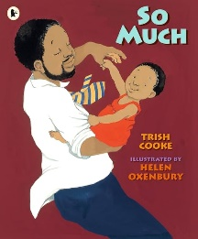
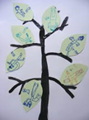
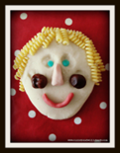
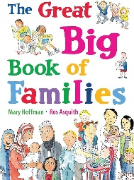
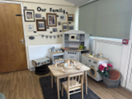
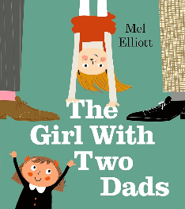
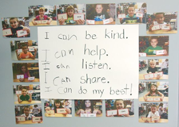
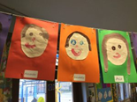
- Describing themselves physically, their likes and dislikes: Pupils should be able to identify and describe basic physical features such as hair colour, eye colour, height, and other distinguishing characteristics. They should also be able to use simple descriptive words like tall, short, curly, straight, etc. Pupils should be able to express their likes and dislikes clearly. This includes naming their favourite and least favourite foods, activities, toys, colours, and other interests. Pupils should be able to talk about things that are important to them, such as a favourite toy, a pet, or a family member. They should also start understanding the concept of feelings and be able to articulate what makes them happy, sad, scared, or excited.
- Defining what a family is and who is in their family: Pupils should understand that a family is a group of people who live together and care for each other. They should know that families provide love, support, and security. Pupils should be able to name and describe the roles of their immediate family members such as parents, siblings, grandparents, and any other significant family members who play a role in their lives.
- Talking about how families can be different: Pupils should learn that families come in different shapes and sizes. They should understand that some families have two parents, some have one, some have grandparents living with them, and some might include adopted members or foster pupils. Pupils should be taught to respect and accept different family structures without prejudice. They should learn that what matters most in a family is love and care, not the specific makeup of the family.
- Sequence key events from their own life: Pupils should start understanding the concept of time and be able to put events in their life in a basic chronological order. This can include sequencing daily routines or significant events like birthdays, holidays, or trips. They should be able to tell simple stories about their past experiences, using words like "first," "next," and "last." This helps develop their narrative skills and understanding of cause and effect.
- Understand what it means to be a friend: Pupils should understand that friends are people who care about each other, play together, and help each other. They should be familiar with concepts like sharing, taking turns, and showing kindness. Pupils should start learning how to make friends by introducing themselves, finding common interests, and playing cooperatively. They should also learn basic conflict resolution skills and understand that it's normal to have disagreements but important to resolve them kindly.
- Talk about similarities and difference between themselves and others in the class: Pupils should be able to recognise and talk about both similarities and differences among their classmates. This can include physical traits, cultural backgrounds, interests, and abilities. They should be encouraged to celebrate and respect these differences, understanding that diversity makes the classroom community rich and interesting.
Misconceptions pupils may have
- Physical Descriptions: Pupils might think that physical features like height or hair color are fixed and do not change over time. They might also have misconceptions about beauty standards and feel that certain traits are better than others.
- Preferences: They might believe that their likes and dislikes are universal and that everyone shares the same preferences. This can lead to confusion or conflict when encountering differing opinions.
- Family Definition: Pupils might have a narrow view of what constitutes a family, thinking that all families look like their own (e.g., only two-parent households). They may not recognise other family types.
- Family Members: Pupils might think that everyone has the same family members or roles (e.g., every family has a mum, dad, and siblings). They might also believe that family roles and relationships are the same across all cultures and households.
- Family Diversity: Pupils might struggle to understand that different family structures are equally valid and loving. They might think that only their family structure is "normal" and view other structures as strange or wrong.
- Respect for Differences: Some pupils might have misconceptions that different family structures are a result of something bad or abnormal, rather than just a different way of living.
- Friendship Basics: Pupils might believe that friends must always agree with them or like the same things. They may also think that a single disagreement means the end of a friendship.
- Making and Keeping Friends: Pupils might misunderstand that friendships require effort and compromise. They might also believe that being popular or having many friends is more important than having meaningful relationships.
- Identifying Similarities and Differences: Pupils might think that differences among classmates are bad or make others inferior. They might also believe that everyone should be the same to get along.
- Celebrating Diversity: They might have the misconception that acknowledging differences will cause division rather than promote understanding and respect.
- Chronological Understanding: Pupils might struggle with the concept of time and sequence, thinking that past, present, and future events are interchangeable or not understanding the progression of time.

