MFL at Yatton Schools
In Year 3 and 4 the following units will be taught:
Year 3 | Unité 1  Bonjour | Unité 2  Je m’appelle Sophie | Unité 3  Combien de biscuits? | Unité 4  J’ai six ans | Unité 5  J’ai un frère | Unité 6  Beaucoup de bonbons | Unité 7  Un bonbon rouge
Year 4 | Unité 8  J’ai un chat | Unité 9  J’adore les serpents | Unité 10  Dimanche c’est mon anniversaire | Unité 11  Trente et un invités | Unité 12  Quelle est la date de ton anniversaire? | Unité 13  J’ai mal! | Unité 13  Où est ma trousse?

In Year 5 and 6 the following units will be taught:
Year 5 | Unité 1  Luc est le Professeur | Unité 2  Le Vrai professeur | Unité 7  Combien de Paquets? | Unité 8  J’ai trente-deux pacquets | Unité 9  Luc est Sophie font les devoirs | Unité 12  Dans la sale de classe | Christmas  Unité 4  Une letter au Pére Noël
Year 6 | Unité 3  J’ai les cheveux noirs et longs | Unité 6  Quel temps fait –il? | Unité 10  C’est délicieux! | Unité 11  Je vais aller en vacance! | Unité 13  J’adore le football! | Unité 14  Il est grand et gros | Christmas  Unité 5  Joyeuz Noël

The scheme has been written to ensure the coverage of the National Curriculum Programmes of Study.
By the end of Year 4 children should be able to:
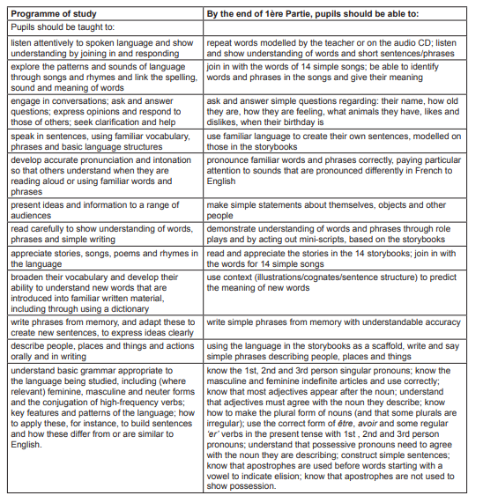

By the end of Year 6 children should be able to:
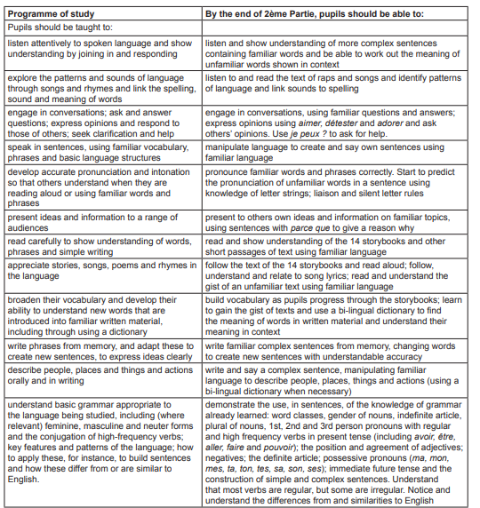

The following Topics/grammar are introduced in each unit:
Year 3 and 4

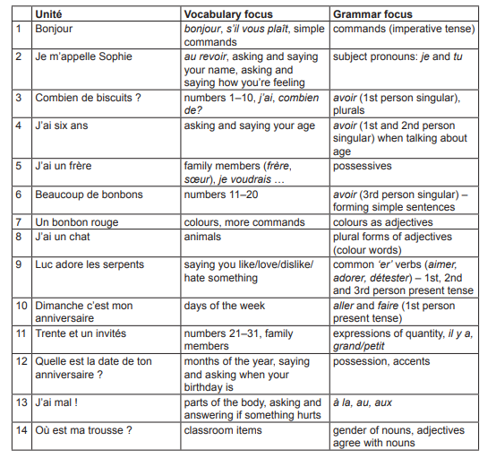

Year 5 and 6
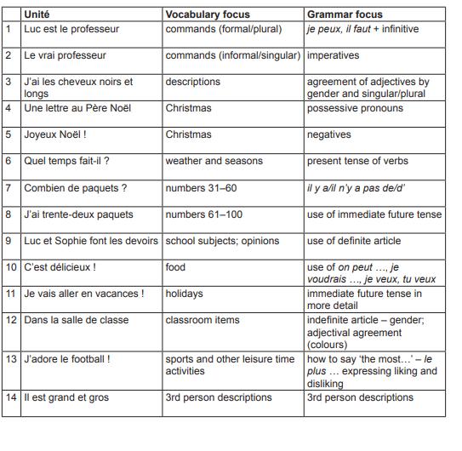
Teaching the units – the units can be covered over a number of lessons. In each lesson the children will:
Listen to the story – hear it once all the way through and then on a second attempt see if the children can work out what is being said. Each book has a vocabulaire section that can be printed for the children to be language detectives.
Read the Story – take it in turns/ act it out.
Practise the new learning by completing the Ecoute/Parler/Lire / Écrire activities in book and on the Smartboard Games
Make note of the grammar section in the Teachers book and bring this into the teaching.

Assessment
At the end of each unit children can do their own self-assessment on their learning. During the teaching teachers will be assessing the children all the time as they participate and may comment at the end of the unit on the children’s self-assessment to celebrate the learning.

