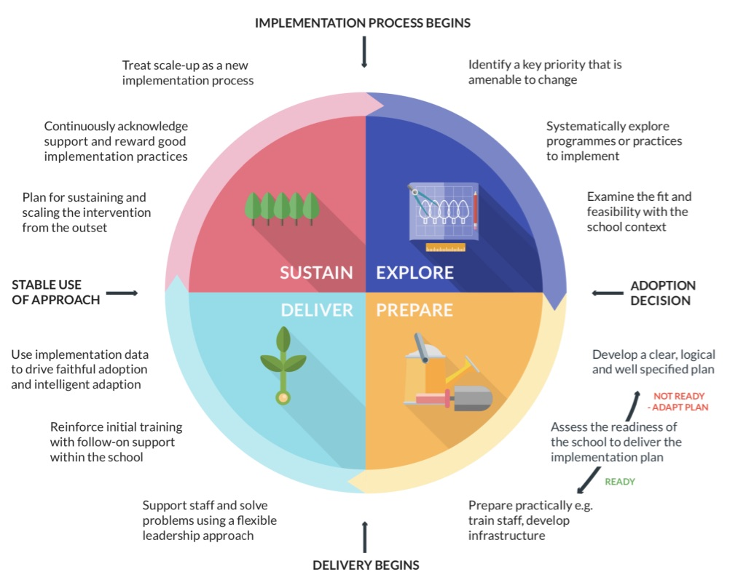
Maths Subject Leader Implementation Plan




Being an effective subject leader at Lighthouse Schools Partnership

At LSP we use the EEF guide to implementation in order to help leaders at all layers of the organisation implement change and evolve/ further develop our practice. We understand that effective implementation is a process, not an event which needs planning and executing in stages.

https://educationendowmentfoundation.org.uk/tools/guidance-reports/a-schools-guide-to-implementation/

At LSP we ask that all subject leaders:

Explore
- Define with senior leaders what the identified area for improvement or evolution will be
- Research the identified area thoroughly using a range of resources so that you are evidence informed and how this will work in-line with our school vision, values and pedagogical approach

Prepare
- Create an implementation plan in-line with the STDP priorities that is in-line with the school vision, values and pedagogical approach
- Define the anticipated measurable outcomes that you want to see over time and within blocks of time
- Work with senior leaders to plan the use of subject leadership time effectively to deliver measurable impact over the defined period of time – what will you do? When? Why? How? Who else will be involved?

Deliver
- Support staff through effective and confidently delivered CPD training – reflect on and adapt training to needs of the school and staff understanding
- Ensure that there is systematic monitoring of impact that includes the voice of staff, parents and children as much as possible alongside any written/data/ other outcomes

Sustain
- Review further training opportunities for yourself and others
- Continue to monitor the impact over time
- Evolve in-line with school approach/ up-to date research and evidence
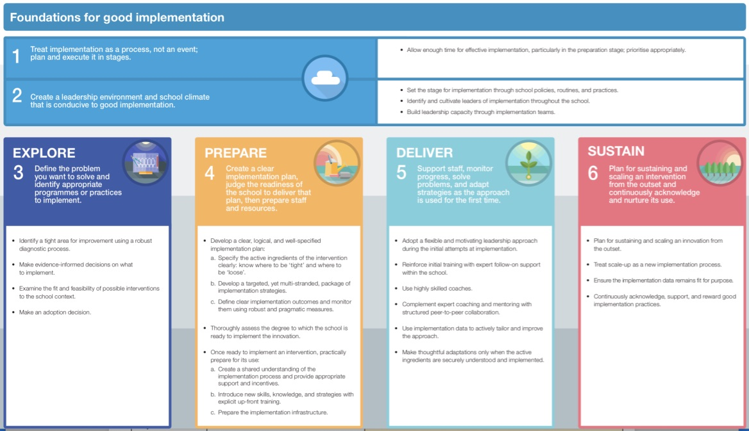

The road map to implementation in maths

The boxes below should be used to map out the different stages of your implementation process during the academic year/ defined period of time using the 4 identified stages of the implementation process. Deliberately plan out the 4 stages of implementation including but not limited to: time to research evidence informed practice; meetings with SLT; CPD opportunities and monitoring of impact.

T1 and T2 Implementation Plan

Objective | Key actions to be taken/ training to be delivered | Measures of success/ T2 outcomes | Monitoring
Continuity across all the school in terms of lesson structure. | - Staff meetings on lesson design using the White Rose ‘episodic teaching model’.  - Deep dive into planning.  - Book looks | Walkthrus being used consistently.  AfL being used to inform next steps within and after lessons. | All lessons use Walkthru strategies: ‘I do, we do, you do’; retrieval; cold calling; hinge questions.
Consistent use of reasoning and problem solving in all lessons. | - Deep dive into planning.  - Book looks | NfER scores  Y6 practice SATs | More evidence in maths workbooks of reasoning and problem solving, starting to be accessed by all pupils (adapted).
Improved scores in Y4 MTC and Year 6 SATs. | - James to visit St Mary’s Primary School and contact maths lead at Golden Valley to discuss their strategies for successful MTC scores in 2024-2025.  - James to meet with Year 4 to discuss use of TTRS and targeting pupils for intervention/precision teaching.  - Y4 teachers to carry out termly MTC checks on TTRS | Baseline results for Year 4: | James visited St Mary’s and Golden Valley. Strategies fedback to Y4 staff.  Next step: look at Mastering Number to embed understanding of number structures that lead to knowledge of times tables.
Introduce worked examples to support the lower 20% of the cohort. | - Staff meeting on worked examples  - Explain theory behind using worked examples  - Teachers to identify the lower 20% the worked examples will benefit. | Staff meeting carried out 4th December. | Teachers are starting to make worked examples for some lessons.
Evaluation of Term 1 and 2
Consistency and continuity across the school is beginning to become embedded. Staff training from last year is evident in teaching practice.
T3 and T4 Implementation Plan

Objective | Key actions to be taken/ training to be delivered | Measures of success/ T4 outcomes | Monitoring
To investigate Mastering Number with a view to implement it in September. | - Maths leads and teaching staff in KS1 and LKS2 to attend Boolean TRG sessions where they will observe Mastering Number in action.  - Maths leads to meet with Boolean Maths Hub lead for advice. | Maths leads feel confident in introducing and delivering Mastering Number. | Unfortunately the KS1 TRG was cancelled.  The KS2 meeting, and the meeting with Boolean lead has taken place
All lessons adapted from the White Rose scheme. | - Monitor through lesson drop-ins  - Book look  - Be familiar with children working below Key Stage / SEND as we drop into lessons and how their learning is being adapted. | Lessons being adapted.  Teachers using AfL continually to adapted lessons to suit the needs of their learners.  Improvement in NfER scores from Y2-Y6. | Monitoring and book look both very positive, though still not consistent across all classes. Nfer scores and practice SATs so far are looking promising.
Consistent use of mathematical representations throughout the school. | - Book look to find out what representations are being used in each year group: is there consistency?  - Review calculation policy  - Feedback to staff in staff meeting (term 4/5?) | Staff are clear which representations they will use for different mathematical concepts. | There is consistency thanks to White Rose being used well across all year groups.  Staff meeting to feedback and discuss calculation policy will now be happening next term.
Evaluation of Term 3 and 4
It has been beneficial that some staff have attended Boolean sessions and fed back positvely.

T5 and T6 Implementation Plan

Objective | Key actions to be taken/ training to be delivered | Measures of success/ T6 outcomes | Monitoring
Investigate alternative ways to deliver RPS for yr 1/children with barriers to reading | - Look into alternative ways of presenting and recording RPS questions.  - Discuss with other maths leads in Boolean meetings.  - Contact Amy Tupman.  - Introduce adaptions in staff meeting | Staff offer adapted lessons.  All children are able to access and record RPS questions
Ensure we have enough equipment for teachers to effectively deliver lessons in measure. | - Audit of equipment for measure.  - Discuss with staff exactly what equipment their year group need to deliver the curriculum.  - Estimate cost of creating a class set of equipment (one for KS1 one for KS2).  - Look into weighted objects  - During pupil voice hands on activities and investigations came up as being some of the children’s favourite maths learning. | Using hands on experience as an integral part of maths teaching.
Ensure lessons are being appropriately adapted for SEND, PPG and WTS | - Staff meeting: ascertain an overview of who these children are  - Remind staff about Fluency Bee and TA Hub as recommended resources for support in maths and LSAs to be aware of how to access these resources.  - How are these children progressing? | Maths leads can confidently talk about provision for SEND, PPG and WTS children in each class.
Pupil engagement | - Look at ways maths investigation can be incorporated into current maths teaching.  - What is available and how should it be delivered.  - Investigate feasibility of it being used as an assessment.  - Link it in with oracy | Potentially have a termly maths investigation linked to a completed the White Rose block
Evaluation of Term 5 and 6

